T-VER-P-TOOL-01-12
Calculation for change in soil organic carbon stocks in agriculture project activities

Version 01

1. Introduction
This tool is used for calculating changes in soil organic carbon stocks of agricultural project activities. This can be used to calculate the quarantine volume both for the base case and for operations.

2. Relevant Definitions
Details as per Annex 1

3. Characteristics of relevant activities and conditions
This tool is suitable for calculating changes in soil organic carbon sequestration in the base case and in the case of agricultural project implementation.

4. Assumptions
The instrument has the following assumptions to assess changes in soil organic carbon sequestration:
- Project implementation increases the amount of organic carbon in the soil. Compared with the amount of organic carbon in the soil before the project until the amount of organic carbon in the soil was stable (steady-state).
- The increase in organic carbon in the soil in the case of the project is constant for 20 years from the year of planting.

5. Calculation of changes in soil organic carbon sequestration
Stratification of project areas can be carried out as follow:
1) Climate zone and soil type (Annex 2 Table 1)
2) Area management before the project for agricultural land (Annex 2 Table 2)
Changes in soil organic carbon accumulation from project implementation There are methods for evaluating as follows:
Step 1 Calculation of organic carbon sequestration in the soil prior to project activities. It can be calculated as the following equation:

Option 1 Soil organic carbon content of the samples collected from the sampling plots
Soil organic carbon accumulation It is the collection of soil samples and analyzing the amount of organic carbon in the soil. and soil bulk density directly from the project area Details on the calculation is shown in the following equation.

$${SOC}_{i,0}={\sum{(}SOC}_{sample,i,0} x {BD}_{sample,i,0} x {Dep}_{sample,i,0} x 0.16)/N_{i}$$

Where:
$${SOC}_{i,0}$$ | = | The amount of carbon deposited in the soil before the project started in the sample unit i of the project area (tonnes carbon per rai)
$${SOC}_{sample,i,0}$$ | = | Soil organic carbon content of the samples taken from sample unit i before the start of the project (Lab values in units, grams of carbon for soil particles < 2 mm in size) (grams of carbon per 100 grams of soil)
$${BD}_{sample,i,0}$$ | = | Bulk density of soil with particle size <2 mm from sample unit i before project implementation. (Value from the laboratory in units grams per cubic centimeter)
$${Dep}_{sample,i,0}$$ | = | Soil depth collected from sample unit i before project commencement (centimeter) (not less than 30 centimeter)
i | = | Sample unit 1, 2, 3, …
0.16 | = | Unit conversion value (1 gram = 10-6 tons and 1 rai = 1.6 x 107 square centimeter)
$$N_{i}$$ | = | The number of sample plots that store data in the i-th sample unit.

Option 2 Carbon sequestration in the soil from a reference value

$${SOC}_{i,0}={SOC}_{REF,i} x F_{LU,i,0} x F_{MG,i,0} x F_{I,i,0}$$
Where:
$${SOC}_{i,0}$$ | = | The amount of carbon deposited in the soil before the project started in the sample unit i of the project area. (tonnes carbon per rai)
$${SOC}_{REF,i}$$ | = | Carbon stocks in natural reference soils (e.g., non-improved areas). does not deteriorate and native vegetation cover) according to climatic zones and soil types in sample unit i of the area (tonnes carbon per rai).
$$F_{LU,i,0}$$ | = | The coefficient of changes in organic carbon accumulation in the soil by land use type before project commencement in sample unit i.
$$F_{MG,i,0}$$ | = | Coefficient of change in soil organic carbon accumulation according to soil management methods before project start date of sample unit i
$$F_{I,i,0}$$ | = | Coefficient of change in soil organic carbon accumulation according to the level of organic matter returned to the soil before project start date of sample unit i
i | = | Sample unit 1, 2, 3, …

Step 2 Calculation of organic carbon accumulation in soil in case of project implementation It can be calculated as the following equation.
Option 1 Soil organic carbon content of the samples collected from the sampling plots
The amount of carbon stored in the soil It is a soil sampling and analysis of soil organic carbon content and soil bulk density directly from the project area. Details of the calculation is shown in the following equation:

$${SOC}_{i,t}={\sum{(}SOC}_{sample,i,t} x {BD}_{sample,i,t} x {Dep}_{sample,i,t} x 0.16)/N_{i}$$

Where:
$${SOC}_{i,t}$$ | = | The amount of carbon accumulated in the soil in the project area from sample unit i at time t (tonnes carbon per rai)
$${SOC}_{sample,i,t}$$ | = | Soil organic carbon content of samples collected from sample unit i at time t (laboratory value in units, grams of carbon for <2 mm soil particles) (grams carbon per 100 grams of soil)
$${BD}_{sample,i,t}$$ | = | Bulk density of soil with particle size <2 mm from unit sample i at time t (laboratory value in gram/cm³).
$${Dep}_{sample,i,t}$$ | = | Soil depth collected from sample unit i at time t (centimeter) (not less than 30 centimeter)
$$N_{i}$$ | = | The number of sample plots that store data in the i-th sample unit.
i | = | Sample unit 1, 2, 3, …
t | = | 1, 2, 3, … years since the project start date
0.16 | = | Unit conversion value (1 gram = 10-6 tons and 1 rai = 1.6 x 107 square centimeter)

Option 2 Carbon sequestration in the soil from a reference value

$${SOC}_{i,t}={SOC}_{REF,i} x f_{LU,i,t} x f_{MG,i,t} x f_{I,i,t}$$

Where:
$${SOC}_{t,i}$$ | = | The amount of carbon deposited in the soil when implementing the project in the sample unit i of the project site. (tonnes carbon per rai)
$${SOC}_{REF,i}$$ | = | Carbon stocks in natural reference soils (e.g., non-improved areas). does not deteriorate and native vegetation cover) according to climatic zones and soil types in sample unit i of the area (tonnes carbon per rai).
$$F_{LU,i,t}$$ | = | Coefficient of changes in soil organic carbon accumulation by land use type When executing a project in sample unit i
$$F_{MG,i,t}$$ | = | Coefficient of change in soil organic carbon accumulation according to soil management methods When executing a project in sample unit i
$$F_{I,i,t}$$ | = | Coefficient of change in soil organic carbon accumulation according to the level of organic matter returned to the soil. When executing a project in sample unit i
i | = | Sample unit 1, 2, 3, …
t | = | 1, 2, 3, … year since the project start date

Step 3 Calculation of change rate of organic carbon deposition in soil in case of project implementation It is the rate of change in the case of project implementation until the amount of organic carbon in the soil remains constant. Details of the assessment are shown below.

$$d{SOC}_{i,t}=\frac{({SOC}_{i,t}-{SOC}_{i,0} )}{20 years}$$
Where:
$$d{SOC}_{i,t}$$ | = | Change rate of soil organic carbon sequestration in sample unit i of the project area in year t (tonnes carbon per rai per year)
$${SOC}_{i,t}$$ | = | The amount of carbon stored in the soil When executing a project in the i instance unit of the project area (tonnes carbon per rai)
$${SOC}_{i,0}$$ | = | The amount of carbon deposited in the soil before the start of the project in the sample unit i of the project site. (tonnes carbon per rai)
i | = | Sample unit 1, 2, 3, …
t | = | 1, 2, 3, … year since the project start date

When considering the uncertainty, the uncertainty and inherent limits for the accuracy of the coefficient estimates used in this tool require that the rate of change in soil organic carbon sequestration is not greater than 0.8 tonnes carbon per hectare per year, or 0.128 tons of carbon per rai per year.
Therefore, if estimated $d{SOC}_{t,i}>$0.128 ton carbon per rai a year, it is determined that $d{SOC}_{t,i}=$0.128 ton carbon per rai a year.

Step 4 The change in soil organic carbon accumulation of the project area in year t was assessed as follows:

$∆{SOC}_{t}= \sum_{i}^{n}{A_{i}}x d{SOC}_{i,t} x \frac{44}{12} x 1 year$

Where:
$$∆{SOC}_{t}$$ | = | Changes in soil organic carbon sequestration for all strata of the project area in year t (tCO₂e per year)
$$A_{i}$$ | = | Project area in sample unit i (rai)
$$d{SOC}_{i,t}$$ | = | Change rate of soil organic carbon accumulation in sample unit i of the project area in year t (tonnes carbon per rai per year)
i | = | Sample unit 1, 2, 3, …
44/12 | = | Molar mass ratio of carbon dioxide to carbon

6. Parameterที่เกี่ยวข้อง

6.1 Parameter not required monitoring
Parameter | $${SOC}_{REF,i}$$
Unit | tons of carbon per rai
Definition | The amount of carbon accumulated in the reference soil.
Source of information | Option 1 2019 Refinement to the 2006 IPCC Guidelines for National Greenhouse Gas Inventories: Volume 4Agriculture, Forestry and Other Land Use (ภาคผนวกที่ 2)  Option 2 The values obtained from research are published in recognized academic papers and can be identified as appropriate for the project area.  Option 3 Collecting samples from the project area to develop values as determined by the TGO
Remark | -

Parameter | $${SOC}_{sample,i,0}$$
Unit | Grams of carbon per 100 g of soil (<2 mm soil particles)
Definition | The organic carbon content of soil samples collected from sample unit i and reported in units g carbon per 100 g of soil.
Source of information | Collect samples from the project area to analyze the amount of organic carbon in the soil in the laboratory to determine the amount of organic carbon deposition in the soil before starting the project (SOC_{i,0})
Remark | -

Parameter | $${BD}_{sample,i,0}$$
Unit | Grams per cubic centimeter
Definition | Bulk density of soil with <2 mm particle size per unit volume. Collected from sample unit i and assigned to report values by dry weight.
Source of information | Collect samples from the project area to analyze the bulk density of the soil in the laboratory to determine the amount of organic carbon deposition in the soil before starting the project (SOC_{i,0})
Remark | -

Parameter | $${Dep}_{sample,i,0}$$
Unit | centimeter
Definition | Soil depth collected from sample unit i
Source of information | Collect data from the project area to determine the amount of organic carbon deposition in the soil before starting the project (SOC_{i,0})
Remark | -

Parameter | $$F_{LU}$$
Unit | -
Definition | Coefficient of change in soil organic carbon accumulation according to soil management methods
Source of information | Option 1 2019 Refinement to the 2006 IPCC Guidelines for National Greenhouse Gas Inventories: Volume 4Agriculture, Forestry and Other Land Use (ภาคผนวกที่ 2)  Option 2 The values obtained from research are published in recognized academic papers and can be identified as appropriate for the project area.  Option 3 Collecting samples from the project area to develop values as determined by the TGO
Remark | ⁻

Parameter | $$F_{MG}$$
Unit | -
Definition | Coefficient of change in soil organic carbon accumulation according to soil management methods
Source of information | Option 1 2019 Refinement to the 2006 IPCC Guidelines for National Greenhouse Gas Inventories: Volume 4Agriculture, Forestry and Other Land Use (ภาคผนวกที่ 2)  Option 2 The values obtained from research are published in recognized academic papers and can be identified as appropriate for the project area.  Option 3 Collecting samples from the project area to develop values as determined by the TGO
Remark | ⁻

Parameter | $$F_{I}$$
Unit | -
Definition | Coefficient of change in soil organic carbon accumulation according to the level of organic matter returned to the soil
Source of information | Option 1 2019 Refinement to the 2006 IPCC Guidelines for National Greenhouse Gas Inventories: Volume 4Agriculture, Forestry and Other Land Use (ภาคผนวกที่ 2)  Option 2 The values obtained from research are published in recognized academic papers and can be identified as appropriate for the project area.  Option 3 Collecting samples from the project area to develop values as determined by the TGO
Remark | -

Parameter | 44/12
Unit | -
Details | Molar mass of carbon dioxide per carbon To convert units from tons of carbon dioxide to tons of carbon dioxide.
Source of information | IPCC Guidelines
Remark | -

6.2 Parameter required monitoring
Parameter | $$A_{i}$$
Unit | rai
Definition | Project area in model unit i
Source of information | - area exploration  - use satellite/air photographs
Frequency of monitoring | Follow-up assessment cycle for accreditation
Remark | -

Parameter | $${SOC}_{sample,i,t}$$
Unit | gram of carbon per 100 g of soil (<2 mm soil particles)
Definition | The organic carbon content of soil samples collected from sample unit i and reported in units of grams of carbon per 100 grams of soil.
Source of information | Collect samples from the project area to analyze the amount of organic carbon in the soil in the laboratory and to determine the amount of organic carbon accumulation in the soil in the case of the project (SOC_{i,t})
Frequency of monitoring | Follow-up assessment cycle for accreditation
Remark | -

Parameter | $${BD}_{sample,i,t}$$
Unit | grams per cubic centimeter
Definition | Bulk density of soil with <2 mm particle size per unit volume. Collected from sample unit i and assigned to report values by dry weight.
Source of information | Collect samples from the project area to analyze soil bulk density in the laboratory. To determine the amount of organic carbon in the soil in the case of a project (SOCi,t).
Frequency of monitoring | Follow-up assessment cycle for accreditation
Remark | -

Parameter | $${Dep}_{sample,i,t}$$
Unit | centimeter
Definition | Soil depth collected from sample unit i
Source of information | Collect data from the project area To determine the amount of organic carbon in the soil in the case of a project (SOCi,t)
Frequency of monitoring | Follow-up assessment cycle for accreditation
Remark | -

7. Reference
- Clean Development Mechanism (CDM)
Tool for estimation of change in soil organic carbon stocks due to the implementation of A/R CDM project activities (Version 01.1.0)
- 2006 IPCC Guidelines for National Greenhouse Gas Inventories: Volume 4 Agriculture, Forestry and Other Land Use
- 2019 Refinement to the 2006 IPCC Guidelines for National Greenhouse Gas Inventories: Volume 4 Agriculture, Forestry and Other Land Use

Annex

Annex 1 Relevant definitions
Soil disturbance | Human activities that result in the release of carbon stored in soil organic form into the atmosphere, such as tillage, digging, harrowing, trenching, and drainage
Soil carbon | Decomposition of organic matter accumulated in the soil in the form of organic carbon
Soil | The natural celestial bodies that thinly cover the Earth's surface are formed as a result of the metamorphism or weathering of rocks and minerals. and organic matter mixed together with the following components:  - Mineral matter is the part of minerals within a rock that have weathered down into tiny pieces. by physical, chemical and biological methods  - Organic matter is the part that is caused by decomposition or decomposition of the accumulated remains of plants and animals.  - Water is water in solution. which are found in the channels between soil grains (aggregate) or soil particles (particles).  - Air is a gas in the space between soil or soil particles. The most common gases found in soil are nitrogen, oxygen and carbon dioxide.
Organic soils | Organic soil is soil that has various characteristics as specified by the FAO, which must have the characteristics in items 1 and 2 or items 1 and 3 as follows:  (1) Have a thickness of 10 centimeters or more Soil thickness <20 cm. must contain organic carbon of 12% or more when soil mixing reaches a depth of 20 cm.  (2) In case the soil has never been saturated with water for more than 2-3 days and has >20% by weight organic carbon (approximately 35% organic matter in the soil).  (3) If the soil is saturated with water and  (i) have at least 12% by weight of soil organic carbon (contains soil organic matter, about 20%) if there is no clay or  (ii) have at least 18% by weight of soil organic carbon (contains soil organic matter, about 30%) if it contains more than 60% clay minerals, or  (iii) moderate soil organic carbon for clay minerals at moderate level.  Area data should be classified according to climatic zones i.e., temperate and humid tropics, and classified by soil fertility for temperate forest areas organic soil area information which may be compiled from the country's official statistical data or the organic soil area of each country reported by the FAO (http://faostat.fao.org/).  Source: 2006 IPCC Guidelines (Volume 4 Chapter 3)

Annex 2 Land Management
Table 1 SOC classified based on climatic zones and soil types
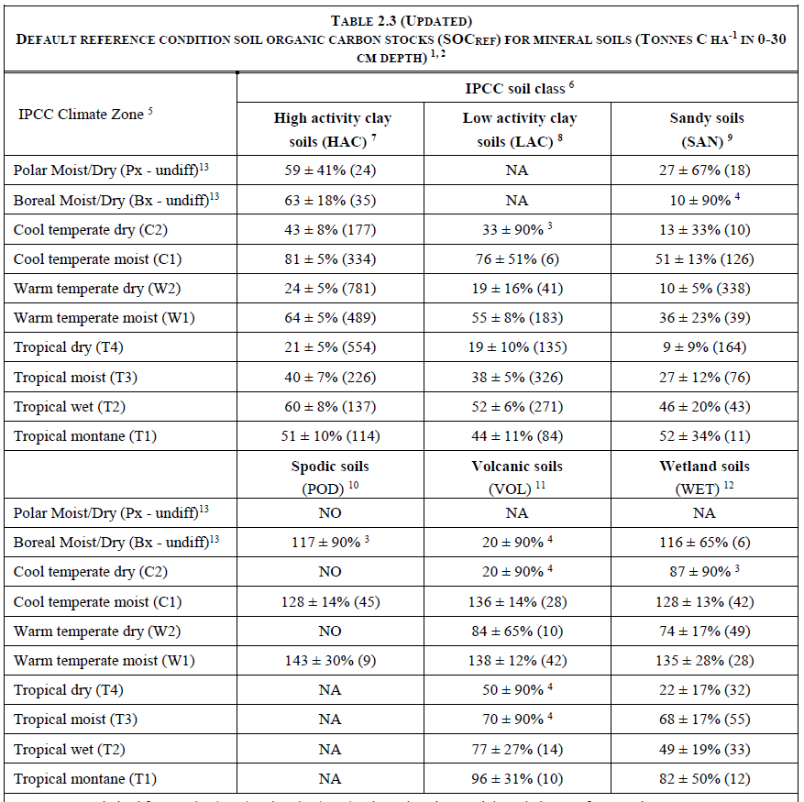
Source 2019 Refinement to the 2006 IPCC Guidelines for National Greenhouse Gas Inventories, Chapter 2: Generic Methodologies Applicable to Multiple Land-Use Categories

Table 2 Agricultural area management
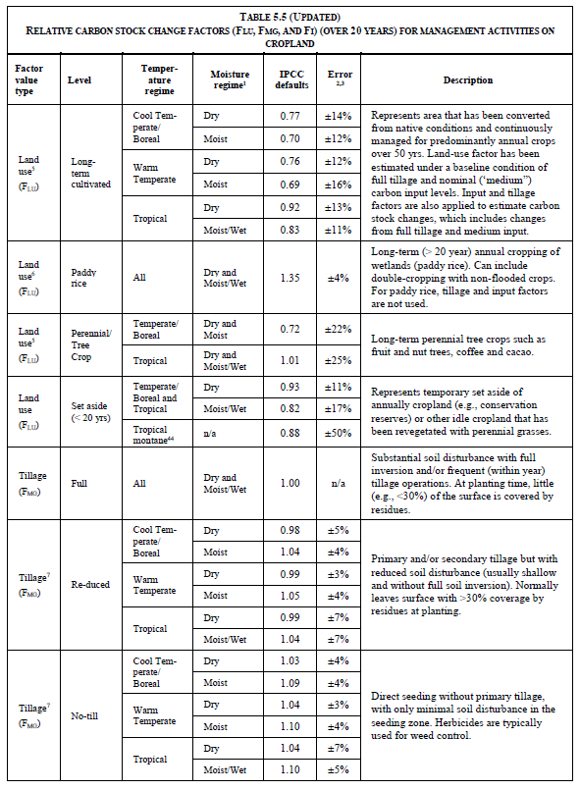
Table 2 Agricultural area management (continue)
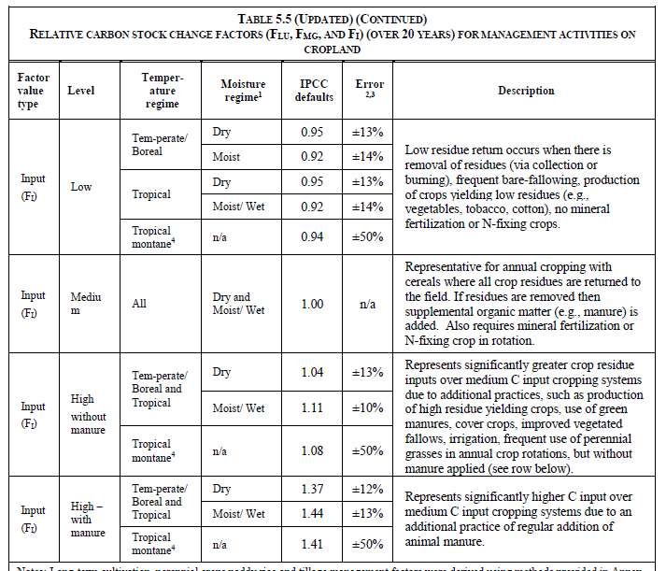
Source: 2019 Refinement to the 2006 IPCC Guidelines for National Greenhouse Gas Inventories, Chapter 5: Cropland

Document information

Version | Amendment | Entry into force | Description
01 | -- | 1 March 2023 | -

