T-VER-P-TOOL-01-04
Calculation for change in soil organic carbon stocks in forest project activities

Version 01

1. Introduction
This document is a tool for estimating changes in soil organic carbon stock in forest project activities, which can be used to estimate carbon stock in both baseline and project scenarios.

2. Relevant Definitions
Details appear in Annex 1

3. Characteristics of Relevant Activities and Conditions
This tool is suitable for estimating changes in soil organic carbon stock in the baseline and project scenarios in the areas of land with the following characteristics:
Areas of land where this tool can be used are:
(1) those are not wetlands; or
(2) those are not organic soils as defined in 2006 IPCC Guidelines (Vol. 4 Chapter 3).
(3) they must not be areas with land management and organic materials loading listed in Annex 2, Tables 1 and 2, especially activities with high organic carbon accumulation in soils such as tilling and/or adding organic material.
- Forest project activities must meet the following conditions:
(1) The litter must be left in the area and not removed in the project activities; and
(2) soil disturbances in accordance with project activities (if any)
a. Consistent with activities that can appropriately conserve soil, such as land contour
b. Limit soil disturbances from pre-planting site preparation and must not disturb the soil repeatedly at least 20 years

4. Hypothesis
This tool provides hypotheses to estimate changes in soil organic carbon stocks as follows:

- Area reparation and tree planting are carried out within 1 year.
- Project operations increase the soil organic carbon stock in the area, compared with soil organic carbon stocks before the project until the soil organic carbon stock was stable (steady-state).
- Increase in soil organic carbon stock when the project has been maintained at constant rate over a period of 20 years from the year of planting.

5. Calculation of carbon stock in soil
Project areas are classified by landscape (stratification) as per following conditions:
- Climatic zones and soil types (Appendix 2, Table 3)
- Land undergone land management for agriculture prior to project initiation as mentioned in Annex 2, Table 4.
- Land undergone area preparation for grassland prior to project initiation as mentioned in Annex 2, Table 4.
Changes in soil organic carbon stock collected from project implementation can be estimated through the following estimation methods:

Step 1 Estimation of soil organic carbon stock prior to project activities It can be estimated as the following equation.

Option 1 Soil organic carbon stocks of samples collected from the sample plots
Soil organic carbon stocks collected from sampling collection and analysis of carbon stock in soil and soil density from project area. The estimation details are shown in the following equation.

$${SOC}_{0,sp,i}={SOC}_{sample,sp,i} x {BD}_{sample,sp,i} x {Dep}_{sample,sp,i} x 0.16$$

Where:
$${SOC}_{0,sp,i}$$ | = | Soil organic carbon stock prior to the project start in the stratum i of sample plot sp in the project site (ton of carbon per rai)
$${SOC}_{sample,sp,i}$$ | = | Soil organic carbon stock of samples collected from sample plots sp in the stratum i (unit lab values for soil particles < 2 mm) (g carbon per 100 g soil)
$${BD}_{sample,sp,i}$$ | = | Soil density with particle size < 2 mm in sp sample plots in the stratum I (Laboratory value in Unit grams per cubic centimeter)
$${Dep}_{sample,sp,i}$$ | = | Depth of soil collected from sample plot sp in the stratum I (cm) (not less than 30 cm)
sp | = | Sample plot 1, 2, 3, …P_{i} in the stratum i
i | = | Stratum1, 2, 3, …
0.16 | = | Unit conversion cost (1 gram = 10-⁶ tons and 1 Rai = 1.6 x 107 square centimeters)

$${SOC}_{0,i} = \frac{\sum_{sp=1}^{Pi}{\left({SOC}_{0, sp,i}\right)}}{P_{i}}$$
Where:
$${SOC}_{0,i}$$ | = | Soil organic carbon stock prior to the start of the project in stratum i of the project site (Tons of carbon per rai)
$${SOC}_{0,sp,i}$$ | = | Soil organic carbon stock prior to the project start in the stratum i in sample plot sp of the project site (ton of carbon per Rai).
$$P_{i}$$ | = | Number of sample plots in the stratum i
sp | = | Sample plot 1, 2, 3, …P_{i} in the stratum i
i | = | Stratum 1, 2, 3, …

Option 2 The amount of carbon stored in the reference soil

$${SOC}_{0,i}={SOC}_{REF,0,i} x f_{LU,0,i} x f_{MG,0,i} x f_{I,0,i}$$
Where:
$${SOC}_{0,i}$$ | = | Soil organic carbon stock prior to the start of the project in the stratum i of the project site (Tons of carbon per พai)
$${SOC}_{REF,i}$$ | = | Soil organic carbon stock in the reference soil that is natural (e.g. unimproved not deteriorating and cover with indigenous flora) by climatic zone and soil type in landscape i (tons of carbon per rai)
$$f_{LU,0,i}$$ | = | Change coefficients for soil organic carbon stock by land use type before starting the project in stratum i
$$f_{MG,0,i}$$ | = | Change coefficient of soil organic carbon stock according to soil management method before starting the project in landscape i
$$f_{I,0,i}$$ | = | Change coefficient of soil organic carbon stock by level of organic matter returning to the soil before starting the project in stratum i
i | = | Stratum 1, 2, 3, …

Step 2 Estimation of loss of soil organic carbon stock from soil disturbance in the project site in larger area than baseline value (if any) or more than 10% of the stratum, such carbon loss from soil disturbance can be calculated as follow:

$${SOC}_{LOSS,i}={SOC}_{0,i} x 0.1$$

Other stratum with soil disturbances not more than 10% of the stratum can be determined as no loss of soil organic carbon stock or ${SOC}_{LOSS,i}=0$

Where:
$${SOC}_{LOSS,i}$$ | = | Loss of soil organic carbon stock from soil disturbance resulting from project activities in the i tier of the project site. (Tons of carbon per rai)
0.1 | = | The approximate proportion of SOC lost by soil disturbance
i | = | Stratum 1, 2, 3, …

Step 3 Estimation of soil organic carbon stock during project operation can be estimated as the following equation.

$${SOC}_{t,i}={SOC}_{REF,i} x f_{LU,t,i} x f_{MG,t,i} x f_{I,t,i}$$

Where:
$${SOC}_{t,i}$$ | = | Soil organic carbon stock when implementing the project in the stratum i of the project site (ton carbon per rai)
$${SOC}_{REF,i}$$ | = | Soil organic carbon stock in the reference soil that is natural (e.g. unimproved not deteriorating and cover with indigenous flora) by climatic zone and soil type in the terrain layer i (tons of carbon per rai)
$$f_{LU,t,i}$$ | = | Change coefficients for soil organic carbon stock by land use type when executing the project in stratum i (value determined is 1) referred to 2019 refinement to the 2006 IPCC guidelines for national greenhouse gas inventories: Volume 4
$$f_{MG,t,i}$$ | = | Change coefficients for soil organic carbon stock according to soil management method when executing the project in stratum i (value determined is 1) referred to 2019 refinement to the 2006 IPCC guidelines for national greenhouse gas inventories: Volume 4
$$f_{I,t,i}$$ | = | Change coefficients for soil organic carbon stock according to the level of reclaimed organic matter. when executing the project in stratum i (value determined is 1) referred to 2019 refinement to the 2006 IPCC guidelines for national greenhouse gas inventories: Volume 4
i | = | Stratum 1, 2, 3, …

Step 4 Estimation of the rate of change in soil organic carbon stock during project operation uses the change rate during project operation until the soil organic carbon stock is stable. Details of the estimation are shown as follows.

Soil was prepared and disturbed in previous years (t < t_{PREP})

$$d{SOC}_{t,i}={0 for t<t}_{PREP,i}$$

Year in which the soil in project site is prepared and disturbed (t = t_{PREP})

$$d{SOC}_{t,i}=-\frac{{SOC}_{LOSS,i}}{1 year}{for t=t}_{PREP,i}$$

At least for the period 20 years after project operations taking place with no soil disturbance or preparation (t_{PREP}< t ≤ t_{PREP}+20)

$$d{SOC}_{t,i}=\frac{{SOC}_{t,i}-({SOC}_{0,i}- {SOC}_{LOSS,i})}{20 years}{for t}_{PREP,i}<{t≤t}_{PREP,i}+20$$

When:
$$d{SOC}_{t,i}$$ | = | Rate of change in soil organic carbon stock in the stratum of the project site in year t (tons of carbon per rai per year).
$$t_{PREP,i}$$ | = | Year of the first soil disturbance in the stratum i of the project site.
$${SOC}_{LOSS,i}$$ | = | Soil organic carbon loss from soil disturbance resulting from project activities in stratum i of the project site (Tons of carbon per rai)
$${SOC}_{t,i}$$ | = | Soil organic carbon stock when the project is carried out in the i layer of the project area (tons of carbon per Rai) or equal to ${SOC}_{REF,i}$for forestry activities
$${SOC}_{0,i}$$ | = | Soil organic carbon stock before the start of the project in the i landscape of the project site (tons of carbon per rai)
$${SOC}_{REF,i}$$ | = | Soil organic carbon stock in natural reference soils (e.g. unimproved areas not deteriorating and cover with indigenous flora) in climatic zone and soil type in the i landscape (tons of carbon per rai)
i | = | Stratum 1, 2, 3, …
t | = | 1, 2, 3, … year from the project initiation

Considering the uncertainty and inherent limitation of the coefficient estimation accuracy used in this tool, they determine the rate of change in soil carbon stock which is valued less than 0.8 tons of carbon per rai or 0.128 tons of carbon per rai per year.
So, if estimated $d{SOC}_{t,i}>$0.128 tons of carbon per rai in a yar, the project must use $d{SOC}_{t,i}=$0.128 tons of carbon per rai per year.
Step 5 Change in soil organic carbon stock for all stratum of the project in year t can be estimated as follows:

$∆{SOC}_{AL,t}= \sum_{i}^{n}{A_{i}}x d{SOC}_{t,i} x \frac{44}{12} x 1 year$

Where:
$$∆{SOC}_{AL,t}$$ | = | Changes in soil organic carbon stock for all stratum of the project site in year t (tons of carbon dioxide equivalent per year).
$$A_{i}$$ | = | Project area in stratum i (rai)
$$d{SOC}_{t,i}$$ | = | Rate of change in soil organic carbon stock in the stratum i of the project site in year t (tons of carbon per rai per year).
i | = | Stratum 1, 2, 3, …
44/12 | = | Carbon dioxide to carbon molecular mass ratio

6. Relevant Parameters

6.1 Parameter not required monitoring
Parameter | $${SOC}_{REF,i}$$
Unit | tons of carbon per rai
Definition | Soil organic carbon stock in the reference soil
Source of Information | Option 1 2019 refinement to the 2006 IPCC guidelines for national greenhouse gas inventories: Volume 4 Agriculture, Forestry and Other Land Use  Option 2 as specified by the TAO in the reference manual for the development of the Voluntary Greenhouse Gas Reduction Project according to the standards of Thailand Forestry and Agriculture  Option 3 Values derived from research published in academic papers that are recognized and identifiable as appropriate for the project area.
Remark | -

Parameter | $$F_{LU}$$
Unit | -
Definition | Coefficient of soil organic carbon stock according to land use
Source of Information | Option 1 2019 Refinement to the 2006 IPCC guidelines for national greenhouse gas inventories: Volume 4Agriculture, Forestry and Other Land Use (except for coefficients for activities with high soil carbon accumulation)  Option 2 Values derived from research published in academic papers that are recognized and identifiable as appropriate for the project area.  Option 3 Collect samples from the project area to develop the values as specified by the TGO.
Remark | ⁻

Parameter | $$F_{MG}$$
Unit | -
Definition | Coefficient of change soil organic carbon stock according to soil management method
Source of Information | Option 1 2019 refinement to the 2006 IPCC guidelines for national greenhouse gas inventories: Volume 4Agriculture, Forestry and Other Land Use (except for coefficients for activities with high soil carbon accumulation)  Option 2 Values derived from research published in academic papers that are recognized and identifiable as appropriate for the project area.  Option 3 Collect samples from the project area to develop the values as specified by the TGO
Remark | ⁻

Parameter | $$F_{I}$$
Unit | -
Definition | Coefficient of change soil organic carbon stock according to the level of reclaimed organic matter
Source of Information | Option 1 2019 refinement to the 2006 IPCC guidelines for national greenhouse gas inventories: Volume 4Agriculture, Forestry and Other Land Use (excluding coefficients for activities with high soil carbon accumulation)  Option 2 Values derived from research published in academic papers that are recognized and identifiable as appropriate for the project area.  Option 3 Collect samples from the project area to develop the values as specified by the TGO
Remark | -

Parameter | 44/12
Unit | -
รายละเอียด | molecular mass of carbon dioxide to carbon to convert unit from tons of carbon to tons of carbon dioxide
Source of Information | IPCC Guideline
Remark | -

6.2 Parameter required monitoring
Parameter | $$A$$
Unit | Rai
Definition | All project areas
Source of Information | - Land exploration  - Use satellite/aerial imagery.
Frequency of monitoring | Following a cycle of follow-up assessments for certification
Remark | -

Parameter | $${SOC}_{sample,sp,i}$$
Unit | gram carbon per 100-gram soil (soil particles < 2 mm)
Definition | Samples of soil organic carbon stock collected and reported in gram unit of carbon per 100 g of soil
Source of Information | Samples were collected from the project area and analyzed for soil carbon content in the laboratory to determine the soil organic carbon stock prior to project initiation (SOC_{0,i})
Frequency of monitoring | Following a cycle of follow-up assessments for certification
Remark | -

Parameter | $${BD}_{sample,sp,i}$$
Unit | grams per cubic centimeter
Definition | Soil density with particle size < 2 mm per unit volume. and required to report the values by dry weight
Source of Information | Samples were collected from the project site and analyzed for soil density in the laboratory to determine the amount of soil carbon deposition prior to the start of the project (SOC0,i)
Frequency of monitoring | Following a cycle of follow-up assessments for certification
Remark | -

Parameter | $${Dep}_{sample,sp,i}$$
Unit | centimeter
Definition | Depth of soil
Source of Information | Collect data from the project area to determine the soil organic carbon stock prior to the start of the project (SOC0,i)
Frequency of monitoring | Following a cycle of follow-up assessments for certification
Remark | -

7. References
- Clean Development Mechanism (CDM)
Tool for estimation of change in soil organic carbon stocks due to the implementation of A/R CDM project activities (Version 01.1.0)
- 2006 IPCC Guidelines for National Greenhouse Gas Inventories: Volume 4 Agriculture, Forestry and Other Land Use

Annex

Annex 1 Relevant Definitions
Soil disturbance | Human activities that result in the release of soil organic carbon stock to the atmosphere, such as tilling, digging, raking, trenching, drainage, etc.
Soil carbon | Decomposition of organic matter that accumulates in soil to form organic carbon.
Soil | Natural objects that cover the earth's surface are thin, formed as a result of the transformation or decay of rocks and minerals and organic matter mixed together with the following components  Inorganic matter (mineral matter) is the portion of minerals within a rock that has been eroded into tiny pieces. by physical, chemical and biological methods  Organic matter is the decaying, decaying or decomposing part of plant and animal remains that are deposited together.  Water is water in solution which is found in the gap between the soil or soil particles  Air is a gas that lies in the space between soil grains or soil particles. The most common gases found in soil are nitrogen, oxygen, and carbon dioxide.
Organic soils | Organic soil is Soil with various characteristics as specified by FAO, which must have the characteristics in items 1 and 2 or items 1 and 3 as follows:  (1) having a thickness of 10 cm or more The soil layer is <20 cm thick and must contain at least 12% organic carbon in the soil when the soil is mixed to a depth of 20 cm.  (2) In case the soil has not been saturated with water for more than 2-3 days and has soil organic carbon >20% by weight (approximately 35% soil organic matter).  (3) In case the soil is saturated with water and  (i) at least 12% by weight of soil organic carbon (containing soil organic matter  about 20%) if there is no clay ore, or  (ii) at least 18% by weight of soil organic carbon (containing soil organic matter about 30%), if it contains 60% or more of clay minerals, or  (iii) Carbon containment in soil at median level and at median level for clay minerals  Area data should be classified by climatic zone, namely temperate and tropical. and classified according to soil fertility for temperate forest areas. Organic land area data may be compiled from official country statistics. or the organic land area of each country as reported by the FAO (http://faostat.fao.org/)  Source: 2006 IPCC Guidelines (Vol. 4 Chapter 3)
Wetlands | The Ramsar Convention or the Convention on Wetlands (Article 1.1 and Article 2.1) has defined “Wetlands” as lowlands, lowlands, wet areas, swamps, bodies of water, both natural and man-made. Either with waterlogging or Floods are permanent and temporary. both as a source of still and running water Both freshwater, brackish and saltwater, including the coast and inland areas where when the tide is the lowest with a depth of not more than 6 m.

Annex 2 Land Management
Table 1 Land management area
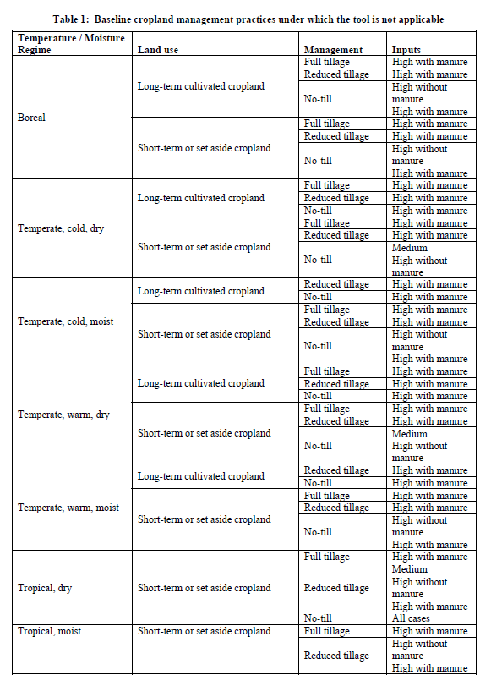
Table 1 Land Management Area (cont.)
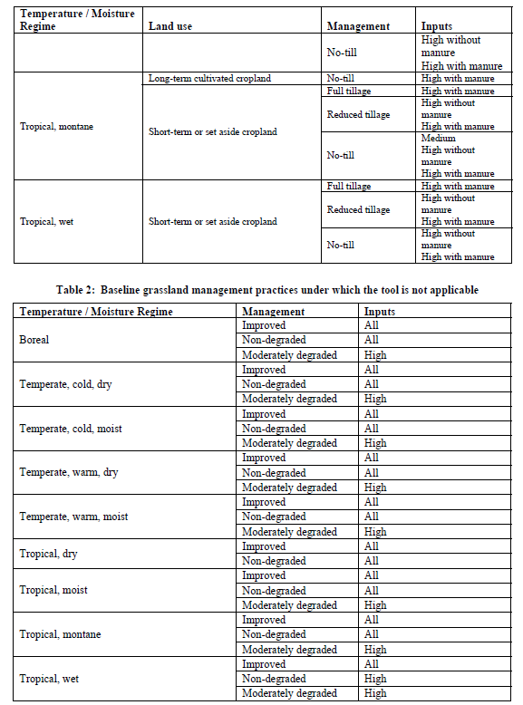
Table 2 Land containing the following organic materials

Table 3 SOC classified by climate zone and soil type
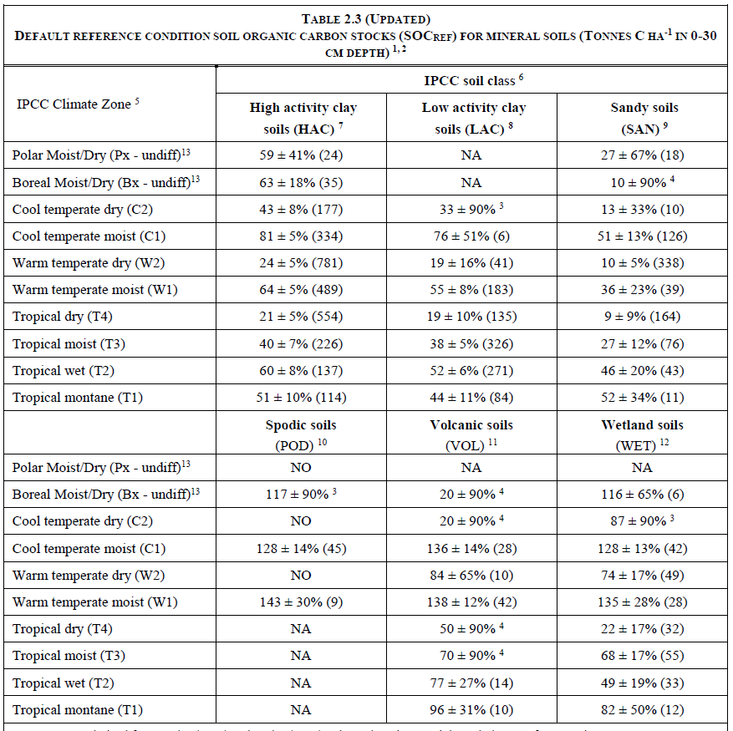
Source: 2019 Refinement to the 2006 IPCC Guidelines for National Greenhouse Gas Inventories, Chapter 2: Generic Methodologies Applicable to Multiple Land-Use Categories

Table 4 Agricultural Land Management
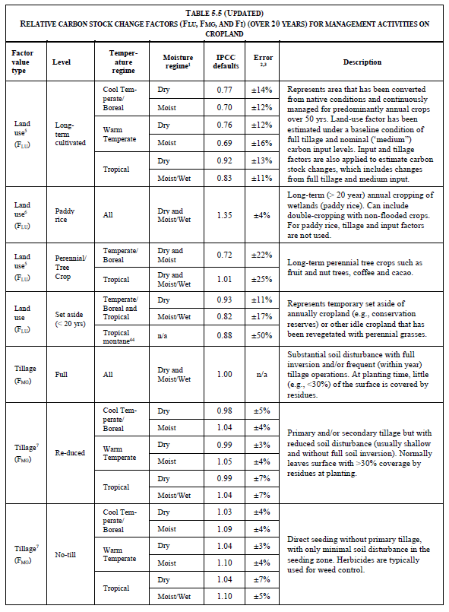

Table 4 Agricultural Land Management (cont.)
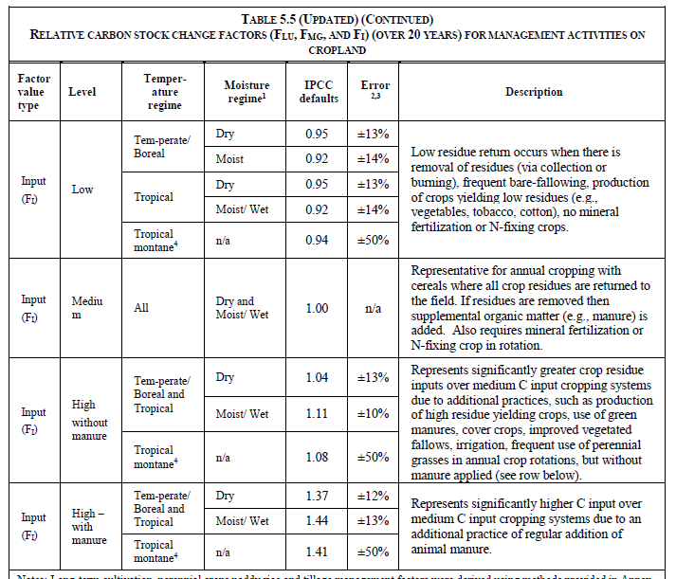
Source: 2019 Refinement to the 2006 IPCC Guidelines for National Greenhouse Gas Inventories, Chapter 5: Clopland

Document information

Version | Amendment | Entry into force | Description
01 | -- | 1 March 2023 | -

