T-VER-P-TOOL-01-13
Calculation for methane emission reduction by adjusted water management practice in rice cultivation

Version 01

1. Introduction
This document is a tool for assessing the reduction of methane emissions from the project's rice cultivations. This can be used to calculate methane emissions from rice cultivation areas in both the bassline and project scenarios under the adjusted water management practice in rice cultivation activities.

2. Relevant definitions
Details appear in Annex 1

3. Characteristics of activities and use conditions
This tool is suitable for calculating the reduction of methane emissions from rice cultivation areas in baseline and project scenarios of the following areas:
- This tool can be used in the area where one of the following actions is performed.
- Rice farms with continuously flood condition in the form of intermittent flood condition and/or reduction of flood condition
- Rice farms with alternate wetting and drying condition and aerobic rice cultivation
- Rice farms with transplanting condition for direct seeding
- Project activities must meet the following conditions:
- The rice cultivation area of the project is irrigated flooded fields and do not cover rainfed, deep water, or upland rice fields that are determined from the survey of the geographical region proposed by the project developer, or by using national data, along with the details of the pre-season water regime and the insertion of organic material for the base case determination.
- The rice cultivation area of the project uses controlled irrigation and drainage equipment or tools to control water in both the rainy and dry seasons.
- Project activities shall not cause a reduction in rice yields beyond the requirements of the method and there is no need to modify the rice varieties planted
- The project must provide training and technical support to the farmers implementing the project especially the area preparation, watering, drainage and fertilizer application and provide documentary evidence of implementation. Project developers must ensure that farmers have the criteria to assess the appropriate amount of nitrogen fertilizer application by using scientific tools such as the use of leaf color charts or recommendations from government agencies or appropriate reference documents with supporting evidence.
- The project developer must demonstrate that the methane reduction activities in the rice cultivation area are not undertaken by the unit's requirements.
- If the assessment is carried out using the default value approach from the rice cultivation area that is measured by the representative area of the project The measurement method must be made using a closed chamber method and analyzed in a laboratory.
- Project activities must specify details of rice cultivation patterns for baseline and project scenarios. Table 1 shows the cultivation patterns for reference.

Table 1 Details of rice cultivation patterns for base cases and project implementation cases
Parameter | Typeª | Category/Value | Information Sources/Methods
Water management style (on-season) | Dynamic | Continuously flooded  Single Drainage  Multiple Drainage | Baseline: Farmer’s information Project: Monitoring
Water management model (pre-season) | Dynamic | Flooded  Short drainage, less than 180 days  Long drained, more than 180 days | Baseline: Farmer’s information Project: Monitoring
Organic Amendment | Dynamic | Straw on-season^{b}  Straw off-season^{b}  Green manure  Farm yard manure  Compost  No organic amendment | Baseline: Farmer’s information Project: Monitoring
Soil pH | Static | <4.5  4.5-5.5  >5.5 | ISRIC-WISE soil property database or national data
Soil Organic carbon (SOC) | Static | <1%  1-3%  >3% | ISRIC-WISE soil property database or national data
Climate | Static | Agroecological zones: AEZ | Data based on Rice Almanac (2002) or HarvestChoice. or according to the recognized area classification in the country
Remark:
ª Dynamic conditions are those that are linked to the activity in the plot, thus causing changes over time and need to follow up Static conditions are parameters specific to the area in determining soil characteristics. and does not change over time therefore measure or report the value only once
^{b} Straw on-season insertion is where the straw that has been left in the soil and that has been plowed into the soil and the rice is planted immediately. This is done within 30 days before rice cultivation. Straw off-season is the use of rice straw in the previous growing season. by doing this for more than 30 days before rice cultivation.
In this regard, the project developer must record the general details of the farmers in the participating rice cultivation areas. The project developer must also report on the details of various cultivation activities, including the day of rice cultivation, the day and the amount of fertilization and the use of organic materials, date and amount of pesticide applied each day, water management system, and rice production by referring to standard reporting formats.

4. Calculation of methane emission reduction from rice cultivation area
Decreasing methane emissions from rice cultivation areas participating in the project implementation, there is an alternative assessment method by using the methane emission coefficient from rice cultivation as follows:

Option 1: The default value approach from the rice cultivation area that is measured by the representative area of the project
Step 1: Calculation of methane emissions from rice cultivation areas in the baseline scenarios can be calculated as the following equation

$${{CH}_{4}soil}_{BSL,t} =\sum_{s}{{{CH}_{4}soil}_{BSL,s}}$$
$${{CH}_{4}soil}_{BSL,s} ={\sum_{g=1}^{G}{EF_{BSL,s,g}}x A_{s,g} x {10}^{-3} x GWP}_{CH4}$$
Where:
${{CH}_{4}soil}_{BSL,t}$ Methane emissions from rice cultivation in the baseline in year t (tons of carbon dioxide equivalent)
${{CH}_{4}soil}_{BSL,s}$ Methane emissions from rice cultivation in the baseline for the growing season s (tons of CO₂ equivalent)
${EF}_{BSL,s,g}$ The methane emission factor from rice cultivation in the baseline of the g pattern for the growing season s (kg methane per Rai per growing season) was measured in the representative area of ​​the project by the enclosed chamber method. Closed chambers throughout the rice growing season had at least 3 replicates for each cultivation pattern (Table 1), and the methane emission factor was used as the mean of the repeats measured
$A_{s,g}$ The rice cultivation area of ​​the project in g pattern for the growing season s (rai)
${GWP}_{CH4}$ Global warming potential of methane
$g$ Cultivation patterns 1,2,3,... must cover all project field
$s$ Growing season

Step 2: Calculation of methane emissions from rice cultivation areas in project scenarios can be calculated as the following equation:

$${{CH}_{4}soil}_{PROJ,t} =\sum_{s}{{{CH}_{4}soil}_{PROJ,s}}$$
$${{CH}_{4}soil}_{PROJ,s} ={\sum_{g=1}^{G}{EF_{PROJ,s,g}}x A_{s,g} x {10}^{-3} x GWP}_{CH4}$$
Where:
${{CH}_{4}soil}_{PROJ,t}$ Methane emissions from rice cultivation in project implementation in year t (tons of carbon dioxide equivalent)
${{CH}_{4}soil}_{PROJ,s}$ Methane emissions from rice cultivation in project implementation for s growing season (tons of carbon dioxide equivalent)
${EF}_{PROJ,s,g}$ The methane emission factor from rice cultivation in project implementation of the g pattern for the growing season s (kg methane per rai per growing season) was measured in the representative area of ​​the project by the chamber method. Closed chamber throughout the rice growing season with at least 3 repetitions for each cultivation pattern, and the methane emission factor used as the mean of the number of repeats measured.
$A_{s,g}$ The rice cultivation area of ​​the project in g pattern for the growing season s (Rai)
${GWP}_{CH4}$ Global warming potential of methane
$g$ Cultivation patterns 1,2,3,... must cover all project field
$s$ Growing season
Step 3: Calculate methane emission reduction from the rice cultivation area from the project scenarios can be calculated as the following equation
$${{CH}_{4}soil}_{ER,t} ={{CH}_{4}soil}_{BSL,t}-{{CH}_{4}soil}_{PROJ,t}$$
Where:
${{CH}_{4}soil}_{ER,t}$ Project methane emission reduction in year t (tons of carbon dioxide equivalent)
${{CH}_{4}soil}_{BSL,t}$ Methane emissions from rice cultivation in the baseline in year t (tons of carbon dioxide equivalent)
${{CH}_{4}soil}_{PROJ,t}$ Methane emissions from rice cultivation in project implementations in year t (tons of carbon dioxide equivalent)

Option 2: Recommended emission factor for rice cultivation
$${{CH}_{4}soil}_{ER,t} ={EF}_{ER} x A_{t} x L_{t} x {10}^{-3}{ x GWP}_{CH4}$$
$${EF}_{ER} ={EF}_{BSL}-{EF}_{PROJ}$$
In case of organic materials used
$${EF}_{BSL} ={EF}_{BSL,c} x {SF}_{BSL,w} x {SF}_{BSL,p} x {SF}_{BSL,o}$$
$${EF}_{PROJ} ={EF}_{BSL,c} x {SF}_{PROJ,w} x {SF}_{PROJ,p} x {SF}_{PROJ,o}$$
In the case of no organic materials used
$${EF}_{BSL} ={EF}_{BSL,c} x {SF}_{BSL,w} x {SF}_{BSL,p}$$
$${EF}_{PROJ} ={EF}_{BSL,c} x {SF}_{PROJ,w} x {SF}_{PROJ,p}$$
Where:
${{CH}_{4}soil}_{ER,t}$ Methane emission reduction decreased in year t of the project (tons of carbon dioxide equivalent)
${EF}_{ER}$ Methane emission factor decreased from rice cultivation in project implementation (Kg Methane Gas per Rai per Day or Kg Methane Gas per Rai per Growing Season)
${EF}_{BSL}$ The methane emission factor from rice cultivation in the baseline (Kg Methane Gas per Rai per Day or Kg Methane Gas per Rai per Growing Season)
${EF}_{PROJ}$ Methane emission factor from rice cultivation in project implementation (Kg Methane Gas per Rai per Day or Kg Methane Gas per Rai per Growing Season)
${EF}_{BSL,c}$ Methane emission factor rice cultivation as continuously flooded on the growing season without organic material in the baseline (kg of methane per Rai per Day or kg of methane per Rai per growing season) with 2 alternatives to use the values ​​as follows: (1) the value obtained from the measurement in the representative area of ​​the project by the closed chamber method throughout the rice growing season, there are at least 3 repetitions for each cultivation pattern and the methane emission coefficient used as the mean of the repeat counts, and (2) the IPCC guideline (Annex 2) recommended value
${SF}_{BSL,w} or {SF}_{PROJ,w}$ Adjustment for water management patterns during the growing season in rice cultivation areas in the baseline or project implementation (Annex 2)
${SF}_{BSL,p} or {SF}_{PROJ,p}$ Adjustment for pre-season continuously flooded patterns in rice cultivation areas in the baseline or project implementation (Annex 2)
${SF}_{BSL,o} or {SF}_{PROJ,o}$ Adjustment for organic material in rice cultivation area in baseline or project implementation by calculating from the following equation

$${SF}_{o}={\left(1+\sum_{ⅈ}{{ROA}_{i} x {CFOA}_{i}}\right)}^{0⋅59}$$

Where:
${ROA}_{i}$ Application rate of organic material type i (tons per rai by dry weight for straw and fresh weight for other materials)
${CFOA}_{i}$ Conversion factor for organic material type i (compared with short-term straw applied) before cultivation (Annex 2)
$A_{t}$ Rice cultivation area of ​​the project in year t (rai)
$L_{t}$ Project rice cultivation period in year t (Day) (use only methane emission factor ที่เป็นหน่วยวัน)
${GWP}_{CH4}$ Global warming potential of methane

5. Relevant Parameters

5.1 Parameter does not require monitoring
Parameter | $${SF}_{BSL,w} or {SF}_{PROJ,w}$$
Unit | -
Definition | Adjustment for water management patterns during the growing season in the rice cultivation area in the baseline or project implementation/scenario
Source of information | Recommended values according to the IPCC (Annex 2)
Remark | -

Parameter | $${SF}_{BSL,p} or {SF}_{PROJ,p}$$
Unit | -
Definition | Modifier for pre-season water management in rice cultivation area in baseline or project implementation/scenario
Source of information | Recommended values according to the IPCC (Annex 2)
Remark | -

Parameter | $$CFOA$$
Unit | -
Definition | Conversion factor for organic materials applied (compared to the short-term application of straw before cultivation)
Source of information | Recommended values according to the IPCC (Annex 2)
Remark | -

5.2 Parameter required monitoring
Option 1: The default value approach from the rice cultivation area that is measured by the representative area of the project
Parameter | $${EF}_{BSL,s,g}$$
Unit | kg of methane per rai per growing season
Definition | Methane emission factor in baseline
Source of information | Methane gas samples were collected from the project's rice cultivation using IPCC-compliant method
Frequency of monitoring | Samples were collected by closed chamber method and reported the ƒGHG emission per growing season
Remark | -

Parameter | $${EF}_{PROJ,s,g}$$
Unit | kg of methane per rai per growing season
Definition | Methane emission factor in case of project implementation/scenario
Source of information | Methane gas samples were collected from the project's rice cultivation using IPCC-compliant method
Frequency of monitoring | Samples were collected by closed chamber method and reported the GHG emissions per growing season
Remark | -

Parameter | $$A_{s,g}$$
Unit | Rai
Definition | Sum of project area in s growing season s in the pattren of g
Source of information | - Area exploration using GPS  - Use satellite/aerial imagery
Frequency of monitoring | report in annual basis
Remark | -

Option 2: Recommended emission factor for rice cultivation
Parameter | $${EF}_{BSL,c}$$
Unit | Kilograms of methane gas per rai per day or kilograms of methane gas per rai per growing season
Definition | Methane emission factor for continuously flooded fields without organic without organic material
Source of information | Option 1: Collect methane gas samples from the project's rice cultivation area using IPCC-compliant methods.  Option 2. Using IPCC recommended values
Frequency of monitoring | Calculate the value before starting the project or yearly monitor
Remark | -

Parameter | $$A_{t}$$
Unit | Rai
Definition | The rice cultivation areas of the project in year t
Source of information | - Area exploration using GPS  - Use satellite/aerial imagery
Frequency of monitoring | report in annual basis
Remark | -

Parameter | $$L_{t}$$
Unit | Day
Definition | The rice cultivation period of the project in year t
Source of information | Explore the area, such as a rice planting diary
Frequency of monitoring | Report in annual basis
Remark | Used in conjunction with the methane emission factor from the unit of rice in cultivation season

6. Reference Documents
- Clean Development Mechanism (CDM) Small-scale methodology: AMS-III.AU. Methane emission reduction by adjusted water management practice in rice cultivation (Version 04.0), 2014.
- 2006 IPCC Guidelines for National Greenhouse Gas Inventories: Volume 4 Agriculture, Forestry and Other Land Use
- 2019 Refinement to the 2006 IPCC Guidelines for National Greenhouse Gas Inventories
Annex

Annex 1 Relevant Definition
Term | Definition
Soil carbon | Decomposition of organic matter that accumulates in soil to form organic carbon
Transplanted rice | The rice is planted with seeds in the seedling plots for about 20-30 days, then the seedlings are planted in the continuously flooded rice fields
Direct seeded rice | Rice cultivation that is sown or germinated rice (Pre-germinated) directly in the cultivation plots in both continuously flooded or dry conditions
Project cultivation practice | It is an activity according to the requirements of the tool by focusing on water management in rice cultivation areas, site preparation, fertilization and pest management as an alternative to the action
Water regime | It is a rice cultivation pattern that considers both the ecosystem type, such as irrigation and rainwater, and according to the flooding pattern, such as continuously flooded throughout the season such as intermittent flooded
Upland rice | The main rice cultivation without flooded
Irrigated rice | The main rice cultivation is flooding and there is a system or management to control the water in the field
Rainfed and deep-water rice | The main rice cultivation is flooding and the water regime of the area depends solely on rainwater

Annex 2 Methane emission coefficient from rice cultivation , rice cultivation period and various modifiers
Reference to 2019 Refinement to the 2006 IPCC Guidelines for National Greenhouse Gas Inventories
  - Methane emission factor for continuously flooded fields without organic amendments (${EF}_{bsl,c}$)
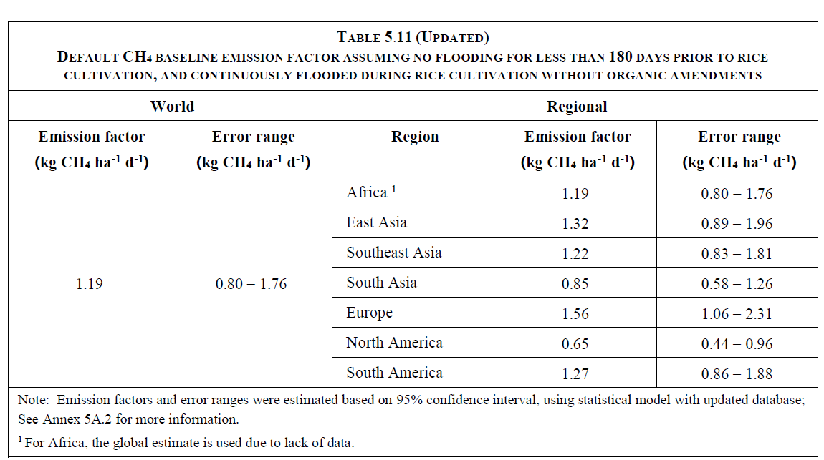
Remark: Applying value conversion unit to kg of methane per rai per day, where 1 hectare equals 6.25 rais
2.2 Modifiers for water management patterns during the growing season in rice cultivation (${SF}_{bsl,w} or {SF}_{proj,w}$)
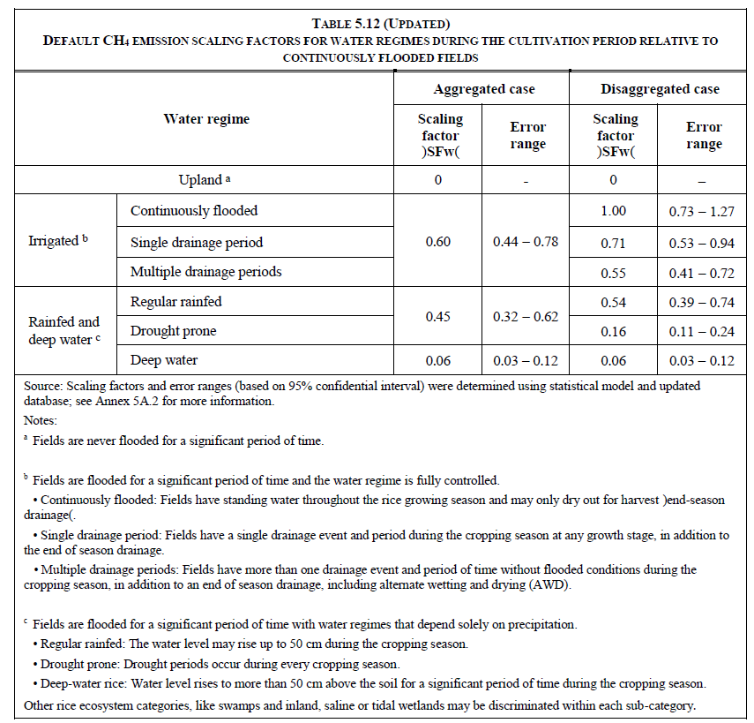

2.3 Modifiers for water management prior to the rice cultivation (${SF}_{bsl,p} or {SF}_{proj,p}$)
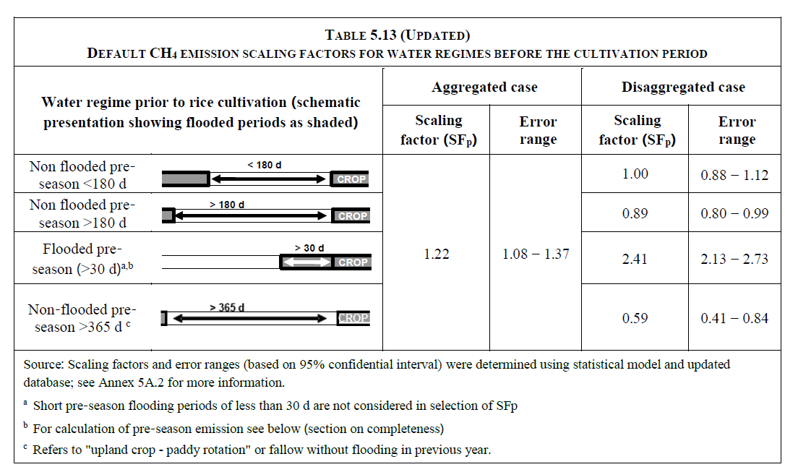

2.4 Conversion Factor for Organic Amendment (CFOA)
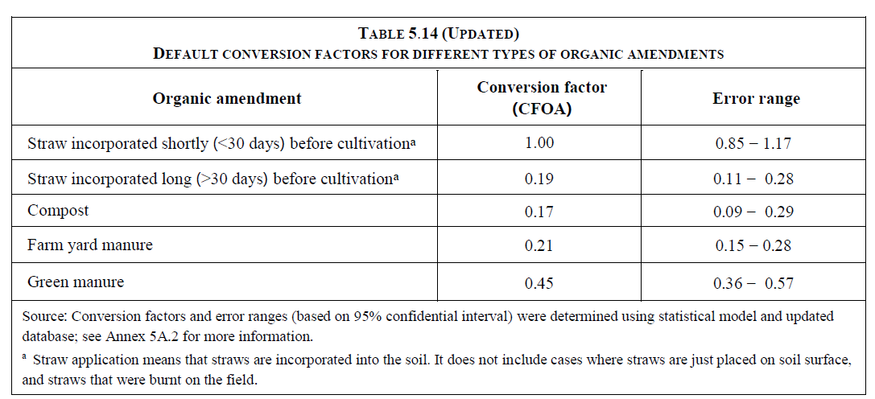

Annex 3 Guidelines for measuring methane emissions from rice cultivation areas
Operational requirements
- Measurement of methane emissions from rice cultivations must be controlled or consulted by professionals who have experience collecting gas samples in the field or trained.
- Project developers must prepare laboratory sampling plan and analysis. To obtain methane emission coefficient from rice cultivation area before the growing season, there are important contents such as the determination of the rice cultivation representative area of ​​the project, including climate, soil type, water management, rice and other crops as well as fertilization and organic materials used for rice cultivation schedule and gas sampling including sample analysis
- Details of the installation of gas sample storage chamber are shown below.
Topic | Details
Materials used for making sample chambers | Option 1: Using an opaque material  • Made of PVC plastic or from factory materials such as galvanized steel or galvanized steel.  • Make white or a substance that helps reflect light.  • Suitable for short-term sampling. Typically about 30 minutes. | Option 2: Using a Translucent Material  • Made of acrylic material.  • The advantage of a translucent chamber is that it has a lid that can be opened and closed. The chamber can be left in the plot longer.
Installation in soil | Option 1: A base that is fixed to the area.  • The base is made of non-rusting material and can be left in the field throughout the growing season.  • Must cover the chamber with rust. and does not allow air to enter and exit  • Drill holes in the base to allow water exchange in the interior and exterior of the base.  • Must be installed at least 24 hours before the first gas sample collection. | Option 2: No Base  • Gas storage chambers placed on the ground and open the lid of the chamber for ventilation
Auxiliary material | • Install an air temperature gauge or device inside the chamber.  Gas sampling point Using rubber stoppers to open and close the sampling point
Base shape | Round or rectangular shape that must cover an area of at least 4 rice stalks or at least 0.1 square meters in size
Chamber height | Option 1: Fixed Height  • not less than the height of the rice plant | Option 2: Adjustable Height  • Height can be adjusted according to the rice plant.  • There are chambers according to different heights

- รายละเอียดการเก็บตัวอย่างก๊าซ
Topic | Details
Number of duplicates per plot | At least 3 duplicates per plot
Number of gas samples per chamber per measurement | At least 3 samples per chamber at a time
Sampling collection period | 30 minutes
Time of sampling collection | Morning
Sampling frequency | At least once a week throughout the rice growing season (Begin cultivation rice until before harvesting rice)
Gas storage tube | It is in a suitable condition for use, i.e. the sample is well collected and does not leak. However, the condition must be checked before use. and use equipment that controls gas storage for ease of use
Sample retention | • Sample analysis within 24 hours. Samples can be stored in gas collection tubes  • Sample analysis for more than 24 hours, gas samples must be collected in vacuum flasks and stored at slightly higher than normal pressure (slight overpressure)

- Details of gas sample analysis
Topic | Details
Measurement method | Gas Chromatograph and use a Flame ionization detector (FID) as a measuring device
Gas injection | Direct injection or use Multi-port valve and Sample loop
Column | Packed or Capillary columns
Calibration | Standard gas samples were analyzed before and after each day of sample analysis

• Method for calculating methane emission rate from rice cultivation area as shown in the following equation
$$m_{CH4,t}=C_{CH4,t} x V_{chamber} x M_{CH4} x \frac{1 atm}{R x T_{t} x 1000}$$
$$s=\frac{Δm_{CH4}}{Δt}$$
$${RE}_{ch}=s x \frac{60 min}{A_{chamber}}$$
$${RE}_{plot}=\frac{\sum{{RE}_{ch}}}{N_{ch}}$$
Where:
$m_{CH4,t}$ Mass of methane in the chamber at time t (mg)
$t$ Point of time of sample (e.g. 0, 15, 30 minutes)
$C_{CH4,t}$ Methane concentration in chamber at time t from the sample analysis (parts per million)
$V_{chamber}$ Chamber volume (liters)
$M_{CH4}$ Molecular mass of methane (16 g/mol)
$1 atm$ Atmospheric pressure (set a constant value of 1 atmosphere or have a measuring device installed inside the chamber)
$R$ Gas constant (defined as 0.08206 L/Kelvin/mol)
$T_{t}$ Temperature at time t (Kelvin)
$s$ The slope of the linear showing relationship between gas concentration and time (value from calculation)
${RE}_{ch}$ Emission rate of chamber (milligrams per square meter height)
$ch$ Chamber 1, 2, 3, … on a the plot
$A_{chamber}$ Cross-sectional area of the chamber (square meter)
${RE}_{plot}$ Average emission rate from a plot (milligrams per square meter height)
$N_{ch}$ Number of chambers in the plot

- Once the average methane emission rate per rice cultivation area is obtained, calculate the amount of methane emissions throughout the rice growing season. For calculating the amount of emissions in each sampling period, we use the total amount of emissions throughout the growing season and report in unit of milligrams per square meter or unit of kilograms per rai.
Document information

Version | Amendment | Entry into force | Description
01 | -- | 1 March 2023 | -

