T-VER-P-TOOL-01-06

Estimation of the increase in GHG emissions attributable to displacement of pre-project agricultural activities in forest project activities

Version 01

1. Introduction
This tool is used for estimation of the increase in GHG emissions attributable to displacement of pre-project agricultural activities in forest project activities. This tool can be used to estimate greenhouse gas emissions in both baseline and project scenarios.

2. Relevant Definition
Details appear in Annex 1

3. Characteristics of relevant activities and conditions
This tool is suitable for estimating the release of leakage emissions if project activities invade into new areas such as farming, setting up residency, and other activities by their nature and fall within the scope (Applicability) and conditions of implementation in accordance with the forestry project characteristics and conditions.

4. Estimation steps
Leakage Emission calculation methods follow the estimation of the increase in GHG emissions attributable to displacement of pre-project agricultural activities in A/R CDM project activity).
Leakage emissions caused by the displacement of agricultural activities and invasion into new areas will be calculated from reductions in carbon sequestration in carbon reservoirs affected by project boundary activities:
- The displacement of agricultural activities alone does not leakage, but if the displacement of agricultural activities leads to higher greenhouse gas emissions compared to those activities in the project area, the leakage emissions must be assessed.
- Leakage emission causes indirect impacts (such as changes in demand-supply and the price of goods) from project activities in the project scope and are considered insignificant. Therefore, the leakage emission is equivalent to zero.

Steps for leakage emission estimation are as follow:
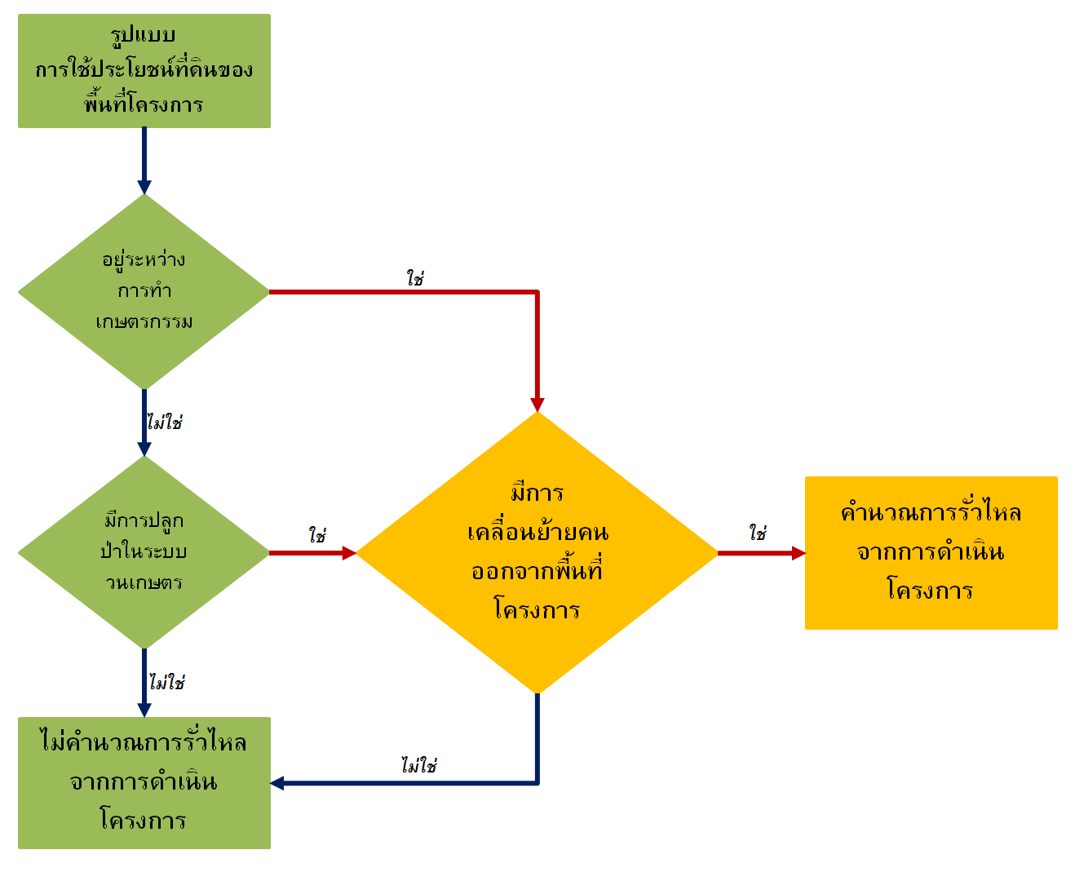
Patterns of land use in project area
Calculation of leakage from project operations
Migration of people out of project area
No
No
No
Yes
Yes
Yes
Planting in the agroforestry system
Under farming process
Calculation of leakages from project operations
The leakage emissions can be estimated as per EQUATION (1)-(3):
${LK}_{AGR,t}=\frac{44}{12}×\left({∆C}_{BIOMASS,t}+{∆SOC}_{LUC,t}\right)$ EQUATION (1)
${∆C}_{BIOMASS,t}=\left[1.1×b_{TREE_ABG}×\left(1+R_{TREE}\right)+b_{SAP_ABG}×\left(1+R_{SAP}\right)\right]×CF×A_{DISP,t}$
EQUATION (2)
$${∆SOC}_{LUC,t}={SOC}_{REF}×\left(f_{LUP}×f_{MGP}×f_{INP}-f_{LUD}×f_{FGD}×f_{IND}\right)×A_{DISP,t}$$
EQUATION (3)
Where
$${LK}_{AGR,t}$$ | = | Leakage due to the displacement of agricultural activities from project activities in year t (tons of carbon dioxide equivalent)
$${∆C}_{BIOMASS,t}$$ | = | Changes in carbon stock in carbo outside project boundaries affected by project activities in year t (carbon tons).  The number 1.1 is a constant used to calculate the total biomass of dead wood and plant waste as a percentage relative to the tree biomass.
$$CF$$ | = | Carbon fraction of tree biomass
$$A_{DISP,t}$$ | = | Agricultural area arising from the displacement of project activities in year t (rai)
$$b_{TREE_ABG}$$ | = | Mean above-ground biomass of trees in agricultural areas arising from displacement from project activities (ton of dry weight per rai)
$$R_{TREE}$$ | = | Root-shoot ratio of tree (no unit)
$$b_{SAP_ABG}$$ | = | Mean above-ground biomass of sapling in agricultural areas arising from displacement from project activities. (ton dry weight per rai)
$$R_{SAP}$$ | = | Root-shoot ratio of sapling (no unit)
$${∆SOC}_{LUC,t}$$ | = | Changes in soil carbon stock caused by changes in land use outside the project before project initiation (tons of carbon).  In the event that the value obtained from the assessment is less than 0 (meaning that the area outside the project scope has increased soil carbon accumulation after the project implementation)  ${∆SOC}_{LUC,t}$ is 0
$${SOC}_{REF}$$ | = | Carbon accumulated in the soil outside the project area prior to the project commencement (tons of carbon per rai)
$$f_{LUP}$$ | = | Coefficient of change in carbon stock in soil outside the project area according to land use before project initiation
$$f_{MGP}$$ | = | Coefficient of change in carbon stock in soil outside the project area according to land management method before project initiation
$$f_{INP}$$ | = | Coefficient of change in carbon stock in soil outside the project area according to the level of organic matter returned to the soil before the project initiation
$$f_{LUD}$$ | = | Coefficient of change in carbon stock in soil outside the project area by land use after project activity
$$f_{MGD}$$ | = | Coefficient of change in carbon stock in soil outside the project area according to land management method after project activities
$$f_{IND}$$ | = | Coefficient of change in carbon stock in soil outside the project area according to the level of organic matter returned to the soil after the project activities.
$$t$$ | = | 1, 2, 3, … year since project initiation

In the event that project activities cause the displacement of activities outside the project areas having different land types, the amount of leakage caused by the change occurred in agricultural land from project activities needs to be calculated separately according to the type of land.
The calculation of carbon stock in soil can be done by using T-VER-P-TOOL-01-04 Calculation for change in soil organic carbon stocks in forest project activities

5. Relevant Parameters

5.1 Parameters required monitoring
Parameter | CF
Unit | No unit
Definition | Carbon fraction of tree biomass
Source of Information | OPTION 1 2019 refinement to the 2006 IPCC guidelines for national greenhouse gas inventories: Volume 4 Agriculture, Forestry and Other Land Use  OPTION 2 As specified by TGO in the reference manual for the development of the Voluntary Greenhouse Gas Reduction Project according to the standards of Thailand Forestry and Agriculture  OPTION 3 Values derived from research published in academic papers that are recognized and identifiable as appropriate for the project area.
REMARK | -

PARAMETER | $$b_{TREE_ABG}$$
UNIT | Dry weight ton per rai
DEFINITION | Mean value of aboveground biomass of trees in agricultural areas arising from displacements from project activities.
SOURCE OF INFORMATION | OPTION 1 2019 refinement to the 2006 IPCC guidelines for national greenhouse gas inventories: Volume 4 Agriculture, Forestry and Other Land Use  OPTION 2 As specified by TGO in the reference manual for the development of the Voluntary Greenhouse Gas Reduction Project according to the standards of Thailand Forestry and Agriculture  OPTION 3 Values derived from research published in academic papers that are recognized and identifiable as appropriate for the project area.
REMARK

PARAMETER | $$b_{SAP_ABG}$$
UNIT | Dry weight ton per rai
DEFINITION | Mean of above-ground biomass of sapling in agricultural areas arising from displacements from project activities.
SOURCE OF INFORMATION | OPTION 1 2019 refinement to the 2006 IPCC guidelines for national greenhouse gas inventories: Volume 4 Agriculture, Forestry and Other Land Use  OPTION2 As specified by TGO in the reference manual for the development of the Voluntary Greenhouse Gas Reduction Project according to the standards of Thailand Forestry and Agriculture  OPTION3 Values derived from research published in academic papers that are recognized and identifiable as appropriate for the project area.
REMARK

PARAMETER | $R_{TREE}$, $R_{SAP}$
UNIT | Ton dry weight of roots per ton dry weight of plant
DEFINITION | Root-shoot ratio per tree/ sapling
SOURCE OF INFORMATION | OPTION 1 2019 refinement to the 2006 IPCC guidelines for national greenhouse gas inventories: Volume 4 Agriculture, Forestry and Other Land Use  OPTION2 As specified by TGO in the reference manual for the development of the Voluntary Greenhouse Gas Reduction Project according to the standards of Thailand Forestry and Agriculture  OPTION3 Values derived from research published in academic papers that are recognized and identifiable as appropriate for the project area.
REMARK | -

PARAMETER | $${SOC}_{REF,i}$$
UNIT | Tons of carbon per rai
DEFINITION | The amount of carbon stock in the reference soil
SOURCE OF INFORMATION | T-VER-P-TOOL-01-04 Calculation for change in soil organic carbon stocks in forest project activities
REMARK | -

PARAMETER | $$F_{LUP}$$
UNIT | -
DEFINITION | Coefficient of change in carbon stock in soil outside the project area according to land use type before project initiation
SOURCE OF INFORMATION | T-VER-P-TOOL-01-04 Calculation for change in soil organic carbon stocks in forest project activities
REMARK | ⁻

PARAMETER | $$F_{MGP}$$
UNIT | -
DEFINITION | Coefficient of change in carbon stock in soil outside the project area according to land management method before project initiation
SOURCE OF INFORMATION | T-VER-P-TOOL-01-04 Calculation for change in soil organic carbon stocks in forest project activities
REMARK | ⁻

PARAMETER | $$F_{INP}$$
UNIT | -
DEFINITION | Coefficient of change in carbon stock in soil outside the project area according to the level of organic matter returned to the soil before the project initiation
SOURCE OF INFORMATION | T-VER-P-TOOL-01-04 Calculation for change in soil organic carbon stocks in forest project activities
REMARK | -

PARAMETER | $$F_{LUD}$$
UNIT | -
DEFINITION | Coefficient of change in carbon stock accumulation in soil outside the project area by type of land use after project activity
SOURCE OF INFORMATION | T-VER-P-TOOL-01-04 Calculation for change in soil organic carbon stocks in forest project activities
REMARK | ⁻

PARAMETER | $$F_{MGD}$$
UNIT | -
DEFINITION | Coefficient of change in carbon stock in soil outside the project area according to land management method after project activities
SOURCE OF INFORMATION | T-VER-P-TOOL-01-04 Calculation for change in soil organic carbon stocks in forest project activities
REMARK | ⁻

PARAMETER | $$F_{IND}$$
UNIT | -
DEFINITION | Coefficient of change in carbon stock in soil outside the project area according to the level of organic matter returned to the soil after the project activities
SOURCE OF INFORMATION | T-VER-P-TOOL-01-04 (Calculation for change in soil organic carbon stocks in forest project activities
REMARK | -

PARAMETER | 44/12
UNIT | No unit
Details | Molecular mass of carbon dioxide to carbon used for unit conversion from tons of carbon to tons of carbon dioxide
SOURCE OF INFORMATION | 2006 IPCC Guidelines
REMARK

PARAMETER | 1.1
UNIT | No unit
DETAILS | The constant value used to calculate total biomass of dead wood and plant residues as a percentage relative to the tree biomass.
SOURCE OF INFORMATION | AR CDM Tool (A/R CDM) Estimation of the increase in GHG emissions attributable to displacement of pre-project agricultural activities in A/R CDM project activity)
REMARK

5.2 Parameters required monitoring
PARAMETER | $$A_{DISP,t}$$
UNIT | Rai
DEFINITION | Agricultural areas arising outside the project scope from the displacement of project activities.
SOURCE OF INFORMATION | Monitoring report
Monitoring method | - Area exploration  - Use of satellite/aerial imagery
Frequency of monitoring | Following a follow-up assessment cycle for certification
REMARK

6. References
AR-TOOL15Estimation of the increase in GHG emissions attributable to displacement of pre-project agricultural activities in A/R CDM project activity Version 02.0

Annex

Annex 1 Relevant Definitions
Baseline | Greenhouse gas emissions in business-as-usual case when the project has not yet initiated its activities at all
Leakage emission | Leakage emissions arising from the displacement of agricultural activities to areas outside the project boundaries resulting from forest project activities
Small scale project | Greenhouse gas reduction projects that can reduce or capture greenhouse gases up to 16,000 tons of carbon dioxide equivalent per year.
Large scale project | Greenhouse gas reduction projects that can reduce or capture more than 16,000 tons of carbon dioxide equivalent per year.

Document information

Version | Amendment | Entry into force | Description
01 | -- | 1 March 2023 | -

