T-VER-P-METH-13-02
Afforestation/Reforestation of Degraded Mangrove Habitats

Version 01
Sectoral Scope: 14 –Afforestation and reforestation
Entry into force on 1 March 2023

- Methodology Title | Afforestation/Reforestation of degraded mangrove habitats
- Project Type | Reduction, absorption and removal of greenhouse gases from the forestry and agriculture sectors
- Sector | Afforestation and reforestation
- Project Outline | Greenhouse gas reduction activity incurred from carbon sink increase of above-ground and below-ground biomass including dead woods, plants, and soil (alternative) in afforestation and reforestation area (except wetland)
- Applicability | - Correct afforestation, forest conservation and management methodology  - Project area has land-use rights certificate as specified by law  - Baseline area before project initiation must not be a forest (crown covering of a fully grown tree must not less than 3 meters or less than 30% of the total area in average)  - Project activity focuses on planting mangrove and other plants for afforestation and reforestation using mangrove species in more than 90% of total project area. If more than 10% of the project area is planted with non-mangrove species, then the project activity does not lead to alteration of hydrology of the project area and hydrology of connected up-gradient and down-gradient wetland area.
- Project Conditions | - Project area may compose of many areas together  - Refrain from clear-cutting or total timber harvesting within the project area for 10 years after project initiation.  - The project must operate its additionality activities as an increment to legal requirement, but not be against the laws relevant to its operations, except activities of government agencies, state enterprises, and agencies under the government’s administration  - The project must not create more than 10% of soil disturbance such as digging a plant hole, and making a trench in the following areas:  - Land containing organic soils or  - Land prior to project operations must be managed and treated in a way to increase soil carbon sink such as use minimum tillage and organic matters (Details appear in Annex)
- Project starting date | Planting or sowing seeding in the project area. This does not include site preparation such as weeding digging planting holes, etc.
- Remarks

Definitions
Baseline | In business-as-usual greenhouse gas emission event, greenhouse gas emission reduction activity is zero
Afforestation | Planting trees on unforested land over a period of 50 years by planting from saplings or seeds and/or by arrangements that promote natural renewal (natural regeneration)  In the case of T-VER project development, evidence can be presented such as satellite images aerial photograph not later than 20 years to confirm the wilderness of the project area
Reforestation | Planting trees on areas that used to be forests but were destroyed by planting from seedlings or seeds and/or arrangements that promote natural renewable growth.
Hydrological changes | Change in average elevation of water above ground changes in the frequency or duration of flood water entering the area during high tide, etc.
Soil disturbance | Human activities that result in the release of carbon accumulated in organic form in the soil into the atmosphere, such as tilling, digging, cultivating, trenching, draining, etc.
Small scale project | Greenhouse gas reduction projects that can reduce or store greenhouse gases up to 16,000 tCO₂eq/year.
Large scale project | Greenhouse gas reduction projects that can reduce or store more than 16,000 tCO₂eq/year
Organic soil | Organic soil is soil with various characteristics as specified by FAO, which must have the characteristics in Clauses 1 and 2 or Clauses 1 and 3 as follows:  (1) having a thickness of 10 cm or more The soil layer is <₂0 cm thick and must contain at least 12% organic carbon in the soil when the soil is mixed to a depth of 20 cm.  (₂) In case the soil has not been saturated with water for more than 2-3 days and has soil organic carbon >20% by weight (approximately 35% soil organic matter).  (3) In case the soil is saturated with water and  (i) at least 12% by weight of soil organic carbon (containing organic matter  in soil approximately 20%), if there is no clay mineral or  (ii) at least 18% by weight of soil organic carbon (containing organic matter  in the soil of about 30%), if it contains 60% or more of clay minerals, or  (iii) There is moderate soil organic carbon for moderately clay minerals.  Area data should be classified by climatic zone, namely temperate and tropical. and classified according to soil fertility for temperate forest areas. Organic land area data may be compiled from official country statistics. or the organic land area of each country as reported by the FAO. (http://faostat.fao.org/)  Data Source: 2006 IPCC Guidelines (Vol. 4 Chapter 3)
Document or certificate of land use rights | Documents showing rights to use the land according to the law, such as a land title deed (Nor. Sor 4), a certificate of utilization (Nor Sor 3) or a land use authorization letter from the relevant government agency, etc.
In addition to the definitions contained in this document, Use definitions consistent with definitions in the T-VER, CDM and IPCC Guidelines.

T-VER Methodology for
Afforestation/Reforestation of Degraded Mangrove Habitats

1. Scope of Project

1.1 Operation Characteristics
Afforestation and reforestation project in mangrove area must implement activities that significantly contribute to carbon pooling purpose of the project. Such activities include correct planting, maintenance and management methodology.

1.2 Project boundary
Project participants must identify project location including geographic coordinate, location, and other details of such location as well as a legal land use certificate.

2. Selection of carbon pools and greenhouse gases for calculation

2.1 Source of carbon pools and greenhouse gases for calculation
Carbon pools | Selected | Explanation
Aboveground biomass: ABG | Yes | This is the major carbon pool subjected to project activity that calculated from wood biomass (tree) and sapling collected aboveground such as stem, branches, and leaves
Belowground biomass: BLG | Yes | This is the major carbon pool subjected to project activity, A carbon stock calculated from wood biomass (tree) and sapling collected belowground such as root
Dead wood: DW | Optional | A carbon source that may be occurred from project activities, is calculated from dead woods in the project area
Litter: LI | No | A carbon source that may be occurred from project activities is calculated from litters in the project area
Soil organic carbon | Optional | A carbon source that may be occurred from project activities is calculated from soil organic carbon in the project area

2.2 Emission source and GHG type selected for calculation
Sources | Greenhouse Gas | Selected | Explanation
Burning of woody biomass | CO₂ | No | CO₂ emissions due to burning of biomass are accounted as a change in carbon stock
Burning of woody biomass | CH₄ | Yes | Burning from site preparation and other activities happened as part of forest management and forest fire must be used for GHG emission calculation
Burning of woody biomass | N₂O | Yes | Burning from site preparation and other activities happened as part of forest management and forest fire must be used for GHG emission calculation
Use of fossil fuel | CO₂ | Yes | Use of fossil fuel in machines used for as part of forest management and reforestation such as site preparation must be used for GHG emission calculation of a large-scale project

3. Identification of baseline scenario and demonstration of additionality
Project participants must prepare land use pattern data before project initiation for a proper baseline scenario determination and a demonstration of additionality from business as usual by using T-VER-P-TOOL-01-01 Combined tool to identify the baseline scenario and demonstrate additionality in forest project activities

4. Stratification
If biomass distribution over the project land is heterogeneous, stratification should be carried out to improve the precision of carbon stock estimation especially in the following scenarios.
- For baseline net GHG removals by sinks, it is usually sufficient to stratify the area according to major vegetation types and their crown cover and/or land use types
- For net GHG removal forecast, it is sufficient to stratify the area according to major vegetation and forest management
- For net GHG removal (post implementation), the stratification depends on major vegetation and actual forest management. In the case of project impacts from natural or human disasters, such as storms or other factors such as sediment loads, which cause the trend of the project's biomass carbon sequestration to change. It is necessary to re- stratification accordingly.

5. Baseline net GHG removals by sinks
The baseline net GHG removals by sinks shall be calculated as follows:
$${∆C}_{BSL,t}={∆C}_{TREE_BSL,t}+{∆C}_{SAP_BSL,t}+{∆C}_{DW_BSL,t}$$
Where
$${∆C}_{BSL,t}$$ | = | Baseline net GHG removals by sinks in year t; tCO₂eq
$${∆C}_{TREE_BSL,t}$$ | = | Change in carbon stock in baseline tree biomass within the project boundary in year t, tCO₂eq as estimated according to T-VER-P-TOOL-01-02 Calculation for carbon stocks and change in carbon stocks of trees in forest project activities
$${∆C}_{SAP_BSL,t}$$ | = | Change in carbon sink in baseline sapling within the project boundary in year t (Option), tCO₂eq as estimated according to T-VER-P-TOOL-01-02 Calculation for carbon stocks and change in carbon stocks of trees in forest project activities
$${∆C}_{DW_BSL,t}$$ | = | Change in carbon stock in baseline dead wood biomass within the project boundary, in year t (Option), tCO₂eq as estimated according to T-VER-P-TOOL-01-03 Calculation for carbon stocks and change in carbon stocks of dead wood and litter in forest project activities

However, change in net carbon stock in baseline, in year t, may be equivalent to zero, if the calculation appears according to the related calculation tool.

6. Actual net GHG removals by sinks
The actual net GHG removals by sinks shall be calculated as follows
$${∆C}_{ACTUAL,t}={∆C}_{P,t}-{GHG}_{E,t}$$
When
$${∆C}_{ACTUAL,t}$$ | = | Actual net GHG removals by sinks, in year t; tCO₂eq
$${∆C}_{P,t}$$ | = | Change in the carbon stocks in project, occurring in the selected carbon pools, in year t; tCO₂eq
$${GHG}_{E,t}$$ | = | Increase in GHG emissions within the project boundary in year t; tCO₂eq

6.1 Change in the carbon stocks in project
Change in the carbon stocks in project, occurring in the selected carbon pools in year t shall be calculated as follows
$${∆C}_{P,t}={∆C}_{TREE_P,t}+{∆C}_{SAP_P,t}+{∆C}_{DW_P,t}+{∆SOC}_{P,t}$$
Where
$${∆C}_{P,t}$$ | = | Change in the carbon stocks in project, occurring in the selected carbon pools, in year t; tCO₂eq
$${∆C}_{TREE_P,t}$$ | = | Change in the carbon stocks in tree biomass in project in year t, tCO₂eq, as estimated according to T-VER-P-TOOL-01-02 Calculation for carbon stocks and change in carbon stocks of trees in forest project activities
$${∆C}_{SAP_P,t}$$ | = | Change in the carbon stocks in sapling in project in year t (Option), tCO₂eq, as estimated according to T-VER-P-TOOL-01-02 Calculation for carbon stocks and change in carbon stocks of trees in forest project activities
$${∆C}_{DW_P,t}$$ | = | Change in the carbon stocks in dead wood in project in year t (Option), tCO₂eq, as estimated according to T-VER-P-TOOL-01-03 Calculation for carbon stocks and change in carbon stocks of dead wood and litter in forest project activities
$${∆SOC}_{P,t}$$ | = | Change in carbon stock in SOC in project, in year t (Option), tCO₂eq, as estimated according to T-VER-P-TOOL-01-04 Calculation for change in soil organic carbon stocks in forest project activities

The implementation of the project has increased the soil carbon content of the project site. Compared to the soil carbon content before the project until it is constant. (steady-state) The amount of change in soil carbon sequestration (SOC) from project implementation in year t can be calculated from the equation.
$$Δ{SOC}_{P,t}= \frac{44}{12}×\sum_{t=1}^{t}{A_{t}×d{SOC}_{t}×1year}$$
Where:
$$Δ{SOC}_{P,t}$$ | = | Change in SOC stocks within the project boundary, in year t; tCO₂eq
$$A_{t}$$ | = | Area planted in year t; Rai
$$d{SOC}_{t}$$ | = | The rate of change in SOC stocks within the project boundary, in  year t; tCO₂eq / rai / year  The following default value of is used, unless transparent and  verifiable information can be provided to justify a different value:  (i) $d{SOC}_{t}$= 0.26 tCO₂eq / rai / year for year t = is the year in which planting takes place +20  (ii) $d{SOC}_{t}$= 0 tCO₂eq / rai / year for year t > year in which planting take place+20  Refer to Table 4.12. The IPCC “2013 supplement to the 2006 IPCC guidelines for national greenhouse gas inventories: wetlands” defines $d{SOC}_{t}$=1.62 tC/ha/yaer or 0.26 tCO₂eq/rai/year.  Remarks The increase in soil carbon in the case of project implementation is constant over 20 years from the year of planting.

6.2 Calculation of GHG emission from project activities
The calculation of project emissions encompasses non-CO2 emissions from biomass burning, such as site preparation, land management, or wildfires. Additionally, it includes emissions from fossil fuel combustion by machinery used in plantation and forest management activities (e.g., mechanized site preparation). However, small-scale projects are exempt from calculating project emissions derived from fossil fuel consumption. For small-scale project, it is not necessary to conduct GHG emission calculation for fossil fuel use in the project.
The project is not required to assess additional GHG emission activities listed below.
- cuttings of herbaceous plants and shrubs
- fertilizing
- decomposition of plant residues and roots
- Road construction in the project area and transportation from project activities
GHG emission from these activities does not significantly affect carbon sink quantity of the project and its value is equivalent to zero
Additional GHG emission calculation shall be calculated as follow:
$${GHG}_{E,t}={GHG}_{Burning,t}+{GHG}_{Fuel,t}$$
Where
$${GHG}_{E,t}$$ | = | Additional GHG emission from project activities in year t; tCO₂eq
$${GHG}_{Burning,t}$$ | = | GHG emission from project activities’ biomass burning in year t; tCO₂eq as estimated according to T-VER-P-TOOL-01-05 Calculation for non-CO₂ greenhouse gas emissions from burning of biomass in forest project activities
$${GHG}_{Fuel,t}$$ | = | GHG emission from project activities’ fossil fuel use in year t; tCO₂eq

Quantity of GHG emission released from fossil fuel use in the project can be calculated as follow.

$${GHG}_{Fuel}= \sum{\left({FC}_{i}×\left({NCV}_{i}×{10}^{-6}\right)×{EF}_{{CO2}_{i}}\right)×{10}^{-3}}$$

Where
$${GHG}_{Fuel,t}$$ | = | GHG emission from project activities’ fossil fuel use in year t; tCO₂eq
$${FC}_{i}$$ | = | Quantity of fossil fuel use type i for the operating project (unit)
$${NCV}_{i}$$ | = | Net Calorific Value of fossil fuel use type$i$ (MJ/unit)
$${EF}_{{CO2}_{i}}$$ | = | GHG emission from fossil fuel burning type $i$ (kg CO₂/TJ)

7. Leakage Emission
Leakage emission happens from project activities in new boundary such as agricultural activities and displacement. Its GHG emission must be calculated as follow:
$${LK}_{t}={LK}_{AGR,t}$$
$${LK}_{t}$$ | = | GHG emissions due to leakage, in year t; tCO₂eq
$${LK}_{AGR,t}$$ | = | Leakage due to the displacement of agriculture activities in year t, tCO₂eq, as estimated according to T-VER-P-TOOL-01-06 Estimation of the increase in GHG emissions attributable to displacement of pre-project agricultural activities in forest project activities

8. Net anthropogenic GHG removals by sinks
Net anthropogenic GHG removals by sinks can be calculated as follow

$${∆C}_{AR}= \sum_{t=1}^{t=n}{{∆C}_{AR,t}}$$
$${∆C}_{AR,t}= {∆C}_{ACTUAL,t}-{∆C}_{BSL,t}-{LK}_{t}$$
Where
$${∆C}_{AR}$$ | = | Net anthropogenic GHG removals by sinks, from the operating year t₁ to year t_{n}; tCO₂eq
$${∆C}_{AR,t}$$ | = | Net anthropogenic GHG removals in year t; tCO₂eq
$${∆C}_{ACTUAL,t}$$ | = | Actual net GHG removals by sinks, in year t; tCO₂eq
$${∆C}_{BSL,t}$$ | = | Baseline net GHG removals by sinks, in year t, tCO₂eq
$${LK}_{t}$$ | = | GHG emissions due to leakage, in year t, tCO₂eq
$$t$$ | = | 1,2,3 … n year from the project initiation

9. Monitoring Procedure

9.1 Monitoring Plan
Monitoring plan shall provide for collection of all relevant data necessary for verification of changes in carbon stocks in the pools selected and leakage emission.

9.2 Monitoring of project implementation
Information for project implementation monitoring is provided in the project design document (PDD) that includes monitoring parameters, QA/QC methodology, frequency of QA/QC as per TGO requirements.

9.3 Data and parameters not monitored
Parameter | $$d{SOC}_{t}$$
Unit | tCO₂eq / rai / year
Definition | The rate of change in carbon sequestration from soil organic carbon under the project implementation in year t
Data Source | Option 1  $d{SOC}_{t}$= 0.26 tCO₂eq / rai / year  For year t = planting year to year t = planting year +20 year  $d{SOC}_{t}$= 0 tCO₂eq / rai / year  For year t > planting year +20 year  Refer to Table 4.12. IPCC “2013 supplement to the 2006 IPCC guidelines for national greenhouse gas inventories: wetlands” specified that $d{SOC}_{t}$= 1.62  tCO₂eq/ha/year or 0.26 tCO₂eq / rai / year  Option 2 Values derived from research published in academic papers that are recognized and identifiable as appropriate for the project area.  Option 3 Collect samples from the project area to develop the values as specified by the TGO.
Remarks

Parameter | NCV_{i,}
Unit | MJ/Unit
Definition | Net Calorific Value of fossil fuel type i
Data Source | Option 1 Net calorific value of fossil fuel specified in invoice from fuel supplier  Option 2 from monitoring  Option 3 Thailand energy statistics report, Department of Alternative Energy Development and Efficiency, Ministry of Energy
Remarks

Parameter | $${EF}_{{CO}_{2},i}$$
Unit | kg CO₂/TJ
Definition | GHG emission value from fossil fuel burning type i
Data Source | Table 1.4 2006 IPCC Guidelines for National GHG Inventories
Remarks | -

Other parameters that do not require monitoring appear in related calculation tools.

9.4 Data and parameters monitored
Parameter | Project location
Unit | UTM or Latitude, Longitude
Definition | Location coordinate of project boundary
Data Source | Monitoring report
Monitoring Method | Geographic coordinate from geolocation measuring tool or  A value from a government map of at least four points indicating the location of the different directions: north-most, southern-most, eastern-most, and westernmost
Frequency | In accordance with the monitoring and verification cycles for credit issuance.
Remarks | -

Parameter | Project boundary
Unit | Rai
Definition | Total project area
Data Source | Monitoring report
Monitoring Method | - Exploration in the boundary  - Use satellite/aerial imagery
Frequency | In accordance with the monitoring and verification cycles for credit issuance.
Remarks | -

Parameter | $${∆C}_{TREE_BSL,t}$$
Unit | tCO₂eq
Definition | Change in carbon sink in tree in baseline year t
Data Source | Monitoring report
Monitoring Method | T-VER-P-TOOL-01-02 Calculation for carbon stocks and change in carbon stocks of trees in forest project activities
Frequency | In accordance with the monitoring and verification cycles for credit issuance.
Remarks | -

Parameter | $${∆C}_{SAP_BSL,t}$$
Unit | tCO₂eq
Definition | Change in carbon sink in sapling in baseline year t
Data Source | Monitoring report
Monitoring Method | T-VER-P-TOOL-01-02 Calculation for carbon stocks and change in carbon stocks of trees in forest project activities
Frequency | In accordance with the monitoring and verification cycles for credit issuance.
Remarks | Optional

Parameter | $${∆C}_{DW_BSL,t}$$
Unit | tCO₂eq
Definition | Change in carbon sink in dead wood in baseline year t
Data Source | Monitoring report
Monitoring Method | T-VER-P-TOOL-01-03 Calculation of carbon stocks and change in carbon stocks in dead wood and litter in forest project activities
Frequency | In accordance with the monitoring and verification cycles for credit issuance.
Remarks | Optional

Parameter | $${∆C}_{LI_BSL,t}$$
Unit | tCO₂eq
Definition | Change in carbon sink in plant decomposition in baseline year t
Data Source | Monitoring report
Monitoring Method | T-VER-P-TOOL-01-03 Calculation of carbon stocks and change in carbon stocks in dead wood and litter in forest project activities
Frequency | In accordance with the monitoring and verification cycles for credit issuance.
Remarks | Optional

Parameter | $${∆C}_{TREE_P,t}$$
Unit | tCO₂eq
Definition | Change in carbon sink in tree in project year t
Data Source | Monitoring report
Monitoring Method | T-VER-P-TOOL-01-02 Calculation for carbon stocks and change in carbon stocks of trees in forest project activities
Frequency | In accordance with the monitoring and verification cycles for credit issuance.
Remarks | -

Parameter | $${∆C}_{SAP_P,t}$$
Unit | tCO₂eq
Definition | Change in carbon sink of sapling under the project activities year t
Data Source | Monitoring report
Monitoring Method | T-VER-P-TOOL-01-02 Calculation for carbon stocks and change in carbon stocks of trees in forest project activities
Frequency | In accordance with the monitoring and verification cycles for credit issuance.
Remarks | Optional

Parameter | $${∆C}_{DW_P,t}$$
Unit | tCO₂eq
Definition | Change in carbon sink of dead wood under the project activities year t
Data Source | Monitoring report
Monitoring Method | T-VER-P-TOOL-01-03 Calculation of carbon stocks and change in carbon stocks in dead wood and litter in forest project activities
Frequency | In accordance with the monitoring and verification cycles for credit issuance.
Remarks | Optional

Parameter | $${FC}_{i}$$
Unit | Fuel unit
Definition | Consumption of fossil fuel type i in case of project implementation in year t
Data Source | measurement report
Monitoring method | Option 1: In case of purchasing or disbursing fuel by using all the fuel at once no spare. Follow up on invoices or disbursement records showing fuel consumption.  Option 2: In case of having a fuel storage container and disbursing from the storage container. To measure the mass or volume of fuel used and continuously record fuel consumption.
Frequency | continuous monitoring by recording at least monthly
Remarks | -

Other parameters that require monitoring appear in related calculation tools.

10. References

- AR-AM0014 Afforestation and reforestation of degraded mangrove habitats (Version 3.0)
- AR-AMS0003 Afforestation and reforestation project activities implemented on wetlands (Version 3.0)
- Combined tool to identify the baseline scenario and demonstrate additionality in A/R CDM project activities
- Demonstration of additionality of small-scale project activities
- Estimation of carbon stocks and change in carbon stocks of trees and shrubs in A/R CDM project activities
- Estimation of carbon stocks and change in carbon stocks in dead wood and litter in A/R CDM project activities
- Estimation of non-CO2 greenhouse gas (GHG) emissions resulting from burning of biomass attributable to an A/R CDM project activity
- Estimation of the increase in GHG emissions attributable to displacement of pre-project agricultural activities in A/R CDM project activity
- 2006 IPCC Guidelines
- IPCC Good Practice Guidance for Land Use, Land-Use Change and Forestry, 2003

Appendix

Appendix 1: Soil disturbance in agriculture land
In case the land use pattern of project boundary in baseline falls under a land use condition that has land management and intake factor (such as organic matters) as shown in the table below, the project must limit soil disturbance not more than 10% of the project boundary (for example, digging pit at the size of 0.50 m x 0.50 m (width x length) at the distance of 3 m x 3 m is equivalent to 2.78 percent of total area)
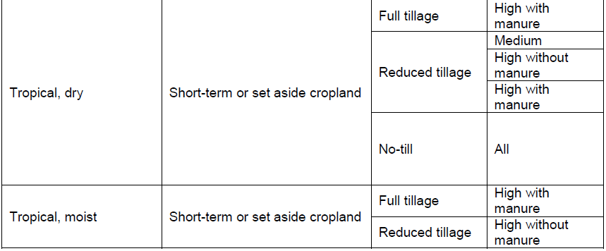
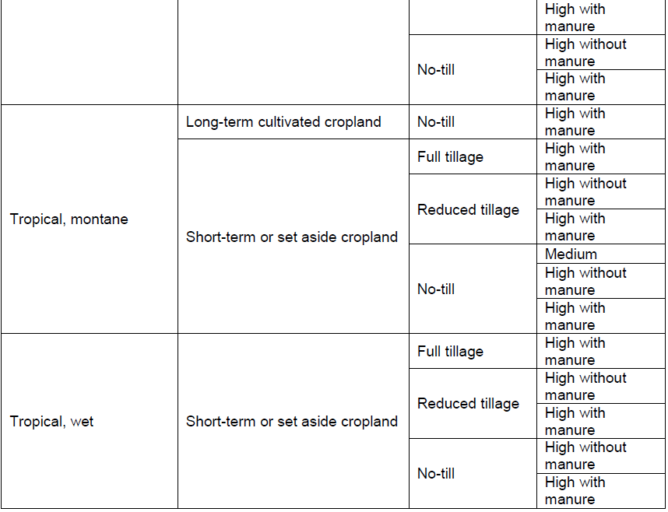
Modified from “Table 5.5 2006 IPCC Guidelines for National Greenhouse Gas Inventories”

Document information

Version | Amendment | Entry into force | Description
01 | -- | 1 March 2023 | -

