T-VER-P-METH-13-01
Afforestation/Reforestation of Lands Except wetlands

Version 01
Sector: 14 –Afforestation and Reforestation
Entry into force on 1 March 2023

- Methodology Title | Afforestation/Reforestation of lands except wetlands
- Project Type | Reduction, absorption and removal of greenhouse gases from the forestry and agriculture sectors
- Sector | Afforestation and reforestation
- Project Outline | Greenhouse gas reduction activity incurred from carbon sink increase of above-ground and below-ground biomass including dead woods, plants, and soil (alternative) in afforestation and reforestation area (except wetland)
- Applicability | - Correct afforestation, forest conservation and management methodology  - Perennial planting (trees)  - Project area has land-use rights certificate as specified by law  - Baseline area before project initiation must not be a forest (crown covering of a fully grown tree must not less than 3 meters or less than 30% of the total area in average)  - Baseline area prior to project initiation must not be a wetland
- Project Conditions | - Project area may compose of many areas together  - No wood transported outside during the first 10 years after project initiation  - The project must operate its additionality activities as an increment to legal requirement, but not be against the laws relevant to its operations, except activities of government agencies, state enterprises, and agencies under the government’s administration  - The project must not create more than 10% of soil disturbance such as digging a plant hole, and making a trench in the following areas:  - Land containing organic soils or  - Land prior to project operations must be managed and treated in a way to increase soil organic carbon such as use minimum tillage and organic fertilizer (Details appear in Annex)
- Project starting date | Planting or sowing seeding in the project area. This does not include site preparation such as weeding digging planting holes, etc.
- Remark

Definitions
Baseline | In business-as-usual greenhouse gas emission event
Afforestation | Planting trees on unforested land over a period of 50 years by planting from saplings or seeds and/or by arrangements that promote natural renewal (natural regeneration)  In the case of T-VER project development, evidence can be presented such as satellite images aerial photograph not later than ₂0 years to confirm the wilderness of the project area
Reforestation | Planting trees on areas that used to be forests but were destroyed by planting from seedlings or seeds and/or arrangements that promote natural renewable growth.
Soil disturbance | Human activities that result in the release of carbon accumulated in organic form in the soil into the atmosphere, such as tilling, digging, cultivating, trenching, draining, etc.
Small scale project | Greenhouse gas reduction projects that can reduce or store greenhouse gases up to 16,000 tCO₂eq/year.
Large scale project | Greenhouse gas reduction projects that can reduce or store more than 16,000 tCO₂eq/year.
Organic soil | Organic soil is soil with various characteristics as specified by FAO, which must have the characteristics in Clauses 1 and 2 or Clauses 1 and 3 as follows:  (1) having a thickness of 10 cm or more The soil layer is <20 cm thick and must contain at least 12% organic carbon in the soil when the soil is mixed to a depth of 20 cm.  (2) In case the soil has not been saturated with water for more than 2-3 days and has soil organic carbon >20% by weight (approximately 35% soil organic matter).  (3) In case the soil is saturated with water and  (i) at least 12% by weight of soil organic carbon (containing organic matter  in soil approximately 20%), if there is no clay mineral or  (ii) at least 18% by weight of soil organic carbon (containing organic matter  in the soil of about 30%), if it contains 60% or more of clay minerals, or  (iii) There is moderate soil organic carbon for moderately clay minerals.  Area data should be classified by climatic zone, namely temperate and tropical. and classified according to soil fertility for temperate forest areas. Organic land area data may be compiled from official country statistics. or the organic land area of each country as reported by the FAO. (http://faostat.fao.org/)  Data Source: 2006 IPCC Guidelines (Vol. 4 Chapter 3)
Wetlands | According to the Ramsar Convention or the Convention on Wetlands (in Articles 1.1 and Article 2.1 of the Convention, wetlands are defined as "Wetlands" means lowlands, lowlands, wet areas, peatlands, bodies of water, both naturally occurring and man-made. Either with waterlogging or Floods are permanent and temporary. both as a source of still and running water Both freshwater, brackish and saltwater, including the coast and inland areas where when the tide is the lowest with a depth of not more than 6 m.
Document or certificate of land use rights | Documents showing rights to use the land according to the law, such as a land title deed (Nor. Sor 4), a certificate of utilization (Nor Sor 3) or a land use authorization letter from the relevant government agency, etc.
In addition to the definitions contained in this document, Use definitions consistent with definitions in the T-VER, CDM and IPCC Guidelines.

T-VER Methodology for
Afforestation/Reforestation of lands except wetlands

1. Scope of project

1.1 Operation Characteristics
Afforestation and reforestation of land except wetland is a large-scale project that can perform greenhouse gas reduction and removal of more than 16,000 tons of carbon dioxide equivalent per year, or a small-scale project that can perform greenhouse gas reduction and removal of not more than 16,000 tons of carbon dioxide equivalent per year. Activities relevant to this activity that are important to the project’s carbon sink capacity include correct tree planting, forest conservation and management listed below.
- Tree planting means planting new trees in the area
  - Site preparation
  - Seedling preparation
  - Planting methods
- Conservation means care and maintenance provision to new plants and those existing in the area to increase carbon sink capacity
  - Weeding
  - Watering
- Technical afforestation and other significant factors affecting carbon sink in wood
  - Pruning
  - Thinning
  - Fire prevention barrier
  - Surveillance monitoring

1.2 Scope of Work
The project developer must identify project location including geographic coordinate, location, and other details of such location as well as a legal land use certificate.

2. Selection of carbon sources and greenhouse gases in calculation

2.1 Source of carbon and greenhouse gases in calculation
Carbon pools | Selected | Explanation
Aboveground Biomass: ABG | Yes | This is the major carbon pool subjected to project activity that calculated from wood biomass (tree) and sapling collected aboveground such as stem, branches, and leaves
Belowground Biomass: BLG | Yes | This is the major carbon pool subjected to project activity, A carbon stock calculated from wood biomass (tree) and sapling collected belowground such as root
Dead Wood: DW | Optional | A carbon source may increase from project activities, calculated from dead woods in the project area
Litter: LI | Optional | A carbon source may increase occurred from project activities calculated from litters in the project area
Soil organic carbon | Optional | A carbon source may increase occurred from project activities calculated from soil organic carbon in the project area

2.2 Emission source and greenhouse gas type used for calculation
Sources | Greenhouse Gas | Selected | Explanation
Burning of woody biomass | CO₂ | No | CO₂ emissions due to burning of biomass are accounted as a change in carbon stock
 | CH₄ | Yes | Burning from site preparation and other activities happened as part of forest management and forest fire must be used for GHG emission calculation
 | N₂O | Yes | Burning from site preparation and other activities happened as part of forest management and forest fire must be used for GHG emission calculation
Use of fossil fuel | CO₂ | Yes | Use of fossil fuel in machines used for as part of forest management and reforestation such as site preparation must be used for GHG emission calculation of a large-scale project

3. Identification of baseline scenario and demonstration of additionality
The project developer must prepare land use pattern data before project initiation for a proper baseline scenario determination and a demonstration of additionality from business as usual by using T-VER-P-TOOL-01-01 Combined tool to identify the baseline scenario and demonstrate additionality in forest project activities

4. Stratification
If biomass distribution over the project land is heterogeneous, stratification should be carried out to improve the precision of carbon stock estimation especially in the following scenarios.
- For baseline net GHG removals by sinks, it is usually sufficient to stratify the area according to major vegetation types and their crown cover and/or land use types
- For net GHG removal forecast, it is sufficient to stratify the area according to major vegetation and forest management
- For net GHG removal (post implementation), the stratification depends on major vegetation and actual forest management. In the case of project impacts from natural or human disasters, such as storms or other factors such as sediment loads, which cause the trend of the project's biomass carbon sequestration to change. It is necessary to re-stratification accordingly.

5. Baseline net GHG removals by sinks
The baseline net GHG removals by sinks shall be calculated as follows:
$${∆C}_{BSL,t}={∆C}_{TREE_BSL,t}+{∆C}_{SAP_BSL,t}+{∆C}_{DW_BSL,t}+{∆C}_{LI_BSL,t}$$
Where
$${∆C}_{BSL,t}$$ | = | Baseline net GHG removals by sinks in year t; tCO₂eq
$${∆C}_{TREE_BSL,t}$$ | = | Change in carbon stock in baseline tree biomass within the project boundary in year t, tCO₂eq and calculate according to T-VER-P-TOOL-01-02 Calculation for carbon stocks and change in carbon stocks of trees in forest project activities
$${∆C}_{SAP_BSL,t}$$ | = | Change in carbon sink in baseline sapling within the project boundary in year t (alternative), tCO₂eq and calculate according to T-VER-P-TOOL-01-02 Calculation for carbon stocks and change in carbon stocks of trees in forest project activities
$${∆C}_{DW_BSL,t}$$ | = | Change in carbon stock in baseline dead wood biomass within the project boundary, in year t (alternative), tCO₂eq and calculate according to T-VER-P-TOOL-01-03 Calculation for carbon stocks and change in carbon stocks of dead wood and litter in forest project activities
$${∆C}_{LI_BSL,t}$$ | = | Change in carbon stock in baseline litter biomass within the project boundary, in year t (alternative), tCO₂eq and calculate according to T-VER-P-TOOL-01-03 Calculation for carbon stocks and change in carbon stocks of dead wood and litter in forest project activities
However, change in net carbon stock in baseline, in year t, may be equivalent to zero, if the calculation appears according to the related calculation tool.

6. Actual net GHG removals by sinks
The actual net GHG removals by sinks shall be calculated as follows
$${∆C}_{ACTUAL,t}={∆C}_{P,t}-{GHG}_{E,t}$$
Where
$${∆C}_{ACTUAL,t}$$ | = | Actual net GHG removals by sinks, in year t; tCO₂eq
$${∆C}_{P,t}$$ | = | Change in the carbon stocks in project, occurring in the selected carbon pools, in year t; tCO₂eq
$${GHG}_{E,t}$$ | = | Increase in GHG emissions within the project boundary in year t; tCO₂eq

6.1 Change in the carbon stocks in project
Change in the carbon stocks in project, occurring in the selected carbon pools in year t shall be calculated as follows
$${∆C}_{P,t}={∆C}_{TREE_P,t}+{∆C}_{SAP_P,t}+{∆C}_{DW_P,t}+{∆C}_{LI_P,t}+{∆SOC}_{P,t}$$
Where
$${∆C}_{P,t}$$ | = | Change in the carbon stocks in project, occurring in the selected carbon pools, in year t; tCO₂eq
$${∆C}_{TREE_P,t}$$ | = | Change in the carbon stocks in tree biomass in project in year t, tCO₂eq, as estimated according to T-VER-P-TOOL-01-02 Calculation for carbon stocks and change in carbon stocks of trees in forest project activities
$${∆C}_{SAP_P,t}$$ | = | Change in the carbon stocks in sapling in project in year t (alternative), tCO₂eq, as estimated according to T-VER-P-TOOL-01-02 Calculation for carbon stocks and change in carbon stocks of trees in forest project activities
$${∆C}_{DW_P,t}$$ | = | Change in the carbon stocks in dead wood in project in year t (alternative), tCO₂eq, as estimated according to T-VER-P-TOOL-01-03 Calculation for carbon stocks and change in carbon stocks of dead wood and litter in forest project activities
$${∆C}_{LI_P,t}$$ | = | Change in carbon stock in litter in project in year t (alternative) in year t, tCO₂eq, as estimated according to T-VER-P-TOOL-01-03 Calculation for carbon stocks and change in carbon stocks of dead wood and litter in forest project activities
$${∆SOC}_{P,t}$$ | = | Change in carbon stock in SOC in project, in year t (alternative), tCO₂eq, as estimated according to T-VER-P-TOOL-01-04 Calculation for change in soil organic carbon stocks in forest project activities

6.2 Additional GHG emission calculation from project activities
Additional GHG emission calculation composes of the calculation of non-carbon gases from biomass burning such as site preparation or management, and forest fire; and the calculation of GHG emission from fossil fuel burning from machines.
Both calculations are not applicable for small-scale project.
- cuttings of herbaceous plants and shrubs
- fertilizing
- decomposition of plant residues and roots
- Road construction in the project area and transportation from project activities

GHG emission from these activities does not significantly affect carbon sink quantity of the project and its value is equivalent to zero.
Additional GHG emission calculation shall be calculated as follow:
$${GHG}_{E,t}={GHG}_{Burning,t}+{GHG}_{Fuel,t}$$
Where
$${GHG}_{E,t}$$ | = | Additional GHG emission from project activities in year t; tCO₂eq
$${GHG}_{Burning,t}$$ | = | GHG emission from project activities’ biomass burning in year t; tCO₂eq, as estimated according to T-VER-P-TOOL-01-05 Calculation for non-CO₂ greenhouse gas emissions from burning of biomass in forest project activities
$${GHG}_{Fuel,t}$$ | = | GHG emission from project activities’ fossil fuel use in year t; tCO₂eq; for large-scale project can calculated as follow

$${GHG}_{Fuel,t}= \sum{\left({FC}_{i}×\left({NCV}_{i}×{10}^{-6}\right)×{EF}_{{CO2}_{i}}\right)×{10}^{-3}}$$

Where
$${GHG}_{Fuel,t}$$ | = | GHG emission from project activities’ fossil fuel use in year t; tCO₂eq
$${FC}_{i}$$ | = | Quantity of fossil fuel use type i for the operating project (unit)
$${NCV}_{i}$$ | = | Net Calorific Value of fossil fuel use type$i$ (MJ/unit)
$${EF}_{{CO2}_{i}}$$ | = | GHG emission from fossil fuel burning type $i$ (kg CO₂/TJ)

7. Leakage emission
Leakage emission happens from project activities in new boundary such as agricultural activities and displacement. Its GHG emission must be calculated as follow:
$${LK}_{t}={LK}_{AGR,t}$$
$${LK}_{t}$$ | = | GHG emissions due to leakage, in year t; tCO₂eq
$${LK}_{AGR,t}$$ | = | Leakage due to the displacement of agriculture activities in year t, tCO₂eq, as estimated according to T-VER-P-TOOL-01-06 Estimation of the increase in GHG emissions attributable to displacement of pre-project agricultural activities in forest project activities

8. Net anthropogenic GHG removals by sinks
Net anthropogenic GHG removals by sinks can be calculated as follow

$${∆C}_{AR} =\sum_{t=1}^{t=n}{{∆C}_{AR,t}}$$
$${∆C}_{AR,t}= {∆C}_{ACTUAL,t}-{∆C}_{BSL,t}-{LK}_{t}$$
Where
$${∆C}_{AR}$$ | = | Net anthropogenic GHG removals by sinks, from the operating year t₁ to year t_{n}; tCO₂eq
$${∆C}_{AR,t}$$ | = | Net anthropogenic GHG removals in year t; tCO₂eq
$${∆C}_{ACTUAL,t}$$ | = | Actual net GHG removals by sinks, in year t; tCO₂eq
$${∆C}_{BSL,t}$$ | = | Baseline net GHG removals by sinks, in year t, tCO₂eq
$${LK}_{t}$$ | = | GHG emissions due to leakage, in year t, tCO₂eq
$$t$$ | = | 1,2,3 … n year from the project initiation

9. Monitoring Procedure

9.1 Monitoring Plan

Monitoring plan shall provide for collection of all relevant data necessary for verification of changes in carbon stocks in the pools selected, project emissions and leakage emission.

9.2 Monitoring of project implementation
Information for project implementation monitoring is provided in the project design document (PDD) that includes monitoring parameters, QA/QC methodology, frequency of QA/QC as per TGO requirements.

9.3 Parameter not require monitoring
Parameter | NCV_{i,}
Unit | MJ/Unit
Definition | Net Calorific Value of fossil fuel type i
Data Source | Option 1 Net Calorific Value of fossil fuel specified in invoice from fuel supplier  Option 2 from monitoring  Option 3 Thailand energy statistics report, Department of Alternative Energy Development and Efficiency, Ministry of Energy
Remarks

Parameter | $${EF}_{{CO}_{2},i}$$
Unit | kg CO₂/TJ
Definition | GHG emission value from fossil fuel type i
Data Source | Table 1.4 2006 IPCC Guidelines for National GHG Inventories
Remarks | -

Other parameters that do not require monitoring appear in related calculation tools.

9.4 Parameters require monitoring
Parameter | Project location
Unit | UTM or Latitude, Longitude
Definition | Location coordinate of project boundary
Data Source | Monitoring report
Monitoring Methodology | Geographic coordinate from geolocation measuring tool or  A value from a government map of at least four points indicating the location of the different directions: north-most, southern-most, eastern-most, and westernmost
Monitoring Frequency | Following a cycle of follow-up assessments for certification
Remarks | -

Parameter | Project boundary
Unit | Rai
Definition | Total project area
Data Source | Monitoring report
Monitoring Methodology | - Exploration in the boundary  - Use Satellite Imagery or Aerial Photography
Monitoring Frequency | Following a cycle of follow-up assessments for certification
Remarks | -

Parameter | $${∆C}_{TREE_BSL,t}$$
Unit | tCO₂eq
Definition | Change in carbon sink in tree in baseline year t
Data Source | Monitoring report
Monitoring Methodology | T-VER-P-TOOL-01-02 Calculation for carbon stocks and change in carbon stocks of trees in forest project activities
Monitoring Frequency | Following a cycle of follow-up assessments for certification.
Remarks | -

Parameter | $${∆C}_{SAP_BSL,t}$$
Unit | tCO₂eq
Definition | Change in carbon sink in sapling in baseline year t
Data Source | Monitoring report
Monitoring Methodology | T-VER-P-TOOL-01-02 Calculation for carbon stocks and change in carbon stocks of trees in forest project activities
Monitoring Frequency | Following a cycle of follow-up assessments for certification.
Remarks | optional

Parameter | $${∆C}_{DW_BSL,t}$$
Unit | tCO₂eq
Definition | Change in carbon sink in dead wood in baseline year t
Data Source | Monitoring report
Monitoring Methodology | T-VER-P-TOOL-01-03 Calculation of carbon stocks and change in carbon stocks in dead wood and litter in forest project activities
Monitoring Frequency | Following a cycle of follow-up assessments for certification.
Remarks | optional

Parameter | $${∆C}_{LI_BSL,t}$$
Unit | tCO₂eq
Definition | Change in carbon sink in plant decomposition in baseline year t
Data Source | Monitoring report
Monitoring Methodology | T-VER-P-TOOL-01-03 Calculation of carbon stocks and change in carbon stocks in dead wood and litter in forest project activities
Monitoring Frequency | Following a cycle of follow-up assessments for certification.
Remarks | optional

Parameter | $${∆C}_{TREE_P,t}$$
Unit | tCO₂eq
Definition | Change in carbon sink in tree in project year t
Data Source | Monitoring report
Monitoring Methodology | T-VER-P-TOOL-01-02 Calculation for carbon stocks and change in carbon stocks of trees in forest project activities
Monitoring Frequency | Following a cycle of follow-up assessments for certification.
Remarks | -

Parameter | $${∆C}_{SAP_P,t}$$
Unit | tCO₂eq
Definition | Change in carbon sink of sapling under the project activities year t
Data Source | Monitoring report
Monitoring Methodology | T-VER-P-TOOL-01-02 Calculation for carbon stocks and change in carbon stocks of trees in forest project activities
Monitoring Frequency | Following a cycle of follow-up assessments for certification.
Remarks | optional

Parameter | $${∆C}_{DW_P,t}$$
Unit | tCO₂eq
Definition | Change in carbon sink of dead wood under the project activities year t
Data Source | Monitoring report
Monitoring Methodology | T-VER-P-TOOL-01-03 Calculation of carbon stocks and change in carbon stocks in dead wood and litter in forest project activities
Monitoring Frequency | Following a cycle of follow-up assessments for certification.
Remarks | optional

Parameter | $${∆C}_{LI_P,t}$$
Unit | tCO₂eq
Definition | Change in carbon sink of plant decomposition under the project activities year t
Data Source | Monitoring report
Monitoring Methodology | T-VER-P-TOOL-01-03 Calculation of carbon stocks and change in carbon stocks in dead wood and litter in forest project activities
Monitoring Frequency | Following a cycle of follow-up assessments for certification.
Remarks | optional

Parameter | $${∆SOC}_{P,t}$$
Unit | tCO₂eq
Definition | Change in carbon sink in soil under the project activities year t
Data Source | Monitoring report
Monitoring Methodology | T-VER-P-TOOL-01-04 Calculation for change in soil organic carbon stocks in forest project activities
Monitoring Frequency | Following a cycle of follow-up assessments for certification.
Remarks | optional

Parameter | $${FC}_{i}$$
Unit | Fuel unit
Definition | Consumption of fossil fuel type i in case of project implementation in year t
Data Source | measurement report
Monitoring method | Option 1: In case of purchasing or disbursing fuel by using all the fuel at once no spare. Follow up on invoices or disbursement records showing fuel consumption.  Option 2: In case of having a fuel storage container and disbursing from the storage container. To measure the mass or volume of fuel used and continuously record fuel consumption.
Monitoring Frequency | continuous monitoring by recording at least monthly
Remarks | -

Other parameters that require monitoring appear in related calculation tools.

10. References
- AR-ACM0003 A/R Large-scale Consolidated Methodology: Afforestation and reforestation of lands except wetlands Version 02.0
- AR-AMS0007 Afforestation and reforestation project activities implemented on lands other than wetlands Version 03.1
- T-VER-METH-FOR-01 Sustainable Forestation Version 06
- Combined tool to identify the baseline scenario and demonstrate additionality in A/R CDM project activities
- Demonstration of additionality of small-scale project activities
- Estimation of carbon stocks and change in carbon stocks of trees and shrubs in A/R CDM project activities
- Estimation of carbon stocks and change in carbon stocks in dead wood and litter in A/R CDM project activities
- Tool for estimation of change in soil organic carbon stocks due to the implementation of A/R CDM project activities
- Estimation of non-CO₂ greenhouse gas (GHG) emissions resulting from burning of biomass attributable to an A/R CDM project activity
- Estimation of the increase in GHG emissions attributable to displacement of pre-project agricultural activities in A/R CDM project activity
- 2006 IPCC Guidelines

Appendix
Appendix 1 Soil Disturbance in Agricultural Land
In case the land use pattern of project boundary in baseline falls under a land use condition that has land management and intake factor (such as organic fertilizer) as shown in the table below, the project must limit soil disturbance not more than 10% of the project boundary (for example, digging pit at the size of 0.50 m x 0.50 m (width x length) at the distance of 3 m x 3 m is equivalent to 2.78 percent of total area)

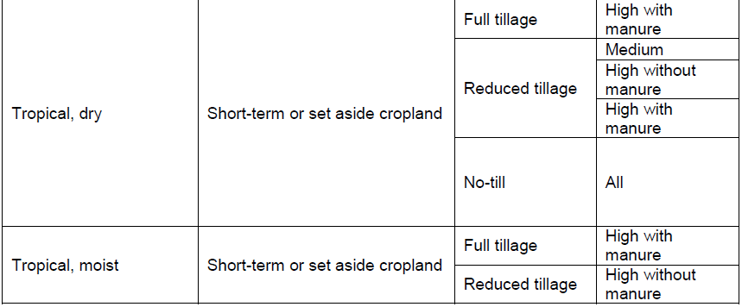
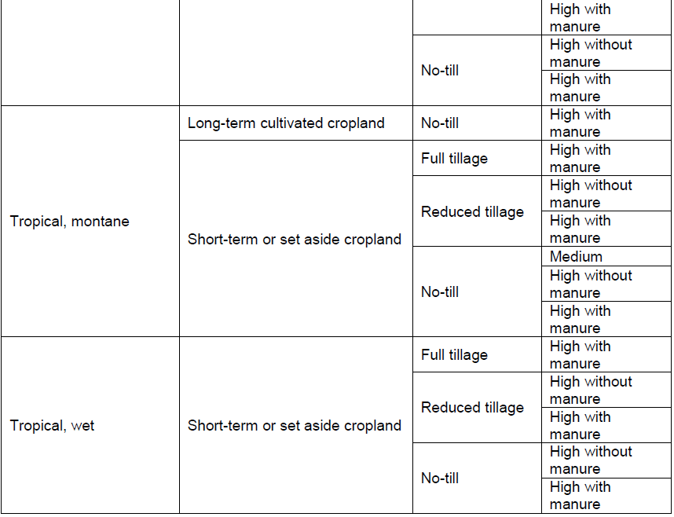
Modified from “Table 5.5 2006 IPCC Guidelines for National Greenhouse Gas Inventories”
Document information

Version | Amendment | Entry into force | Description
01 | -- | 1 March 2023 | -

