T-VER-P-METH-13-07
Voluntary GHG Reduction Methodology
for
Conservation and Restoration of Peatland

Version 01
Sector 14: Afforestation and reforestation

Effective Date 27 September 2023

- Methodology | Conservation and Restoration of Peatland
- Project Type | Reduction, absorption, and storage of greenhouse gases from the forestry and agriculture sectors.
- Sector | 14 –Afforestation and reforestation
- Project Outline | Activities aimed at reducing greenhouse gas emissions resulting from land-use change and area degradation, as well as enhancing carbon sequestration in biomass through peatland restoration.
- Applicability | 1. The project area must possess legal land-use rights documentation as prescribed by law.  2. he project must implement at least one of the following activity types:  2.1 Measures to avoid the conversion of peatland to other forms of land use and/or  2.2 Measures to prevent or reduce the destruction of peatland and/or  2.3 Measures to reduce the degradation of peatland.
- Project Conditions | - The project area must be peatland, defined as an inland wetland characterized by the accumulation of partially decomposed organic matter with an ash content of 35% or less, a peat depth of at least 30 centimeters, and an organic carbon content of at least 12% (by weight).  - The scope includes avoiding planned land-use conversion from peatland to other uses involving government agencies, or greenhouse gas reduction activities in areas prone to unplanned land-use conversion or peatland degradation.  - Projects may combine the activities listed in point 2 with peatland planting and restoration activities.  - Project activities exclude the construction of permanent or semi-permanent structures for managing or controlling water levels in the peatland (rewetting).  - In the baseline scenario, peatland drainage must be calculated based on drainage depth according to common practices in the area, through measurements within appropriate sample plots, or by referencing academic documents, publications, or IPCC default values.  - There must be no ecological leakage resulting from project activities. The project developer must demonstrate:  6.1 No hydrological connectivity with adjacent areas (outside the project), or  6.2 Prevention of ecological leakage caused by hydrological connectivity through project design and site selection, or  6.3 In cases where hydrological connectivity exists and the developer cannot guarantee that no leakage risk will occur, a buffer zone must be established to prevent ecological leakage.  - The project area may consist of multiple aggregated sites.  - Project activities must be additional to what is already required by law and must not conflict with relevant legislation, except for activities conducted by government agencies, state enterprises, and organizations under state supervision.
- Project Start Date | The date when project activities related to peatland restoration begin, as defined by the methodology.
- Remarks

Definitions and Acronyms

Term | Definition
Peatland | Inland wetland characterized by the accumulation of partially decomposed organic matter with an ash content of 35% or less, a peat depth of at least 30 centimeters, and an organic carbon content of at least 12% (by weight).
Accumulation rate | The rate of peat accumulation calculated by depth (centimeters per year).
Peat Depletion Time (PDT) | The duration of time until peat is lost from the area following natural disasters or human-induced events, which typically result from fire and/or oxidation.
Activity displacement leakage | Leakage resulting from project activities that represent the shifting of pre-planned activities to non-forest areas, which causes land degradation and is likely to lead to greenhouse gas emissions outside the project boundary.
Baseline | The greenhouse gas emissions under business-as-usual conditions in the absence of any greenhouse gas emission reduction project implementation.
Deforestation | The direct human-induced conversion of forested land to non-forest land. Deforestation refers to the long-term or permanent loss of forest area. For this methodology, the conversion of land from forest to non-forest must persist for no less than 3 years.
Legal land-use rights documentation | Documents indicating land ownership or legal land-use rights, such as land title deeds (N.S. 4), certificates of utilization (N.S. 3), documents granting permission to utilize land in Agricultural Land Reform areas (S.P.K.), letters requesting the use of public land, permits for land utilization in self-help settlements (N.K. 3), or land-use permits from relevant government agencies, etc.

Voluntary Greenhouse Gas Reduction Methodology Details
for Peatland Conservation and Restoration Activities

1. Scope of Project

1.1 Scope
Implementing greenhouse gas emission reduction activities from land-use change and area degradation, and enhancing carbon sequestration in biomass through peatland restoration, covers the following types of activities:
- Activities to avoid planned land use conversion of peatlands to other land uses involving government agencies or other relevant entities, such as land allocation for housing, land allocation for agriculture, or the promotion of land use conversion from peatlands to other areas, etc. This excludes land use conversion plans of communities or households.
- Activities to reduce greenhouse gas emissions from unplanned land use conversion of peatlands to other land uses.
- Activities to reduce greenhouse gas emissions from peatland degradation.
- Activities to enhance carbon sequestration in peatlands through the planting and restoration of peatlands with native vegetation in the ecosystem.

This methodology cannot be applied under the following conditions:
- Activities to reduce greenhouse gas emissions from deforestation and forest degradation that are legally authorized, such as compensatory tree planting in areas granted mining concessions at the end of the contract, etc.
- Implementation of planting and restoration activities in peatlands alone.

1.2 Project Boundary
The project proponent must specify the project location, providing the coordinates, position, and details of the project area in a comprehensive manner, along with documentation of legal land-use rights as prescribed by law

1.3 Buffer Zone
Project areas with hydrological connectivity to external areas must establish a buffer zone to ensure the monitoring of potential negative impacts on hydrology, such as a decrease in water levels outside the project area. The buffer zone may be located inside or outside the geographical boundaries of the project area. In cases where it is outside the project area, the buffer zone must be adjacent to the project area, and there must be a binding water management agreement with the landholders in the buffer zone by the time of the first verification. The size and shape of the buffer zone must be sufficient to monitor negative impacts both within and outside the project area, which may be demonstrated through expert-reviewed documents and/or references to relevant academic literature

1.4 Stratification
1.4.1 Land Use and Land Cover
If the project implementation area is heterogeneous, it must be stratified to improve the accuracy of greenhouse gas sequestration assessments.
- For the assessment of baseline net GHG removals by sinks, the area can be stratified according to vegetation types, crown cover, peat depth, current and historical land tenure and land use, or the current land use in the absence of project activities, etc.
- For the ex-ante estimation of actual net GHG removals by sinks from project activities, the area can be stratified according to the activity implementation plan for the avoidance or prevention of land use conversion and peatland restoration.
- For the ex-post assessment of actual net GHG removals by sinks from project activities (post-implementation), stratification depends on the implementation of activities for the avoidance or prevention of land use conversion and peatland restoration. In cases where the project is affected by natural or anthropogenic impacts, such as wildfires, which alter the trends of carbon sequestration in biomass or peat soil, ex-post stratification must be revised accordingly to remain consistent with the current situation.

1.4.2 Peat Depth
To estimate the Peat Depletion Time (PDT) for the project area, it is necessary to stratify the peat layers based on the duration until the peat decreases and disappears from the site, which is typically caused by fire and/or oxidation. Since greenhouse gas emissions from peat soil persist as long as oxidation occurs, the peat surface will subside over time. Oxidation continues until either the peat depth or the water table depth reaches a threshold where oxidation can no longer take place. The point at which the peat is no longer oxidized is defined as the Peat Depletion Time (PDT), as it represents the point where there are no additional greenhouse gas emissions from peat oxidation within the area. The procedures are as follows:

(1) Peat Depth Map at the Project Start Date
The project proponent may select the most appropriate mapping method for stratifying peat depth based on the project's specific circumstances. The peat depth map must have a spatial resolution of at least 30 meters x 30 meters and must undergo accuracy verification. Examples of methods for preparing a peat depth map include:
- Field sampling methods using a soil auger or soil drill to measure peat depth. These sampling points must be distributed along transects perpendicular to rivers or perpendicular to the peat dome (for circular peat domes) or distributed uniformly across the project area. Subsequently, the map must be adjusted for accuracy, with sampling procedures following academic principles or research references.
- The use of remote sensing technology in combination with field sampling.
- Remote sensing using medium-to-high resolution satellite imagery such as Sentinel-2 or Landsat 8, in combination with radar satellite imagery such as ALOS-PALSAR2 or SAR (Synthetic Aperture Radar), supplemented by a Digital Elevation Model (DEM) such as NASA SRTM DEMs.

The project proponent must prepare a peat depth map for the project area at the project start date. If the map is created using data from before the start date, the project proponent must demonstrate that the map has been updated to reflect conditions at the project start date, as disturbances or subsidence may have occurred prior to that date.
If subsidence or area disturbance occurs after the mapping at the project start date (which may be evident on the date of field inspection by an external auditor), the map does not need to be revised. However, adjustments must be made for the prediction of potential peat accumulation. If measurements are taken in disturbed areas after the project start date, such areas will have a peat depth lower than the baseline at the start date, resulting in reduced baseline greenhouse gas emissions for those areas. Nevertheless, undisturbed areas must be managed carefully by separating them from the disturbed areas. Peat accumulation rates may be selected from relevant references if site-specific data is unavailable.
Once the peat depth map for the entire project area at the start date has been created, the area must be stratified into intermediate peat depth classes (k), which will be used to calculate the baseline peat burn depth. This peat depth stratification map will be used to monitor greenhouse gas emissions within the peatland. The project proponent shall determine the appropriate class intervals, where the first class must start at a depth from 0 cm to 30 cm, which is the minimum peat depth according to the peatland definition.
Once the peat depth stratification is completed, the average peat depth for each class k at the project start date shall be calculated as follows:
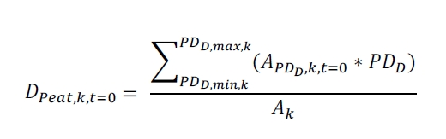
Where:
$D_{peat,k,t=0}$ = Average peat depth in stratum k at the project start date (cm)
${PD}_{D, max,k}$ = Maximum value of peat depth class D within stratum k (cm)
${PD}_{D, min,k}$ = Minimum value of peat depth class D within stratum k (cm)
$A_{{PD}_{D},k,t=0}$ = Area of stratum k for peat depth class D at the project start date (rai)
${PD}_{D}$ = Peat depth of peat depth class D (cm)
$A_{k}$ = Total area in stratum k (rai)
k = Peat depth stratum 1, 2, 3, ..., k

(2) Baseline Peat Depth Stratification Map
The following steps shall be used to stratify the project area according to the Peat Depletion Time (PDT) in the baseline scenario.
(2.1) In cases where area burning occurs in the baseline scenario, a peat depth stratification map for the project area after baseline burning must be prepared by subtracting the peat burn depth in each stratum (k) using the following equation:
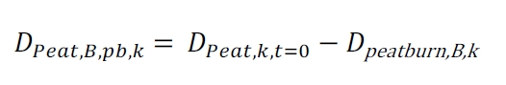
Where:
$D_{peat,B,pb,k}$ = Average peat depth after baseline burning of biomass and peat for stratum k (cm) (equal to l in step 2.2 below)
$D_{peat,B,k,t=0}$ = Average peat depth in stratum k at the project start date (cm)
$D_{peatburn,B,k}$ = Peat burn depth in the baseline scenario in stratum k (cm) (must not exceed the maximum peat burn depth as specified below)

The result of this step is a peat depth stratification map for the project area after baseline site preparation burning. This average peat depth is represented by parameter l, which must be used in the next step to calculate the project's peat burn depth and the Peat Depletion Time (PDT).
This method conservatively assumes that after the initial burning event, no further fires will occur in the baseline scenario.
(2.2) Prepare a peat map based on burn depth strata combined with baseline project site preparation data. The result is a map of peat burn depth strata for project implementation year t. Each stratum in this map is represented by parameter b (as per calculations in section 4.2.2).
(2.2.1) The average post-burning peat depth (l) obtained from step (2.1) will be subtracted from the peat depth map at the project start date in step (1) to create a map of the peat burn depth across the project area. Each stratum will represent the peat burn depth (cm) in the baseline scenario.
(2.2.2) This map may be combined with data on the year the area will be cleared and burned again, depending on the project proponent’s discretion on how to best apply this step. However, the result must be a map showing the peat strata across the entire project area that are burned at each depth found in the baseline scenario, which will affect project implementation in year t.
One possible alternative is to perform calculations in GIS software using the raster calculator tool to multiply the project implementation year t by 100 and then add it to the peat burn depth from the map. For example, an area with a 30 cm peat burn depth in year 1 would be represented by the value 130. The advantage of this method is that the value provides information on both the year and the depth at which the peat was burned.
(2.2.3) The result of this step is a stratification map of the peat burn depth for project implementation year t, which will be used to calculate greenhouse gas emissions from peat burning during project implementation.

(3) Calculation of Peat Depletion Time (PDT)
The calculation of the Peat Depletion Time for each stratum in the map created in step (1), using a conservative subsidence rate to calculate the number of years until the peat is depleted, as per the following equation:
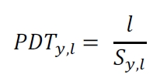
Where:
${PDT}_{y,l}$ = Number of years after site preparation/burning in stratum l at which peat oxidation ends (years)
$S_{y,l}$ = Peat subsidence rate in stratum l (cm/year)
l = Average peat depth after baseline burning of biomass and peat for stratum k (cm)

(3.1) A survey of land-use changes in the vicinity of the project area must be conducted to determine common drainage practices, including the drainage depth used for water management. The results of this survey must be reported in the project proposal, and the derived values must be used in calculations. However, if the project proponent lacks this data because neighboring landowners are unwilling to share specific practices or data, they may use existing references or the default values provided in Table 1. In all cases, the same subsidence rate must be used for both PDT calculations and project drainage calculations.
(3.2) Determination of drainage depth: Hooijer et al. (2006) reported minimum and maximum estimated drainage depths for large-scale plantations and mixed/smallholder agriculture, as shown in Table 1. These estimates are considered conservative; for example, average drainage depths exceeding 1 meter (and up to 3 meters in some cases) have been reported for oil palm, rubber, and commercial timber plantations. Therefore, in areas where peat depth exceeds 1.5 meters, projects without specific data must use a conservative drainage depth of 0.8 meters for a baseline scenario involving conversion to large-scale plantations and 0.4 meters for a baseline scenario involving conversion to small-scale agriculture. In cases where the total peat depth is between 0.5 and 1.0 meters, the initial drainage depth must be conservatively maintained at 50% of the total peat depth for large-scale plantations and 25% when the baseline scenario is small-scale agriculture.
Table 1: Minimum, Probable, and Maximum Drainage Levels Classified by Land Use Type
Land Use | Minimum (m) | Probable (m) | Maximum
Large-scale plantations, including forest plantations | 0.80 | 0.95 | 1.10
Small-scale agriculture | 0.40 | 0.60 | 0.80
Source: Hooijer et al. (2006)
(3.3) The project proponent must use data from historical or local common practices or expert judgment to determine the correct peat drainage rate based on peat depth. The reference value for the peat drainage/subsidence rate for areas with a peat depth of ≥ 50 cm is 4.5 cm per year. Peat subsidence and oxidation immediately following site preparation and the initial burning occur at significantly higher rates than in subsequent years. The project proponent may opt to use a variable subsidence rate in year y by providing evidence that this applies to the project area. This subsidence rate and the greenhouse gas emission factors used must be applied to both the preparation of the PDT stratification map and the calculation of greenhouse gas emissions. To reduce calculation complexity and distribute greenhouse gas emission values equally throughout the project's lifetime, a linear subsidence rate and appropriate greenhouse gas emission factors for the project duration may be used instead.
(3.4) The result of this step is a stratification map representing the number of years (y) after the area has been cleared and burned, at which point peat drainage will no longer occur in the baseline scenario. This involves combining the peat burn stratification map with baseline site preparation data to calculate the PDT. In this map, it is represented by the number of years after the project start date (t) at which drainage emissions from the peat stop, calculated for all peatland within the project area.

(4) Calculation of Peat Depletion Time (PDT)
Relative to the project start date Upon completion of step (3), this data will be combined with baseline scenario data for the year of site preparation to calculate the PDT relative to the project start date, using the following formula:
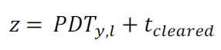

Where:
Z = Number of years t after the project start date at which peat is depleted and/or peat oxidation no longer continues in the baseline scenario (years)
${PDT}_{y,l}$ = Number of years after clearing/burning the area in stratum l at which peat oxidation ends (PDT) (years)
$t_{cleared}$ = Number of years after the project start date in which site preparation occurs (years)

(4.1) The parameter $t_{cleared}$ is part of the baseline calculation (Section 2: Baseline Scenario) and is determined using documentation indicating the timing of area clearing. This parameter represents the year in which the area will be cleared in the baseline scenario relative to the project start date.
(4.2) Both ${PDT}_{y,l}$ and $t_{cleared}$ are spatially explicit; therefore, a GIS raster calculator may be used to perform combined calculations.
(4.3) The result of this step is spatial raster data showing the peat depth at the project start, prepared prior to Step 1. Since the value z represents the number of years until peat is depleted in the baseline scenario, these values may be used to stratify the area by Peat Depletion Time (PDT) into strata j (as per the calculation in section 4.2.3). Stratification begins at 0, which includes all areas with no peat at the project start. The next stratum is identified as 1, which includes all areas where peat will be depleted within Year 1 of the project duration under the baseline scenario. Similarly, stratum values will increase until the end of the project duration. Ultimately, all areas where peat oxidation will continue throughout the project's lifetime may be grouped into a single stratum, as the PDT in these areas exceeds the remaining project duration.

2. Identification of baseline scenario and demonstration of additionality
The project proponent must prepare data on land-use patterns in the project area prior to project implementation to determine an appropriate baseline scenario. Furthermore, it must be demonstrated that the project activities are additional to business-as-usual operations by using the T-VER-P-TOOL-01-01 tool: "Combined tool to identify the baseline scenario and demonstrate additionality in forest project activities."
Eligible project activities for this methodology must be activities to avoid planned land use conversion of peatlands to other land uses involving government agencies, or greenhouse gas reduction activities in areas prone to unplanned land use conversion from peatlands to other areas, or prone to peatland degradation, as well as the joint implementation of the aforementioned activities and activities to enhance carbon sequestration in peatlands. The project proponent must provide verifiable evidence that the area is at risk of being drained or is at risk of land use conversion to other forms, such as:
- Government plans (for public and managed peatlands)
- Community plans (for public peatlands managed by communities)
- Landowner work plans (for private peatlands)
- Other verifiable evidence, such as historical reduction of peatland area, photographs, or site-specific research studies as followed:
The baseline scenario assumes that the entire project area will undergo site preparation and burning of residual biomass before conversion to other land use or land cover types. The project proponent must demonstrate that this baseline scenario is common practice in the area.
The project proponent must identify any land-use activities that may occur in the project's baseline scenario and affect hydrological processes, resulting in increased carbon burial and reduced greenhouse gas emissions within the project area. This includes activities that alter the landscape, such as constructing embankments or dams to restrict water flow or retain water, as well as activities that change the land surface and affect water runoff into the hydrological system, such as forest clearing, ditch construction, or paving, etc.
The project proponent must identify any land-use activities that may occur in the project's baseline scenario and affect hydrological processes, leading to a decrease in sediment volume in the project area, such as the construction of dams or the stabilization of coastal erosion areas. Since sediment volume varies over time, the consideration of these activities must take into account the duration of sediment accumulation within the project area.

3. Greenhouse Gas Emission Activities for Calculation

3.1 แหล่งสะสมคาร์บอนที่นำมาใช้ในการคำนวณ
Carbon Pool | Condition | Details
Aboveground biomass (ABG) | Accounted | This is a major carbon pool for the project activity, calculated from the aboveground biomass of trees and saplings, including stems, branches, and leaves, as well as the biomass of other non-tree vegetation.
Belowground biomass (BLG) | Not Accounted | Not included because belowground biomass in waterlogged areas has low increments, and the death of a large number of fine roots becomes organic matter that contributes to peat accumulation.
Dead wood (DW) | Not Accounted | Exclusion is based on the principle of conservativeness.
Litter (LI) | Not Accounted | Exclusion is based on the principle of conservativeness.
Soil organic carbon (SOC) | Not Accounted | Soil organic carbon components are included within the peat components.
Peat | Accounted | This is a major carbon pool for the project activity, calculated from the quantity of peat.

3.2 Emission Sources and Greenhouse Gas Types Included in the Calculation
The project must account for significant increases in emissions of carbon dioxide (CO₂) nitrous oxide (N₂O) and methane (CH₄) relative to the baseline associated with project activities.
GHG Emission Source |  | Greenhouse Gas | Condition | Details
Baseline Scenario | Burning of woody biomass | CO₂ | Accounted | CO₂ emissions from burned aboveground biomass must be included in the calculation, depending on project activities.
Baseline Scenario | Burning of woody biomass | CH₄ | Accounted | Non-CO2 emissions from burned aboveground biomass must be included in the calculation, depending on project activities.
Baseline Scenario | Burning of woody biomass | N₂O | Accounted
Baseline Scenario | Soil organic carbon | CO₂ | Not Accounted | Soil components are included within the peat components.
Baseline Scenario | Soil organic carbon | CH₄ | Not Accounted | Soil components are included within the peat components.
Baseline Scenario | Soil organic carbon | N₂O | Not Accounted | Soil components are included within the peat components.
Baseline Scenario | Peat | CO₂ | Accounted | CO₂ emissions from burned peat and peat drainage are assessed based on changes in carbon stock.
Baseline Scenario | Peat | CH₄ | Accounted | CH₄ emissions from burned peat and peat drainage must be included in the GHG emission calculation.
Baseline Scenario | Peat | N₂O | Accounted | N₂O emissions from peat due to drainage must be included. For baseline burned peat, N₂O emissions might be higher than during the project period; therefore, non-assessment is based on the principle of conservativeness.
Project Scenario | Burning of woody biomass | CO₂ | Accounted | CO₂ emissions from burned aboveground biomass must be included in the calculation, depending on project activities.
Project Scenario | Burning of woody biomass | CH₄ | Accounted | Non-CO₂ emissions from burned aboveground biomass must be included in the calculation, depending on project activities.
Project Scenario | Burning of woody biomass | N₂O | Accounted
Project Scenario | Soil organic carbon | CO₂ | Not Accounted | Soil components are included within the peat components.
Project Scenario | Soil organic carbon | CH₄ | Not Accounted | Soil components are included within the peat components.
Project Scenario | Soil organic carbon | N₂O | Not Accounted | Soil components are included within the peat components.
Project Scenario | Peat | CO₂ | Accounted | CO₂ emissions from burned peat and peat drainage are assessed based on changes in carbon stock.
Project Scenario | Peat | CH₄ | Accounted | CH₄ emissions from burned peat and peat drainage must be included in the GHG emission calculation.
Project Scenario | Peat | N₂O | Accounted* | N₂O emissions from peat due to drainage must be included. For baseline burned peat, N₂O emissions might be higher than during the project period; therefore, non-assessment is based on the principle of conservativeness.

4. Calculation of Baseline Net GHG Emissions and Removals by Sinks
The baseline scenario for peatland conservation and restoration activities can be defined as follows:

- Planned land-use conversion, such as government allocation of peatland for agricultural purposes.
- Unplanned land-use conversion or unplanned deforestation, such as encroachment on peatland for agriculture.
- Peatland degradation caused by fire and peatland drainage.

The calculation of net greenhouse gas stock changes from various carbon pools—with the primary pools being aboveground biomass and peat—encompassing both greenhouse gas sequestration and emissions, can be performed as follows:

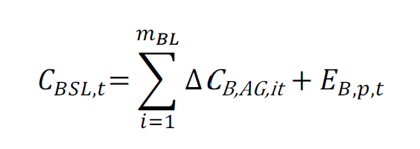
Where:
$$C_{BSL,t}$$ | = | Baseline net greenhouse gas removals by sinks in year t (tonnes of carbon dioxide equivalent)
$${∆C}_{B,AG,i,t}$$ | = | Baseline net greenhouse gas removals by sinks in year t (tonnes of carbon dioxide equivalent)
$$E_{B,p,t}$$ | = | Total greenhouse gas emissions from peat in the baseline scenario in year t (tonnes of carbon dioxide equivalent)

4.1 Calculation of Net Change in Total Aboveground Biomass Carbon Stock
The calculation of the net change in total aboveground biomass carbon stock can be performed as follows:
$${∆C}_{B,AG,i,t}=E_{B,BiomassBurn,i,t}-R_{B,growth,i,t}$$
Where:
$${∆C}_{B,AG,i,t}$$ | = | Net change in total aboveground biomass carbon stock for stratum i in the baseline scenario in year t (tonnes of carbon dioxide equivalent), conducted in accordance with calculation tool T-VER-P-TOOL-01-02
$$E_{B,BiomassBurn,i,t}$$ | = | Total greenhouse gas emissions resulting from biomass burning during site clearing for stratum i in the baseline scenario in year t (tonnes of carbon dioxide equivalent).
$$R_{B,growth,i,t}$$ | = | Total greenhouse gas removals resulting from the growth of trees for stratum i in the baseline scenario in year t (tonnes of carbon dioxide equivalent), conducted in accordance with T-VER-P-TOOL-01-02.

4.1.1 Calculation of Total Greenhouse Gas Emissions from Biomass Burning
The calculation of total greenhouse gas emissions from biomass burning can be performed as follows:
Where:
$$E_{B,BiomassBurn,i,t}$$ | = | Total greenhouse gas emissions resulting from biomass burning for stratum i in the baseline scenario in year t (tonnes of carbon dioxide equivalent)
$$E_{B,BiomassBurn,CO2,i,t}$$ | = | Carbon dioxide emissions resulting from biomass burning for stratum i in the baseline scenario in year t (tonnes of carbon dioxide equivalent)
$$E_{B,BiomassBurn,N2O,i,t}$$ | = | Nitrous oxide emissions resulting from biomass burning for stratum i in the baseline scenario in year t (tonnes of carbon dioxide equivalent)
$$E_{B,BiomassBurn,CH4,i,t}$$ | = | Methane emissions resulting from biomass burning for stratum i in the baseline scenario in year t (tonnes of carbon dioxide equivalent)

4.1.1.1 Calculation of Carbon Dioxide Emissions Resulting from Biomass Burning
The calculation of carbon dioxide emissions resulting from biomass burning can be performed as follows:
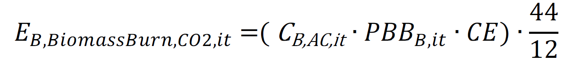
Where:
$$E_{B,BiomassBurn,CO2,i,t}$$ | = | Carbon dioxide emissions resulting from biomass burning for stratum i in the baseline scenario in year t (tonnes of carbon dioxide equivalent)
$$C_{B,AC,it}$$ | = | Estimated carbon stock before biomass burning for stratum i in the baseline scenario in year t (tonnes of carbon)
$${PBB}_{B,it}$$ | = | Proportion of carbon burned (dimensionless); for the baseline scenario, this value is set to 1
$$CE$$ | = | Biomass combustion efficiency (dimensionless); IPCC default values may be used

4.1.1.2 Calculation of Non-CO2 Greenhouse Gas Emissions Resulting from Biomass Burning
The calculation of non-CO2 greenhouse gas emissions resulting from biomass burning, including methane and nitrous oxide, can be performed as follows:
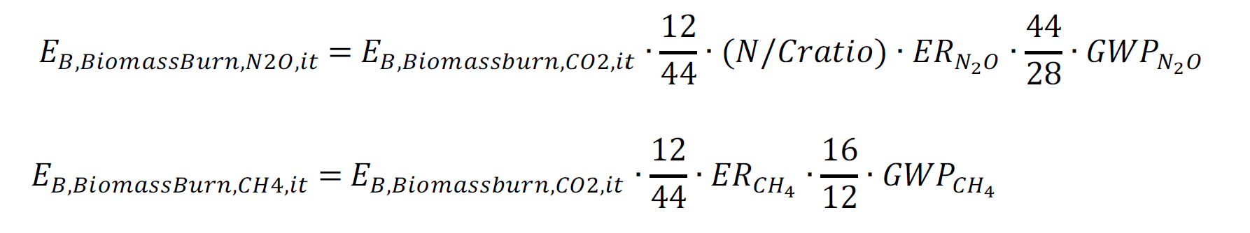
Where:
$$E_{B,BiomassBurn,CO2,it}$$ | = | Carbon dioxide emissions resulting from biomass burning for stratum in the baseline scenario in year (tonnes of carbon dioxide equivalent)
$$E_{B,BiomassBurn,N2O,it}$$ | = | Nitrous oxide emissions resulting from biomass burning for stratum i in the baseline scenario in year t (tonnes of carbon dioxide equivalent)
$$E_{B,BiomassBurn,CH4,it}$$ | = | Methane emissions resulting from biomass burning for stratum i in the baseline scenario in year t (tonnes of carbon dioxide equivalent)
$$N/Cratio$$ |  | Nitrogen-to-carbon ratio (dimensionless); IPCC default values may be used
$${ER}_{N20}$$ | = | Nitrous oxide emission ratio from biomass burning (tonnes of carbon dioxide equivalent per tonne of carbon); IPCC default values may be used
$${ER}_{CH4}$$ | = | Methane emission ratio from biomass burning (tonnes of carbon dioxide equivalent per tonne of carbon); IPCC default values may be used
$${GWP}_{N20}$$ | = | Global Warming Potential for nitrous oxide as per TGO requirements
$${GWP}_{CH4}$$ | = | Global Warming Potential for methane as per TGO requirements

4.2 Calculation of Total Greenhouse Gas Emissions from Peat
The calculation of total greenhouse gas emissions from peat, including emissions from both peat drainage and peat burning, can be performed as follows:
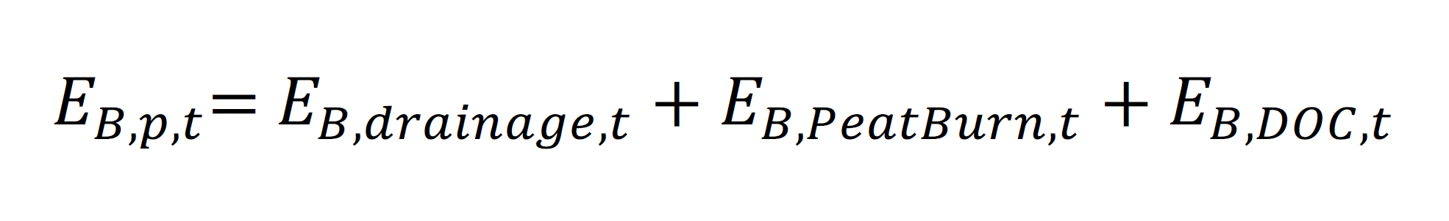
Where:
$$E_{B,p,t}$$ | = | Total greenhouse gas emissions from peat in the baseline scenario in year t (tonnes of carbon dioxide equivalent)
$$E_{B,drainage,t}$$ | = | Greenhouse gas emissions resulting from peatland drainage in the baseline scenario in year t (tonnes of carbon dioxide equivalent)
$$E_{B,PeatBurn,t}$$ | = | Greenhouse gas emissions resulting from peat burning in the baseline scenario in year t (tonnes of carbon dioxide equivalent)
$$E_{B,DOC,t}$$ | = | Greenhouse gas emissions from dissolved organic carbon (DOC) resulting from peatland drainage in the baseline scenario in year t (tonnes of carbon dioxide equivalent)

4.2.1 Calculation of Greenhouse Gas Emissions Resulting from Peatland Drainage can be calculated as follows:
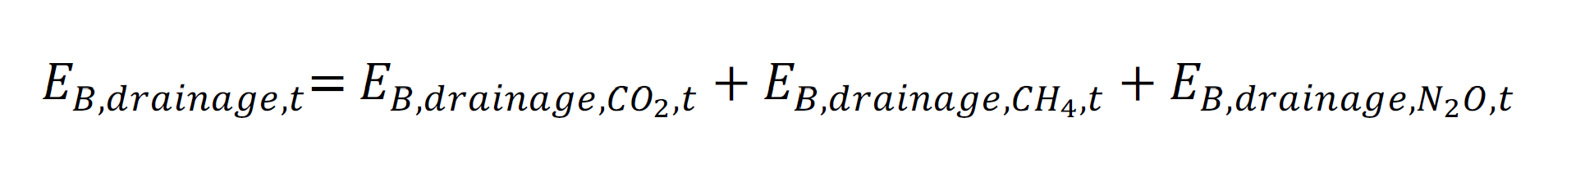
Where:
$$E_{B,drainage,t}$$ | = | Greenhouse gas emissions resulting from peatland drainage in the baseline scenario in year t (tonnes of carbon dioxide equivalent)
$$E_{B,drainage,CO2,t}$$ | = | Carbon dioxide emissions resulting from peatland drainage in the baseline scenario in year t (tonnes of carbon dioxide equivalent)
$$E_{B,drainage,CH4,t}$$ | = | Methane emissions resulting from peatland drainage in the baseline scenario in year t (tonnes of carbon dioxide equivalent)
$$E_{B,drainage,N2O,t}$$ | = | Nitrous oxide emissions resulting from peatland drainage in the baseline scenario in year t (tonnes of carbon dioxide equivalent)

4.2.1.1 Calculation of Carbon Dioxide Emissions Resulting from Peatland Drainage can be calculated as follows:
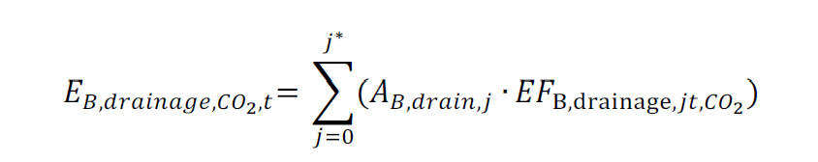
Where:
$$E_{B,drainage,CO2,t}$$ | = | Annual carbon dioxide emissions resulting from peatland drainage in the baseline scenario in year t (tonnes of carbon dioxide equivalent)
$$A_{B,drain,j}$$ | = | Peatland area with drainage for stratum j in the baseline scenario in year t (rai)
$${EF}_{B,drainage,jt,CO2}$$ | = | Carbon dioxide emission factor from peatland drainage for stratum j in the baseline scenario in year t (tonnes of carbon dioxide per rai); IPCC default values may be used

4.2.1.2 Calculation of Methane Emissions Resulting from Peatland Drainage
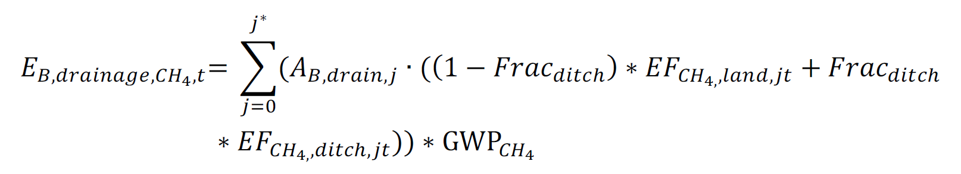
$$E_{B,drainage,CH4,t}$$ | = | Annual methane emissions resulting from peatland drainage in the baseline scenario in year t (tonnes of carbon dioxide equivalent)
$$A_{B,drain,j}$$ | = | Peatland area with drainage for stratum j in the baseline scenario in year t (rai)
$${EF}_{CH4,land,jt}$$ | = | Direct methane emission factor from peatland drainage for stratum j in the baseline scenario in year t (tonnes of methane per rai); IPCC default values may be used
$${EF}_{CH4,ditch,jt}$$ | = | Methane emission factor in waterways (canals/ditches) from peatland drainage for stratum j in the baseline scenario in year t (tonnes of methane per rai); IPCC default values may be used
$${Frac}_{ditch}$$ | = | Proportion of area consisting of waterways (canals/ditches) relative to the total area undergoing peatland drainage (dimensionless)
$${GWP}_{CH4}$$ | = | Global Warming Potential for methane as per TGO requirements

4.2.1.3 Calculation of Nitrous Oxide Emissions Resulting from Peatland Drainage
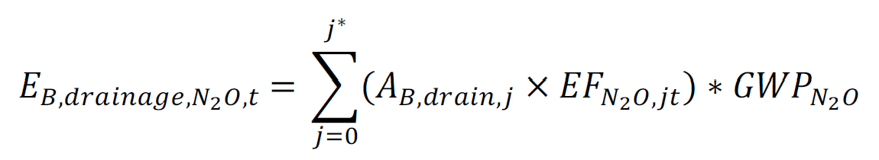
Where:
$$E_{B,drainage,CH4,t}$$ | = | Annual nitrous oxide emissions resulting from peatland drainage in the baseline scenario in year t (tonnes of carbon dioxide equivalent)
$$A_{B,drain,j}$$ | = | Peatland area with drainage for stratum j in the baseline scenario in year t (rai)
$${EF}_{N2O,jt}$$ | = | Nitrous oxide emission factor from peatland drainage for stratum j in the baseline scenario in year t (tonnes of nitrous oxide per rai); IPCC default values may be used
$${GWP}_{N2O}$$ | = | Global Warming Potential for nitrous oxide as per TGO requirements

4.2.2 Calculation of Greenhouse Gas Emissions Resulting from Peat Burning

$E_{B,PeatBurn,t} = E_{B,PeatBurn,CO2,t} + E_{B,PeatBurn,CH4,t}$
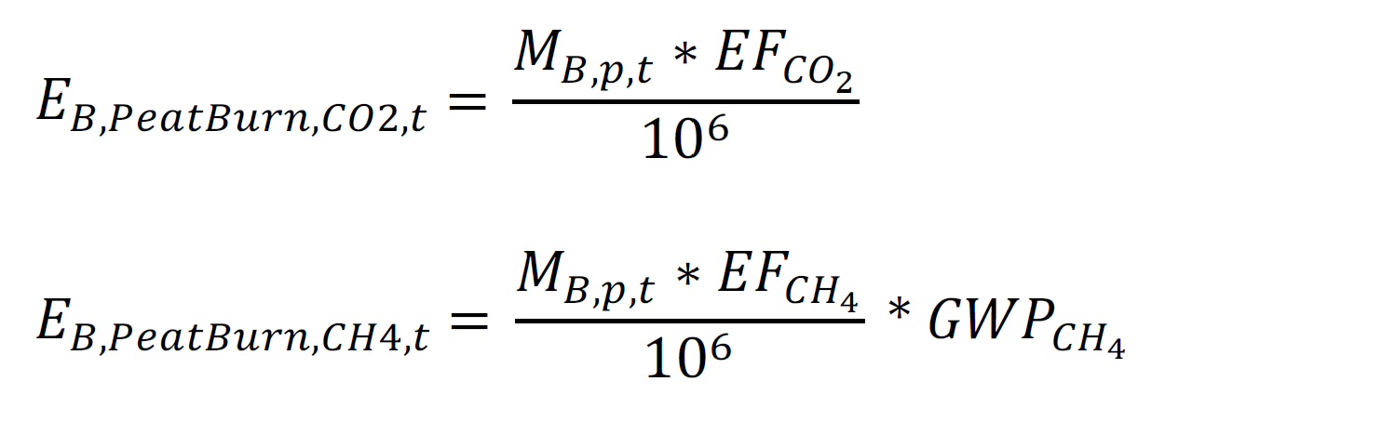
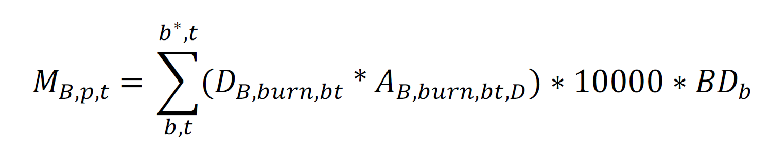
Where:
$$E_{B,PeatBurn,t}$$ | = | Total greenhouse gas emissions resulting from peat burning in the baseline scenario in year t (tonnes of carbon dioxide equivalent)
$$E_{B,PeatBurn,CO2,t}$$ | = | Carbon dioxide emissions resulting from peat burning in the baseline scenario in year t (tonnes of carbon dioxide equivalent)
$$E_{B,PeatBurn,CH4,t}$$ | = | Methane emissions resulting from peat burning in the baseline scenario in year t (tonnes of carbon dioxide equivalent)
$$M_{B,p,t}$$ | = | Mass of peat burned in the baseline scenario in year t (tonnes)
$${EF}_{CO2}$$ | = | Carbon dioxide emission factor from peat burning (grams of carbon dioxide per tonne of peat); IPCC default values may be used
$${EF}_{CH4}$$ | = | Methane emission factor from peat burning (grams of methane per tonne of peat); IPCC default values may be used
$${EF}_{N20}$$ | = | Nitrous oxide emission factor from peat burning (grams of nitrous oxide per tonne of peat); IPCC default values may be used
$$D_{B,burn,bt}$$ | = | Burn depth of peat for stratum b in the baseline scenario in year t (meters)
$$A_{B,burn,bt,D}$$ | = | Area where peat is burned at depth D for stratum b in the baseline scenario in year t (rai)
$${BD}_{b}$$ | = | Peat bulk density for stratum b (grams per cubic centimeter); reference values from published academic literature may be used

4.2.3 Calculation of Greenhouse Gas Emissions from Dissolved Organic Carbon Resulting from Peatland Drainage
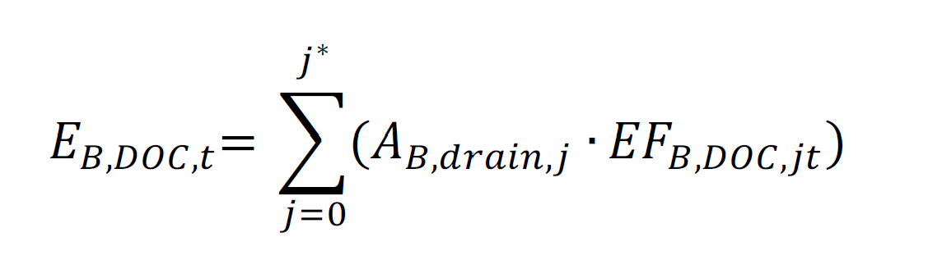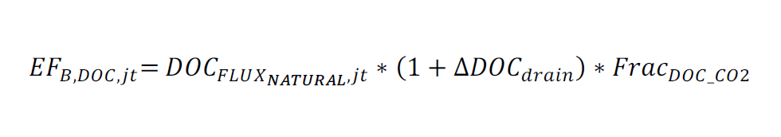
Where:
$$E_{B,DOC,t}$$ | = | Greenhouse gas emissions from dissolved organic carbon (DOC) resulting from peatland drainage in the baseline scenario in year t (tonnes of carbon dioxide equivalent)
$$A_{B,drain,j}$$ | = | Peatland area with drainage for stratum j (rai)
$${EF}_{B,DOC,j,t}$$ | = | Annual carbon dioxide emission factor from dissolved organic carbon resulting from peatland drainage for stratum j in the baseline scenario in year t (tonnes of carbon dioxide equivalent per rai)
$${DOC}_{{FLUX}_{NATURAL,j,t}}$$ | = | Natural gas exchange value from dissolved organic carbon without peatland drainage for stratum j in the baseline scenario in year t (tonnes of carbon dioxide equivalent per rai per year)
$$∆{DOC}_{drain}$$ | = | Proportion of the increase in dissolved organic carbon gas exchange from drainage compared to no peatland drainage (dimensionless)
$${Frac}_{DOC_CO2}$$ | = | Constant for converting the proportion of dissolved organic carbon into carbon dioxide gas (dimensionless)

Greenhouse gas emission factors from dissolved organic carbon resulting from peatland drainage may use IPCC default values or reference values from published academic literature.

4.3 Projection of Baseline Net GHG Emissions and Removals
Changes in baseline carbon stocks do not require measurement and monitoring after project implementation because the calculation of carbon stock changes from various pools within the project boundary under the baseline scenario is subject to project validation. However, as time passes, academic advancements and increased data availability may necessitate the recalculation of baseline carbon stock changes every 15 years.

5. Calculation of Actual Net GHG Emissions and Removals by Sinks
The calculation of actual net GHG emissions and removals by sinks, derived from carbon stock changes in selected carbon pools and the increase in GHG emissions resulting from project activities, can be performed as follows:
$$C_{PRJ,t}=E_{PRJ,t}-R_{PRJ,growt,t}$$
Where:
$$C_{PRJ,t}$$ | = | Net greenhouse gas emissions and removals from project activities in any year t (tonnes of carbon dioxide equivalent)
$$E_{PRJ,t}$$ | = | Total greenhouse gas emissions from project activities in any year t (tonnes of carbon dioxide equivalent)
$$R_{PRJ,growth,i,t}$$ | = | Net carbon stock change from peatland planting and restoration activities in any year t (tonnes of carbon dioxide equivalent), conducted in accordance with calculation tool T-VER-P-TOOL-01-02: Calculation for carbon stocks and change in carbon stocks of trees in forest project activities

5.1 Calculation of Greenhouse Gas Removals from Project Activities (Project removals)
For projects implementing peatland conservation alongside peatland planting and restoration activities in any year (tonnes of carbon dioxide equivalent), greenhouse gas removals from project activities are calculated based on the increase in carbon stock of trees and saplings as follows:
$$R_{PRJ,growt,t}={∆C}_{PRJ,TREE,t}+{∆C}_{PRJ,SAP,t}$$
Where:
$$R_{PRJ,growt,t}$$ | = | Net carbon stock change from peatland planting and restoration activities in any year t (tonnes of carbon dioxide equivalent)
$${∆C}_{TREE_PRJ,t}$$ | = | Change in carbon stock of trees from project activities in year t (tonnes of carbon dioxide equivalent), conducted in accordance with T-VER-P-TOOL-01-02: Calculation for carbon stocks and change in carbon stocks of trees in forest project activities
$${∆C}_{SAP_PRJ,t}$$ | = | Change in carbon stock of saplings from project activities in year t (tonnes of carbon dioxide equivalent), conducted in accordance with T-VER-P-TOOL-01-02: Calculation for carbon stocks and change in carbon stocks of trees in forest project activities

5.2 Calculation of Greenhouse Gas Emissions from Project Activities (Project emissions)
The calculation of greenhouse gas emissions from project activities (project emissions) involves monitoring emissions that may occur within the project boundary from project commencement throughout the project period, such as fire, land degradation, and unplanned land-use change or land encroachment, as follows:
$$E_{PRJ,t}=E_{P,t}^{BLost}+E_{P,t}^{fire}+E_{P,t}^{LCC}+E_{P,drainage,t}$$
Where:
$$E_{PRJ,t}$$ | = | Total greenhouse gas emissions from project activities (Project emissions) in year t (tonnes of carbon dioxide equivalent)
$$E_{P,t}^{BLost}$$ | = | Greenhouse gas emissions resulting from tree felling within the project area in year t (tonnes of carbon dioxide equivalent)
$$E_{P,t}^{fire}$$ | = | Greenhouse gas emissions resulting from fire within the project area in year t (tonnes of carbon dioxide equivalent)
$$E_{P,t}^{LCC}$$ | = | Greenhouse gas emissions resulting from land-use change in year t (tonnes of carbon dioxide equivalent)
$$E_{P,drainage,t}$$ | = | Greenhouse gas emissions resulting from project-related peatland drainage in year t (tonnes of carbon dioxide equivalent)

5.2.1 Calculation of Greenhouse Gas Emissions Resulting from Biomass Loss from Tree Cutting in the Project Area
$$E_{P,t}^{BLost}={∆CLost}_{TREE,t}∙\frac{44}{12}$$
Where:
$$E_{P,t}^{BLost}$$ | = | Greenhouse gas emissions resulting from aboveground biomass loss from tree cutting in the project area in year t (tonnes of carbon dioxide equivalent)
$${∆CLost}_{TREE,t}$$ | = | Loss of carbon stock in aboveground tree biomass from project activities in year t (tonnes of carbon dioxide equivalent), conducted in accordance with T-VER-P-TOOL-01-02: Calculation for carbon stocks and change in carbon stocks of trees in forest project activities

5.2.2 Calculation of Greenhouse Gas Emissions Resulting from Fire in the Project Area
The calculation of greenhouse gas emissions resulting from fire in the project area can be performed as follows:
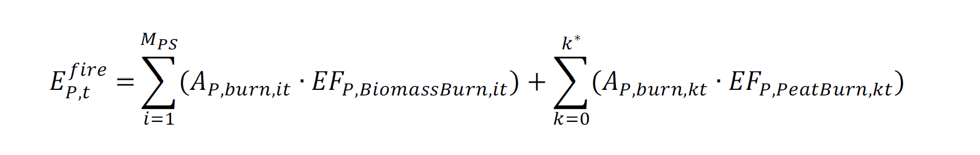
เมื่อ
$$E_{P,t}^{fire}$$ | = | Greenhouse gas emissions resulting from fire in the project area in year t (tonnes of carbon dioxide equivalent)
$$A_{P,burn,it}$$ | = | Area affected by fire for stratum i in year t (rai)
$${EF}_{P,BiomassBurn,i,t}$$ | = | Emission factor from biomass burning for stratum i in year t (tonnes of carbon dioxide equivalent per rai)
$$A_{P,burn,kt}$$ | = | Area where peat burning occurred for stratum k in year t (rai)
$${EF}_{P,PeatBurn,i,t}$$ |  | Emission factor from peat burning for stratum k in year t (tonnes of carbon dioxide equivalent per rai)

5.2.2.1 Calculation of total greenhouse gas emissions, including carbon dioxide and non-CO2 gases, from biomass burning due to fire within the project area for each stratum, can be performed as follows:
Where:
$${EF}_{P,BiomassBurn,it}$$ | = | Total greenhouse gas emissions resulting from biomass burning within the project area for stratum i in year t (tonnes of carbon dioxide equivalent)
$${EF}_{P,BiomassBurn,CO2,it}$$ | = | Carbon dioxide emissions resulting from biomass burning within the project area for stratum i in the baseline scenario in year t (tonnes of carbon dioxide equivalent)
$${EF}_{P,BiomassBurn,N2O,it}$$ | = | Nitrous oxide emissions resulting from biomass burning within the project area for stratum i in the baseline scenario in year t (tonnes of carbon dioxide equivalent)
$${EF}_{P,BiomassBurn,CH4,it}$$ | = | Methane emissions resulting from biomass burning within the project area for stratum i in the baseline scenario in year t (tonnes of carbon dioxide equivalent)
The calculation of carbon dioxide emissions resulting from biomass burning within the project area can be performed as follows:
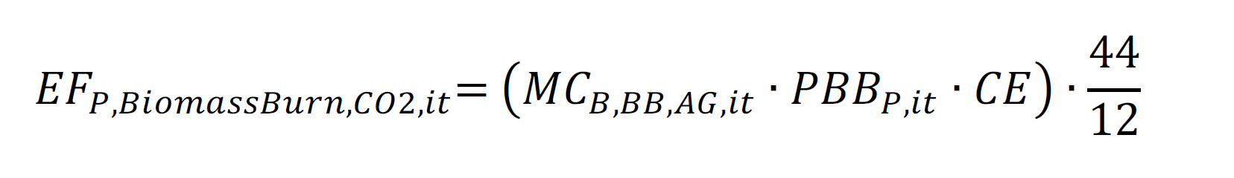

$${EF}_{P,BiomassBurn,CO2,it}$$ | = | Carbon dioxide emissions resulting from biomass burning within the project area for stratum i in year t (tonnes of carbon dioxide equivalent)
$${MC}_{B,BB,AG,it}$$ | = | Estimated aboveground biomass carbon stock before biomass burning within the project area for stratum i in year t (tonnes of carbon per rai)
$${PBB}_{P,it}$$ | = | Proportion of carbon burned within the project area for stratum i in year t (dimensionless); this value is the ratio of the aboveground biomass carbon stock in the project area after the fire to the aboveground biomass carbon stock in the baseline scenario before the fire.
$$CE$$ | = | Biomass combustion efficiency (dimensionless); IPCC default values may be used.

The calculation of non-CO2 greenhouse gas emissions resulting from biomass burning can be performed as follows:
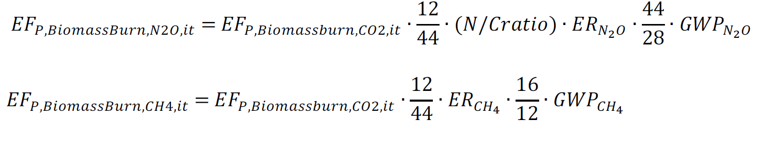
$$E_{P,BiomassBurn,CO2,it}$$ | = | Carbon dioxide emissions resulting from biomass burning within the project area for stratum i in year t (tonnes of carbon dioxide equivalent)
$$E_{B,BiomassBurn,N2O,it}$$ | = | Nitrous oxide emissions resulting from biomass burning for stratum i in the baseline scenario in year t (tonnes of carbon dioxide equivalent)
$$E_{B,BiomassBurn,CH4,it}$$ | = | Methane emissions resulting from biomass burning for stratum i in the baseline scenario in year t (tonnes of carbon dioxide equivalent)
$$N/Cratio$$ |  | Nitrogen-to-carbon ratio (dimensionless); IPCC default values may be used.
$${ER}_{N20}$$ | = | Nitrous oxide emission coefficient resulting from burning (tonnes of carbon dioxide equivalent per tonne of carbon); IPCC default values may be used.
$${ER}_{CH4}$$ | = | Methane emission coefficient resulting from burning (tonnes of carbon dioxide equivalent per tonne of carbon); IPCC default values may be used.
$${GWP}_{N20}$$ | = | Global Warming Potential for nitrous oxide as per TGO requirements.
$${GWP}_{CH4}$$ | = | Global Warming Potential for methane as per TGO requirements.

5.2.2.2 Calculation of greenhouse gas emissions resulting from peat burning can be performed as follows:

$$E_{P,PeatBurn,k,t} = E_{P,PeatBurn,CO2,k,t} + E_{P,PeatBurn,CH4,k,t}$$

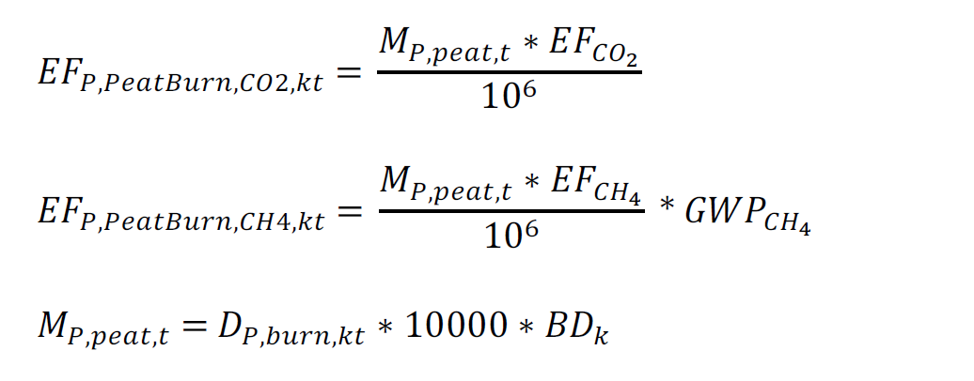
Where:
$$E_{P,PeatBurn,k,t}$$ | = | Greenhouse gas emissions resulting from peat burning in the project area for stratum k in year t (tonnes of carbon dioxide equivalent)
$$E_{P,PeatBurn,CO2,k,t}$$ | = | Carbon dioxide emissions resulting from peat burning in the project area for stratum k in year t (tonnes of carbon dioxide equivalent)
$$E_{P,PeatBurn,CH4,k,t}$$ | = | Methane emissions resulting from peat burning in the project area for stratum k in year t (tonnes of carbon dioxide equivalent)
$$M_{P,peat,k,t}$$ | = | Mass of peat burned in the project area for stratum k in year t (tonnes)
$${EF}_{CO2}$$ | = | Carbon dioxide emission factor from peat burning (grams of carbon dioxide per tonne of peat)
$${EF}_{CH4}$$ | = | Methane emission factor from peat burning (grams of methane per tonne of peat)
$${EF}_{N20}$$ | = | Nitrous oxide emission factor from peat burning (grams of nitrous oxide per tonne of peat)
$$D_{P,burn,k,t}$$ | = | Burn depth of peat in the project area for stratum k in the baseline scenario in year t (meters)
$${BD}_{k}$$ | = | Peat bulk density for stratum k (grams per cubic centimeter)

In this regard, the emission factors for various greenhouse gases resulting from peat burning in the baseline scenario may use site-specific measurements within the project area or reference values from published research.

5.2.3 Calculation of greenhouse gas emissions resulting from land clearing due to land-use change (deforestation) in the project area
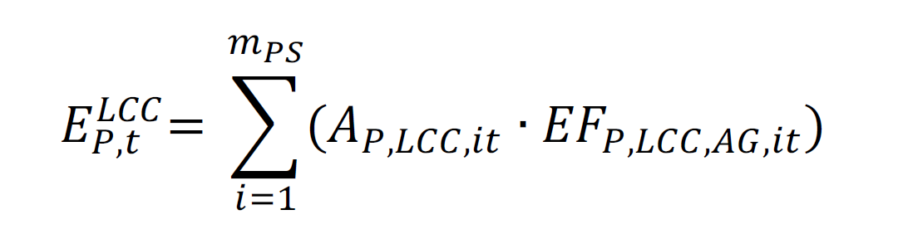
Where:
$$E_{P,t}^{LCC}$$ | = | Greenhouse gas emissions resulting from land clearing due to land-use change (deforestation) in the project area in year t (tonnes of carbon dioxide equivalent)
$$A_{P,LCC,it}$$ | = | Area undergoing land-use change in the project area for stratum i in year t (rai)
$${EF}_{P,LCC,AG,it}$$ | = | Emission factor from land clearing due to land-use change for stratum i (tonnes of carbon dioxide equivalent), calculated from the total aboveground biomass carbon stock in the baseline scenario for stratum i in accordance with calculation tool T-VER-P-TOOL-01-02: Calculation for carbon stocks and change in carbon stocks of trees in forest project activities

5.2.4 Calculation of Greenhouse Gas Emissions from Peatland Drainage in Case of Tree Felling or Land Clearing for Land-Use Change, which may include the excavation of small canals to main water bodies, can be performed as follows:
Where:
$$E_{P,drainage,t}$$ | = | Total greenhouse gas emissions resulting from project-related peatland drainage in year t (tonnes of carbon dioxide equivalent)
$$E_{P,drainage,CO2,t}$$ | = | Carbon dioxide emissions resulting from project-related peatland drainage in year t (tonnes of carbon dioxide equivalent)
$$E_{P,drainage,CH4,t}$$ | = | Methane emissions resulting from project-related peatland drainage in year t (tonnes of carbon dioxide equivalent)
$$E_{P,drainage,N2O,t}$$ | = | Nitrous oxide emissions resulting from project-related peatland drainage in year t (tonnes of carbon dioxide equivalent)

5.2.4.1 Carbon dioxide emissions resulting from project-related peatland drainage can be calculated as follows:
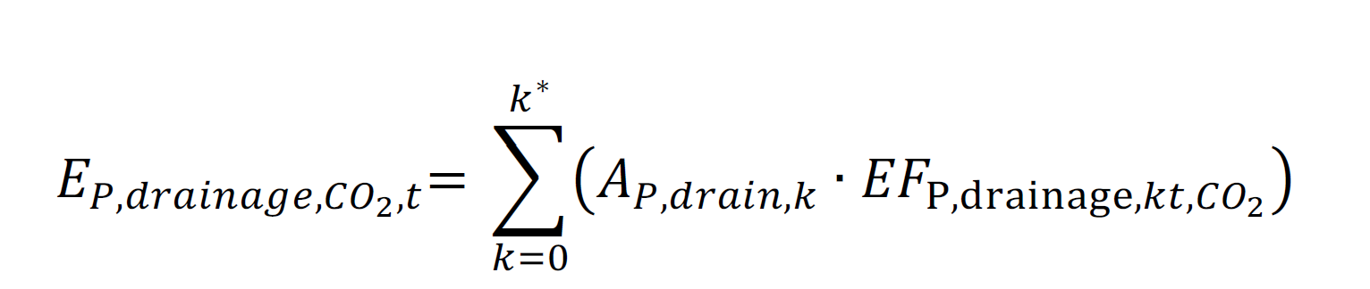
Where:
$$E_{P,drainage,CO2,t}$$ | = | Carbon dioxide emissions resulting from project-related peatland drainage in year t (tonnes of carbon dioxide equivalent)
$$A_{P,drain,k}$$ | = | Area undergoing organic soil drainage from peatland for stratum k (rai)
$${EF}_{P,drainage,kt,CO2}$$ | = | Emission factor from organic soil drainage from peatland for stratum k from project activities in year t (tonnes of carbon dioxide per rai), which is calculated using a model correlating with peat depth.
Methane emissions resulting from project-related peatland drainage can be calculated as follows:
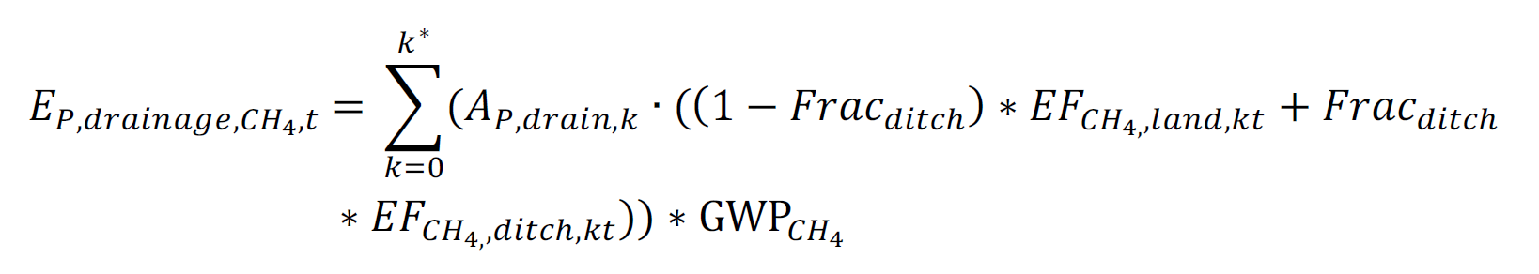
Where:
$$E_{P,drainage,CH4,t}$$ | = | Methane emissions resulting from project-related peatland drainage in year t (tonnes of carbon dioxide equivalent)
$$A_{P,drain,k}$$ | = | Area undergoing organic soil drainage from peatland for stratum k (rai)
$${EF}_{CH4,land,kt}$$ | = | Emission factor from organic soil drainage from peatland for stratum k in year t (tonnes of methane per rai per year)
$${EF}_{CH4,ditch,kt}$$ | = | Emission factor from the excavation of drainage ditches from peatland for stratum k in year t (tonnes of methane per rai per year)
$${Frac}_{ditch}$$ | = | Proportion of the area with drainage ditches relative to the total area (dimensionless)

5.2.4.2 Nitrous oxide emissions resulting from project-related peatland drainage can be calculated as follows:
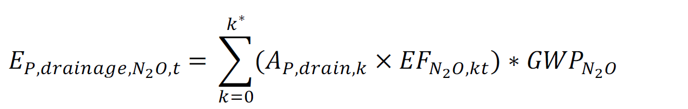
Where:
$$E_{P,drainage,N2O,t}$$ | = | Nitrous oxide emissions resulting from project-related peatland drainage in any year t (tonnes of carbon dioxide equivalent)
$$A_{P,drain,k}$$ | = | Area undergoing organic soil drainage from peatland for stratum k (rai)
$${EF}_{N2O,kt}$$ | = | Annual nitrous oxide emission factor from organic soil drainage from peatland for stratum k in any year (tonnes of nitrous oxide per rai per year)

6. Calculation of Greenhouse Gas Emissions outside the Project Boundary (Leakage Emission)
The calculation of greenhouse gas emissions outside the project boundary is required if project implementation causes land-use changes, whether through planned displacement to other peatland areas to replace the project area or unplanned displacement. The quantity of greenhouse gas emissions outside the project boundary must be calculated as follows:
$${LK}_{t}={LK}_{ActivityDisplacement,t}+{LK}_{Ecological,t}$$
$${LK}_{t}$$ | = | Greenhouse gas emissions outside the project boundary in year t (tonnes of carbon dioxide equivalent)
$${LK}_{ActivityDisplacement,t}$$ | = | Activity displacement leakage from project activities in year t (tonnes of carbon dioxide equivalent)
$${LK}_{Ecological,t}$$ | = | Ecological leakage from project activities in year t (tonnes of carbon dioxide equivalent), which may occur in watershed areas connected to the project area.

The quantity of ecological leakage from project activities can be set to zero based on the assumption that ecological leakage will not occur in projects meeting the methodology's applicability conditions. The project must be designed to ensure that hydrological connectivity with adjacent areas does not lead to a significant increase in greenhouse gas emissions outside the project boundary, as in the following cases:
- Maintaining the condition of the peatland; for example, changing from a flooded area to a peatland will not cause soil oxidation.
- Maintaining the condition of the peatland; for example, changing from a flooded area to a peatland will not cause soil oxidation.
- No management practices that cause degradation or loss of existing vegetation.

Project implementation may cause water leakage to adjacent areas, potentially altering water table depths outside the project boundary (compared to the scenario without project implementation) and resulting in ecological leakage. If the project developer chooses to monitor changes in the water table depth within the project area to demonstrate that there is no change in the average annual groundwater depth in neighboring areas, or that such changes are limited to levels that do not affect greenhouse gas emissions, the developer must use water level gauges, vegetation assessments, or a combination of both. If a buffer zone is established, these gauges must be installed within both the project area and the buffer zone. The procedure for calculating ecological leakage may include steps to monitor changes in water table depth within the project boundary. Readings should be compared with hydrological assessments used to establish the buffer zone. The number and spacing of water level gauges depend on hydrological models and/or expert judgment.

7. Calculation of Net Anthropogenic GHG Emission Reductions and Removals by Sinks
$${NER}_{t}=C_{BSL,t}-C_{PRJ,t }-{LK}_{t}$$
$${NER}_{t}$$ | = | Net Anthropogenic GHG Emission Reductions and Removals from project implementation in any year t (tonnes of carbon dioxide equivalent)
$$C_{BSL,t}$$ | = | Net GHG emissions and removals from the baseline scenario (Project emissions) in any year t (tonnes of carbon dioxide equivalent)
$$C_{PRJ,t}$$ | = | Net GHG emissions and removals from project activities (Project emissions) in any year t (tonnes of carbon dioxide equivalent)
$${LK}_{t}$$ | = | Greenhouse gas emissions outside the project boundary in any year t (tonnes of carbon dioxide equivalent)

8. Monitoring Plan
Data and parameters required for monitoring, including measurement methods and evaluation, in accordance with TGO requirements.

8.1 Parameters Not Requiring Monitoring

Parameter | Combustion Efficiency (CE)
Value | 0.5
Unit | Dimensionless
Meaning | Biomass combustion efficiency
Data Source | Table 2.6, 2006 IPCC AFOLU Guidelines
Note

Parameter | N/C ratio
Value | 0.01
Unit | Dimensionless
Meaning | Nitrogen-to-carbon ratio
Data Source | IPCC default
Note | 2006 IPCC AFOLU Guidelines

Parameter | $${ER}_{N20}$$
Value | 0.007
Unit | Tonnes of carbon dioxide equivalent per tonne of carbon
Meaning | Nitrous oxide emission coefficient resulting from burning
Data Source | IPCC default
Note | Table 3.A.15 IPCC GPGLULUCF

Parameter | $${ER}_{CH4}$$
Value | 0.012
Unit | Tonnes of carbon dioxide equivalent per tonne of carbon
Meaning | Methane emission coefficient resulting from burning
Data Source | IPCC default
Note | Table 3.A.15 IPCC GPGLULUCF

8.2 Parameters Requiring Monitoring
Parameter | Project Location
Unit | UTM or Latitude, Longitude
Meaning | Coordinate values indicating the position of the project area
Data Source | Monitoring Report
Monitoring Method | Geographic coordinates from a geographic positioning tool or values from government maps for at least 4 points identifying directional information: Northmost, Southmost, Eastmost, and Westmost.
Monitoring Frequency | According to the monitoring evaluation cycle for certification.
Note | Information that can be referenced with geographic locations.

Parameter | Project Area
Unit | Rai
Meaning | Total project area
Data Source | Monitoring Report
Monitoring Method | - On-site survey  - Use of satellite imagery/aerial photography
Monitoring Frequency | According to the monitoring evaluation cycle for certification.
Note | Information that can be referenced with geographic locations.

Parameter | $${∆C}_{B,AG,it}$$
Unit | Tonnes of carbon dioxide equivalent
Meaning | otal change in aboveground biomass carbon stock for stratum i in the baseline scenario in year t
Data Source | Monitoring Report
Monitoring Method | T-VER-P-TOOL-01-02: Calculation for carbon stocks and change in carbon stocks of trees in forest project activities
Monitoring Frequency | According to the monitoring evaluation cycle for certification.

Parameter | $$E_{B,p,t}$$
Unit | Tonnes of carbon dioxide equivalent
Meaning | Total greenhouse gas emissions from peat in the baseline scenario in year t
Data Source | Monitoring Report
Monitoring Method | According to the calculation methods in the methodology
Monitoring Frequency | According to the monitoring evaluation cycle for certification

Parameter | $$E_{B,drainage,t}$$
Unit | Tonnes of carbon dioxide equivalent
Meaning | Greenhouse gas emissions resulting from peatland drainage in the baseline scenario in year t
Data Source | Monitoring Report
Monitoring Method | According to the calculation methods in the methodology
Monitoring Frequency | According to the monitoring evaluation cycle for certification

Parameter | $$E_{B,PeatBurn,t}$$
Unit | Tonnes of carbon dioxide equivalent
Meaning | Greenhouse gas emissions resulting from peat burning in the baseline scenario in year t
Data Source | Monitoring Report
Monitoring Method | According to the calculation methods in the methodology
Monitoring Frequency | According to the monitoring evaluation cycle for certification

Parameter | $$E_{B,DOC,t}$$
Unit | Tonnes of carbon dioxide equivalent
Meaning | Greenhouse gas emissions from dissolved organic carbon (DOC) resulting from peatland drainage in the baseline scenario in year t
Data Source | Monitoring Report
Monitoring Method | According to the calculation methods in the methodology
Monitoring Frequency | According to the monitoring evaluation cycle for certification

Parameter | $$E_{B,BomassBurn,N2O,it}$$
Unit | Tonnes of carbon dioxide equivalent
Meaning | Nitrous oxide emissions resulting from biomass burning for stratum i in the baseline scenario in year t
Data Source | Monitoring Report
Monitoring Method | According to the calculation methods in the methodology
Monitoring Frequency | ccording to the monitoring evaluation cycle for certification

Parameter | $$E_{B,BomassBurn,CH4,it}$$
Unit | Tonnes of carbon dioxide equivalent
Meaning | Methane emissions resulting from biomass burning for stratum i in the baseline scenario in year t
Data Source | Monitoring Report
Monitoring Method | According to the calculation methods in the methodology
Monitoring Frequency | According to the monitoring evaluation cycle for certification

Parameter | $$E_{B,BomassBurn,CO2,it}$$
Unit | Tonnes of carbon dioxide equivalent
Meaning | Carbon dioxide emissions resulting from biomass burning for stratum i in the baseline scenario in year t
Data Source | Monitoring Report
Monitoring Method | According to the calculation methods in the methodology
Monitoring Frequency | According to the monitoring evaluation cycle for certification

Parameter | $$E_{P,t}^{logging}$$
Unit | Tonnes of carbon dioxide equivalent
Meaning | Greenhouse gas emissions resulting from logging/tree felling within the project area in year t
Data Source | Monitoring Report
Monitoring Method: | According to the calculation methods in the methodology
Monitoring Frequency | According to the monitoring evaluation cycle for certification

Parameter | $$E_{P,t}^{fire}$$
Unit | Tonnes of carbon dioxide equivalent
Meaning | Greenhouse gas emissions resulting from fire within the project area in year t
Data Source | Monitoring Report
Monitoring Method | According to the calculation methods in the methodology
Monitoring Frequency | According to the monitoring evaluation cycle for certification

Parameter | $$E_{P,BiomassBurn,it}$$
Unit | Tonnes of carbon dioxide equivalent
Meaning | Total greenhouse gas emissions resulting from biomass burning within the project area for stratum i in year t
Data Source | Monitoring Report
Monitoring Method | According to the calculation methods in the methodology
Monitoring Frequency | According to the monitoring evaluation cycle for certification

Parameter | $${EF}_{P,BomassBurn,CO2,it}$$
Unit | Tonnes of carbon dioxide equivalent
Meaning | Carbon dioxide emissions resulting from biomass burning within the project area for stratum i in year t
Data Source | Monitoring Report
Monitoring Method | According to the calculation methods in the methodology
Monitoring Frequency | According to the monitoring evaluation cycle for certification

Parameter | $$E_{B,BomassBurn,N2O,it}$$
Unit | Tonnes of carbon dioxide equivalent
Meaning | Nitrous oxide emissions resulting from biomass burning for stratum i in the baseline scenario in year t
Data Source | Monitoring Report
Monitoring Method | According to the calculation methods in the methodology
Monitoring Frequency | According to the monitoring evaluation cycle for certification

Parameter | $$E_{B,BomassBurn,CH4,it}$$
Unit | Tonnes of carbon dioxide equivalent
Meaning | Methane emissions resulting from biomass burning for stratum i in the baseline scenario in year t
Data Source | Monitoring Report
Monitoring Method | According to the calculation methods in the methodology
Monitoring Frequency | According to the monitoring evaluation cycle for certification

Parameter | $$E_{P,PeatBurn,kt}$$
Unit | Tonnes of carbon dioxide equivalent
Meaning | Greenhouse gas emissions resulting from peat burning in the project area for stratum k in year t
Data Source | Monitoring Report
Monitoring Method | According to the calculation methods in the methodology
Monitoring Frequency | According to the monitoring evaluation cycle for certification

Parameter | $$E_{P,t}^{LCC}$$
Unit | Tonnes of carbon dioxide equivalent
Meaning | Greenhouse gas emissions resulting from land clearing due to land-use change (deforestation) in the project area in year t
Data Source | Monitoring Report
Monitoring Method | According to the calculation methods in the methodology
Monitoring Frequency | According to the monitoring evaluation cycle for certification

Parameter | $$E_{P,drainage,t}$$
Unit | Tonnes of carbon dioxide equivalent
Meaning | Total greenhouse gas emissions resulting from project-related peatland drainage in year t
Data Source | Monitoring Report
Monitoring Method | According to the calculation methods in the methodology
Monitoring Frequency | According to the monitoring evaluation cycle for certification

Parameter | $$E_{P,drainage,CH4,t}$$
Unit | Tonnes of carbon dioxide equivalent
Meaning | Methane emissions resulting from project-related peatland drainage in year t
Data Source | Monitoring Report
Monitoring Method | According to the calculation methods in the methodology
Monitoring Frequency | According to the monitoring evaluation cycle for certification

Parameter | $$E_{P,drainage,N2O,t}$$
Unit | Tonnes of carbon dioxide equivalent
Meaning | Nitrous oxide emissions resulting from project-related peatland drainage in year t
Data Source | Monitoring Report
Monitoring Method | According to the calculation methods in the methodology
Monitoring Frequency | According to the monitoring evaluation cycle for certification

Parameter | $${LK}_{t}$$
Unit | Tonnes of carbon dioxide equivalent
Meaning | Greenhouse gas emissions outside the project boundary in year t
Data Source | Monitoring Report
Monitoring Method | According to the calculation methods in the methodology
Monitoring Frequency | According to the monitoring evaluation cycle for certification

Parameter | $${GWP}_{CH4}$$
Unit | tCO₂eq/tCH₄
Meaning | Global Warming Potential for methane
Data Source | Use data from the climate change assessment reports prepared by the Intergovernmental Panel on Climate Change (IPCC) as announced by TGO
Monitoring Method | For project design document (PDD) preparation  - Use the latest GWP_{CH4} value announced by TGO  For monitoring greenhouse gas emission reductions  - Use the GWP_{CH4} value announced by TGO for evaluating greenhouse gas quantities according to the specific Crediting Period for which certification is requested.

Parameter | $${GWP}_{N2O}$$
Unit | tCO₂eq/tN₂O
Meaning | Global Warming Potential for nitrous oxide
Data Source | Use data from the climate change assessment reports prepared by the Intergovernmental Panel on Climate Change (IPCC) as announced by TGO.
วิธีการติดตามผล | For project design document (PDD) preparation  - Use the latest GWP_{N2O} value announced by TGO  For monitoring greenhouse gas emission reductions  - Use the GWP_{N2O} value announced by TGO for evaluating greenhouse gas quantities according to the specific Crediting Period for which certification is requested.

9. Reference

- 2003 Good Practice Guidance for Land Use, Land-Use Change and Forestry
- 2006 IPCC Guidelines for National Greenhouse Gas Inventories
- 2013 Supplement to the 2006 IPCC Guidelines for National Greenhouse Gas Inventories: Wetlands: Wetlands Supplement)
- 2019 Refinement to 2006 IPCC Guidelines for National Greenhouse Gas Inventories
- AR-AMS0003 Afforestation and reforestation project activities implemented on wetlands
- Hooijer, A., Page, S., Jauhiainen, J., Lee, W. A., Lu, X. X., Idris, A., & Anshari, G. (2012). Subsidence and carbon loss in drained tropical peatlands. Biogeosciences, 9(3), 1053-1071. doi:https://doi.org/10.5194/bg-9-1053-2012
- Hooijer, A., Silvius, M., Wosten, H., & Page, S. (2006). Assessment of CO2 emissions from drained peatlands in SE Asia. Delft Hyraulics report Q3943.
- VM0004 Methodology for avoided planned land use conversion in peat swamp forests
- VM0015 Methodology for Avoided Unplanned Deforestation
- VMD0013 Estimation of greenhouse gas emissions from biomass and peat burning (E-BPB)
- VMD0016 - Methods for Stratification of the Project Area (X-STR)
- VMD0042 - Estimation of baseline soil carbon stock changes and greenhouse gas emissions in peatland rewetting and conservation project activities (BL-PEAT)
- VMD0044 – Estimation of emissions from ecological leakage (LK-ECO)
- VMD0046 - Methods for monitoring of soil carbon stock changes and greenhouse gas emissions and removals in peatland rewetting and conservation project activities (MPEAT)
- T-VER-P-TOOL-01-02 การคำนวณการกักเก็บคาร์บอนและการเปลี่ยนแปลงคาร์บอนของต้นไม้สำหรับกิจกรรมโครงการป่าไม้ (Calculation for carbon stocks and change in carbon stocks of trees in forest project activities)

Edition Log T-VER-METH-Template

Version | Revision | Effective Date | Details
01 | 0 | 27 Sep 2023

